Physics 100 (Stapleton) Name: _______________________________
Unit 4: Work and Energy

Wikipedia says (correctly) “In physics, work is the energy transferred to or from an object via the application of force along a displacement.” Work and energy are essentially interchangeable. Either can be converted to the other, and they both have the same units, Joules (J).

Energy is often defined as “the ability to do work.” Two basic types of energy are kinetic energy (energy something has because it is in motion), and potential energy (stored energy). Both types of energy can be used to do work, and both types of energy can be produced by doing work.

Give some examples of energy being converted to work and work being converted to energy.

Work converted to kinetic energy:

Kinetic energy converted to work:

Work converted to potential energy:

Potential energy converted to work:

Work Formula:

Work Practice:

1. A child pulls a wagon 4m to the right, applying a constant rightward force of 10N. How much work does the child do?


2. A 60kg military cadet holds a plank for 10 seconds. How much work does she do? [Follow the strict physics definition of work]

Mechanical Energy: energy determined by an object’s motion or position. Examples that we will work with during this unit are kinetic energy, gravitational potential energy, and spring potential energy.

Thermal Energy: energy relating to an object’s temperature, which is determined by the speed of its randomly-moving individual molecules. Heat is the flow (or transfer) of thermal energy from one object to another.

Law of Conservation of Energy (in simple situations): Unless mechanical energy is being added to or removed from a system by work, the total amount of mechanical energy in a closed system remains constant. A simple equation expressing this is KE₀+PE₀ = KE + PE (or KE_{initial} +PE_{initial} = KE_{final} + PE_{final}). The total mechanical energy remains constant, so energy is said to be “conserved.” In this situation, “conserved” means “total remains constant.” This is a simple form of the Law of Conservation of Energy.

Use vertical bars to show how the relative values of the skateboarder’s KE and PE, and E_{total} vary at positions 0, 1, and 2.
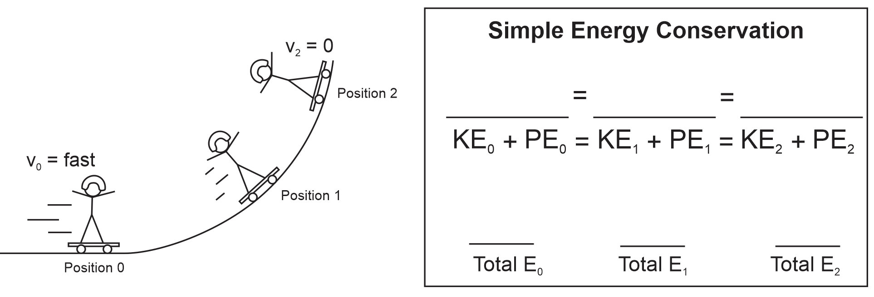

Law of Conservation of Energy (for all energy – closed systems): For any closed system,
KE_{i} + PE_{i} + OE_{i} = KE_{f} + PE_{f} + OE_{f} OE represents “other energy.” Other energy can be chemical, electrostatic, thermal…

Adding to – or Subtracting From – a system’s total Mechanical Energy: Often work is done to add or remove mechanical energy. This work is said to be done by “non-conservative forces,” because the total amount of mechanical energy in the system changes – total mechanical energy is not conserved. Work by non-conservative forces is labeled W_{nc}. A more general equation for mechanical energy takes this work into account…
KE_{initial} +PE_{initial} + W_{nc} = KE_{final} + PE_{final}.

When friction slows something down, W_{nc} is a negative number, because friction opposes motion. When something adds energy, its work (W_{nc}) is a positive number. [Note that, in the case of friction, the energy is not really lost, but rather it gets turned into thermal energy. The equation above applies to mechanical energy, not thermal energy.]

Example -- Negative Work by a Non-conservative Force: A box is sliding down a ramp, slowing down at a constant rate until it stops.
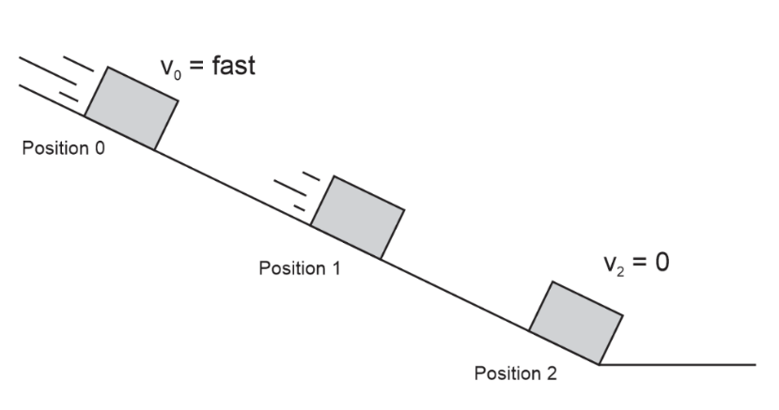
- In the top space, use vertical bars to show the relationship between KE, PE, Mechanical Energy, and non-conservative work.
- Identify the source of the non-conservative work.
- In the bottom spaces, use vertical bars to represent the relative values of the system’s KE, PE, OE, and E_{total} at various stages in its slide.
- Identify the form of OE in this scenario.
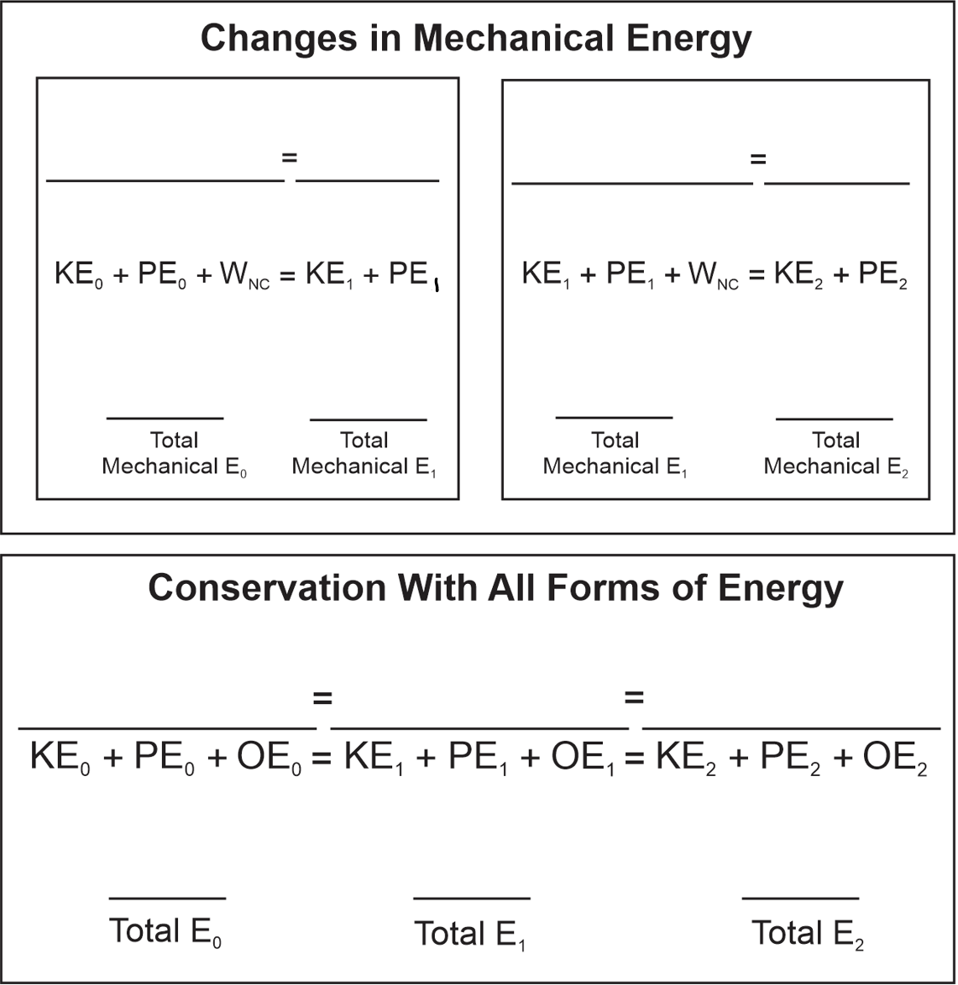
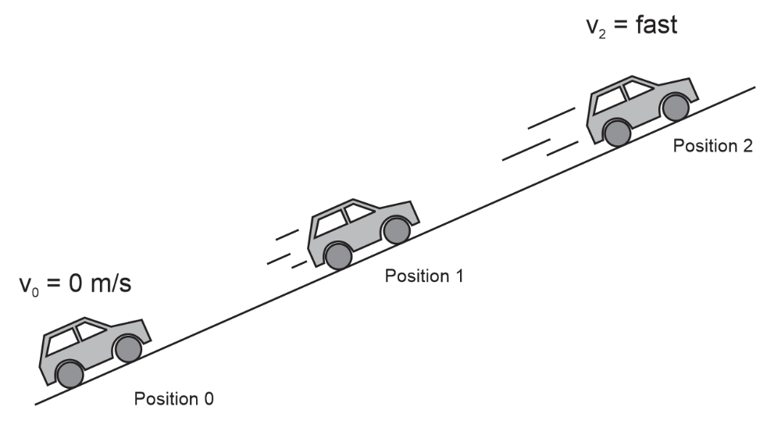
Example -- Positive Work by a Non-conservative Force: Starting from rest, a car continuously accelerates up a hill.
- In the top space, use vertical bars to show the relationship between KE, PE, Mechanical Energy, and non-conservative work.
- Identify the source of the non-conservative work.
- In the bottom spaces, use vertical bars to represent the relative values of the system’s KE, PE, OE, and E_{total} at various stages in its slide.
- Identify the form of OE in this scenario.
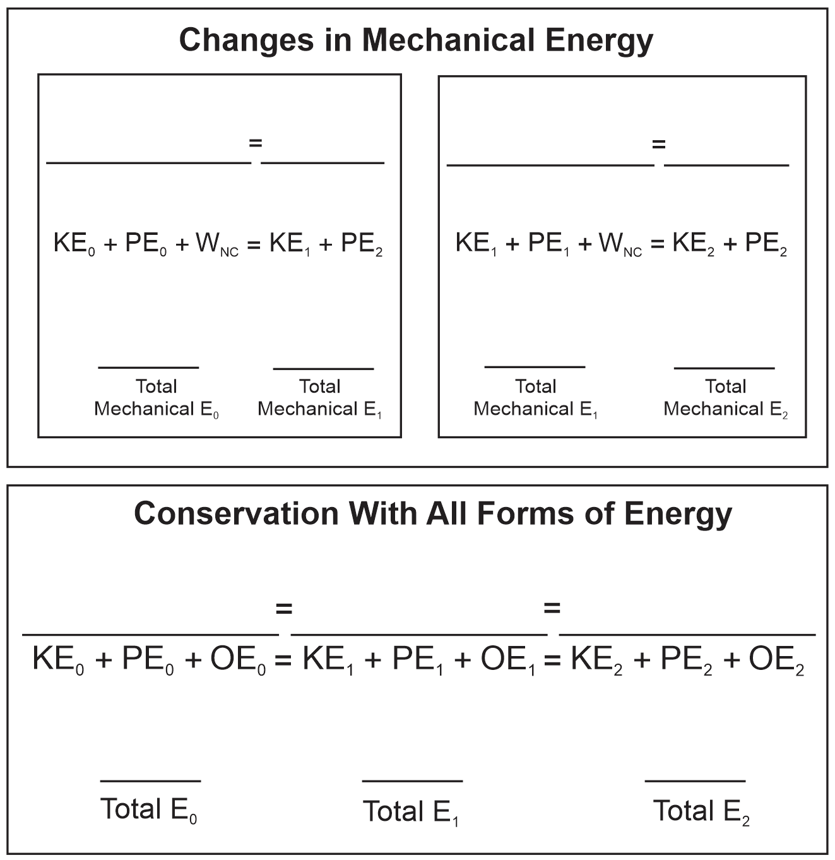
Energy Notes, Part II:

1. What is the formula for Kinetic Energy?

2. Calculate kinetic energy of a 30kg student running at a speed of 4m/s.

3. What is the formula for gravitational potential energy?

4. Calculate the potential energy of a 50kg student who is standing at the top of a 7m tall waterslide.

5. What is power?

The symbol for power is _______ and the units are __________________

What are some other units for power?

6. What is the formula for power?

7. Calculate the power output of a student who applies a force of 200N over a distance of 6m, in a time of 3 seconds?

Convert this to horsepower.

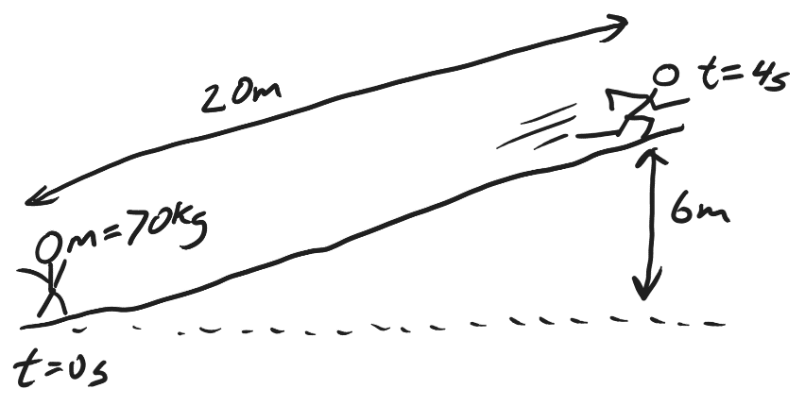
8. Starting from rest, a 70kg student runs a distance of 20m in a time of 4s, finishing at a height 6m above the starting point, and having a final velocity of 5m/s. Calculate the student’s average force and average power output. Convert the power output to horsepower.
  - Step 1: Find the student’s starting and ending KE and PE.

  - Step 2: use the law of conservation of energy to find the non-conservative work that was done by the student.

  - Step 3: use the work formula (and the distance) to calculate the average force exerted by the student.

  - Step 4: use the power formula to calculate the student’s power in Watts.

  - Step 5: convert from Watts to horsepower. Google it if you need to.

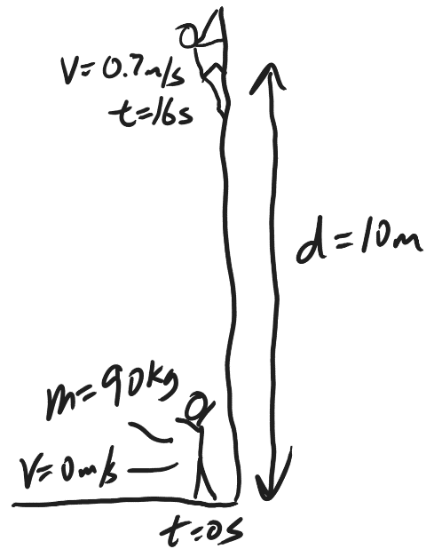
9. Starting from rest, a 90kg student climbs a vertical distance of 10m in a time of 16s, ending with a final velocity of 0.7m/s. Calculate the student’s average force and average power output. Convert the power output to horsepower.
  - Step 1: Find the student’s starting and ending KE and PE.

  - Step 2: use the law of conservation of energy to find the work that was done by the student.

  - Step 3: use the work formula (and the distance) to calculate force.

  - Step 4: use the power formula to calculate power in Watts.

  - Step 5: convert from Watts to horsepower.

