Physics 100 Name: ________________________
Test Review: Energy
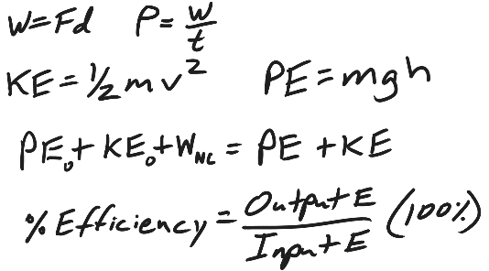
Part 1
1. What is the physics definition of “energy?”

2. What is the physics definition of “work?”

3. How much work is done when a person pushes a car a distance of 15m while applying a constant force of 120N? Include proper units!

4. How much power is generated by the person (from question #3), if the person accomplishes that task in a time of 30 seconds? Include proper units!

5. Explain how kinetic energy and potential energy are different.

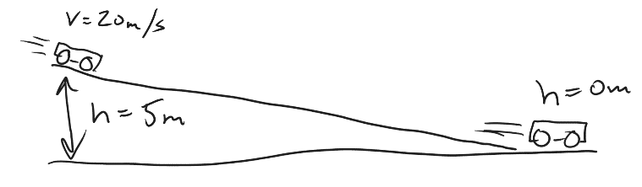
6. A 6kg cart is moving at a speed of 20m/s at a height of 5m. Without experiencing any outside forces, the car rolls down a ramp to a height of 0m. This means the car is “coasting” with no friction.

- Calculate the car’s KE at the top of the ramp.

- Calculate the car’s PE at the top of the ramp.

- Calculate the car’s PE at the bottom of the ramp.

- What is the car’s KE at the bottom of the ramp?

- Explain the reasoning behind your answer to part d.

Part 2

Someone has invented a “machine” to add energy to sledding students. First the students sit motionless in a sled at point A. Then a giant spring pushes them from point A to point B, a distance of 5m. After that, they travel without friction or air resistance from point B all the way to point E, as shown in the diagram. Between points E and F (a distance of 10m), someone spilled gravel in the path, creating friction which slows students down to 4m/s by the time they reach point F. The total mass of a student plus sled = 50kg.

**The areas that are not shaded are frictionless!**

Fill out the empty cells in the chart below. If you’re good at algebra, you could fill out the grey cells for some bonus points, but you don’t have to.
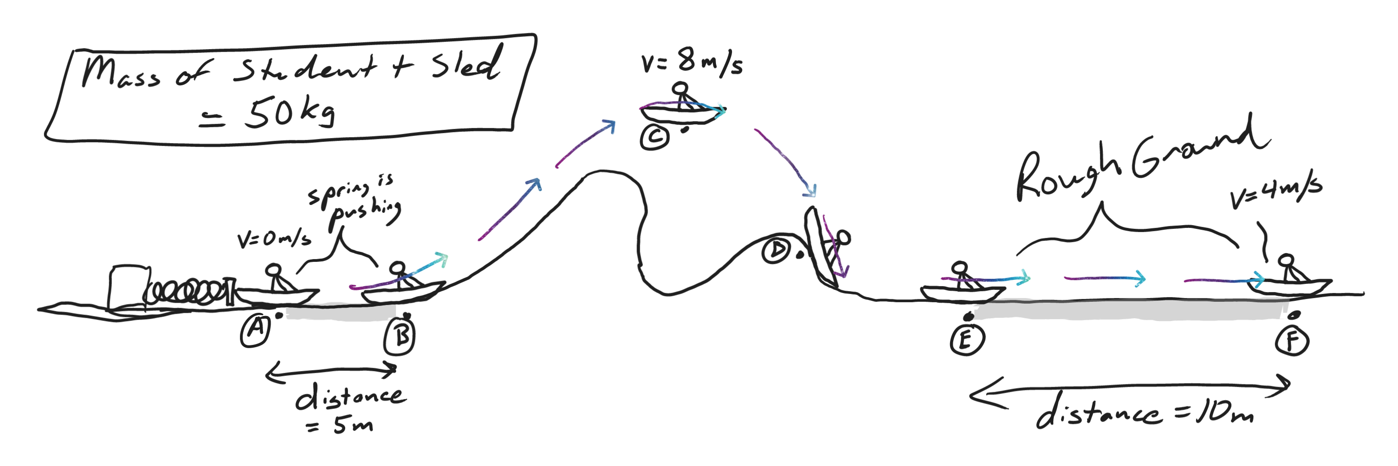
1. Fill out the entire chart, but for this question you will only be graded on the gray cells. For questions that come later, you will need the answers to other cells.
Location | Height (m) | Velocity (m/s) | Potential Energy (J) | Kinetic Energy (J) | Total Energy (J)
A | 0 | 0
B | 0
C | 5 | 8
D | 2
E | 0
F | 0 | 4

2. State the law of conservation of energy.

3. a. Identify an interval (between two lettered points in the sled’s journey) when the sled’s mechanical energy was conserved.
b. Explain why (or how you know) energy was conserved during this interval.

Starting letter: _______ Ending Letter: ________

Explanation:

4. a. Identify two times when the sled’s mechanical energy was not conserved.
b. For each example, explain why (or how you know) energy was not conserved.

Starting letter: _______ Ending Letter: ________

Explanation:

Starting letter: _______ Ending Letter: ________

Explanation:

Part 3 (refer to the sled and data table from page 2)

1. a. How much work did the spring do on the sled?

b. How do you know?

2. Calculate the average net force that the spring applied to the sled.

3. a. How much work did the friction (caused by the gravel) do on the sled between points e and f?

b. How do you know?

4. Calculate the average net force applied by this friction.

5. Remember that the sledding track (and everything in it) was intended to be a machine whose purpose is to add energy to sledding students.
a. What was the amount of input energy?

b. What was the amount of output energy?

c. What was the % efficiency of this machine?

