Physics 100 (Stapleton) Name: ____________________________
Energy Practice Quiz #2

The diagram below shows the path followed by a 200kg car on a roller coaster. First the car sits motionless at point A. Then it is pulled by an electric motor to the top of a 90m hill, where it is released in a motionless position. The ride really “starts” at point B, where the cart begins to roll down hill in the absence of friction, all the way to point C (which is at a height of 50m). Between points C and D (which are 60m apart), brakes are applied to keep the cart from careening off the rails when it goes around the big corner. These brakes slow the car down to a safer speed of 20m/s. After point D, the brakes are released, and the car rolls frictionlessly again, past point E, and on to the finish where it stops and lines up with other carts and waits to be pulled back up the hill.

Fill out the empty cells in the chart below. If you’re good at algebra, you could fill out the grey cells, but you don’t have to.
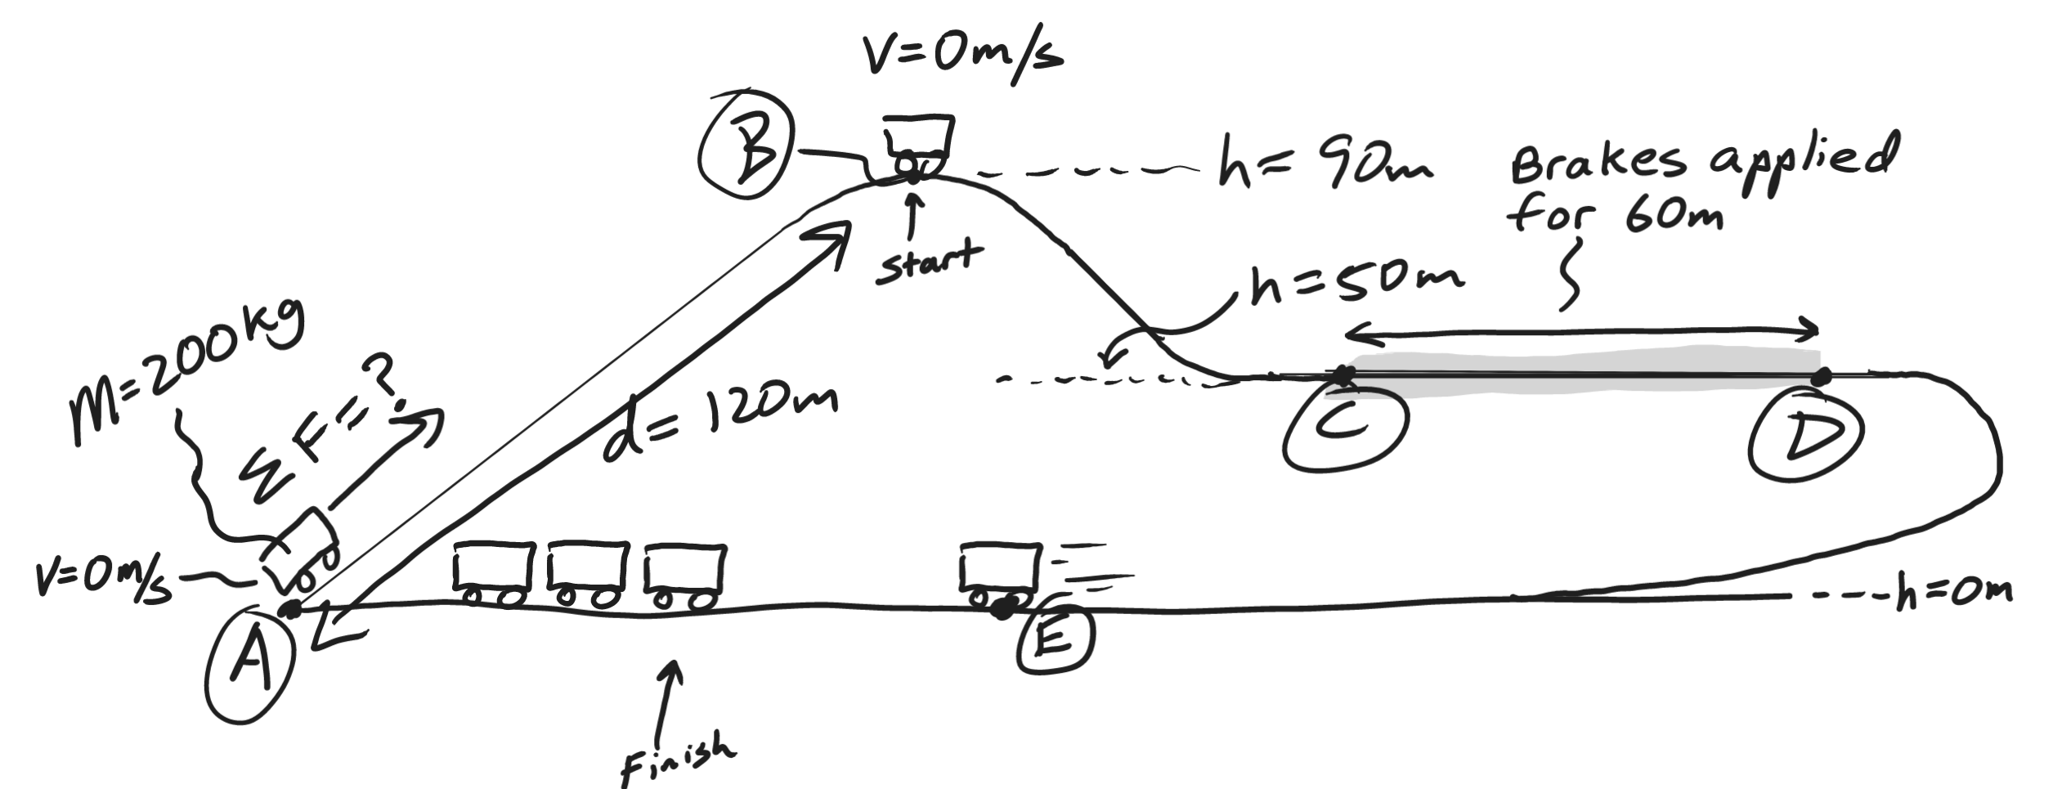
1.
Location | Height (m) | Velocity (m/s) | Potential Energy (J) | Kinetic Energy (J) | Total Energy (J)
A |  | 0
B |  | 0
C
D |  | 20m/s
E

2. State the law of conservation of energy.

3. a. Identify an interval (between two lettered points) when mechanical energy was conserved.
b. Explain why (or how you know) energy was conserved during this interval.

Starting letter: _______ Ending Letter: ________

Explanation:

4. a. Identify two times when the cart’s energy was not conserved.
b. For each example, explain why (or how you know) energy was not conserved.

Starting letter: _______ Ending Letter: ________

Explanation:

Starting letter: _______ Ending Letter: ________

Explanation:

5. a. How much work was done on the car as the motor pulled it up the hill?

b. Calculate the force acting on the car when the motor is pulling it up the hill.

6. a. How much work was done by the brakes?

b. Calculate the force on the car while the brakes are applied.

7. Considering what happens to the cart between points A and E, calculate the efficiency of this ride.

