Physics 100 Name: ______________________________
Unit 4: Energy (Stapleton)
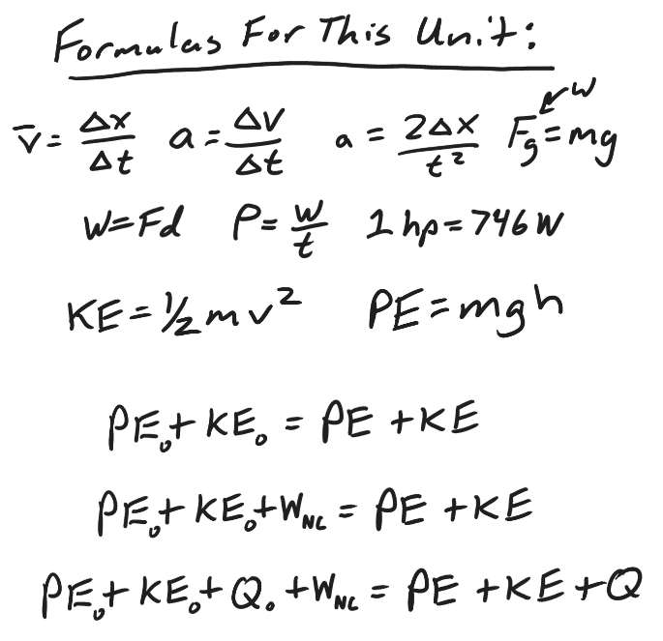
1. What is energy? What are its units?

2. Provide a physics definition (formula) of work? What are the units for work?

3. Give some examples of work.

4. What is kinetic energy? What is its formula? Symbol?

5. Calculate kinetic energy of a 30kg student running at a speed of 4m/s.

6. What is potential energy? What is its symbol?

7. What is the formula for gravitational potential energy?

8. Calculate the potential energy of a 50kg student who is standing at the top of a 7m tall waterslide.

9. What is thermal energy? What is its symbol?

10. Use a formula to explain the law of conservation of energy.

11. What is power?

What is its symbol?

What are the units for Power?

What are some other units for power?

12. What is the formula for power?

13. Calculate the power output of a student who applies a force of 200N over a distance of 6m, in a time of 3 seconds?

Convert this to horsepower.

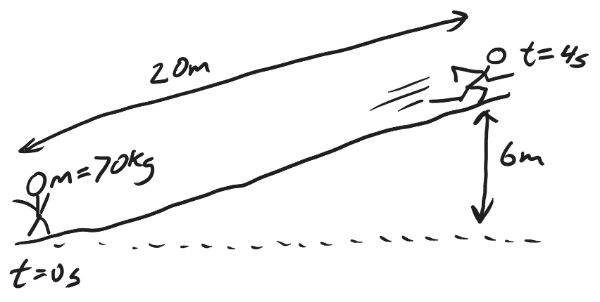
14. Starting from rest, a 70kg student runs a distance of 20m in a time of 4s, finishing at a height 6m above the starting point, and having a final velocity of 5m/s. Calculate the student’s average force and average power output. Convert the power output to horsepower.
  - Step 1: Find the student’s starting and ending KE and PE.

  - Step 2: use the law of conservation of energy to find the work that was done by the student.

  - Step 3: use the work formula (and the distance) to calculate force.

  - Step 4: use the power formula to calculate power in Watts.

  - Step 5: convert from Watts to horsepower. Google it if you need to.

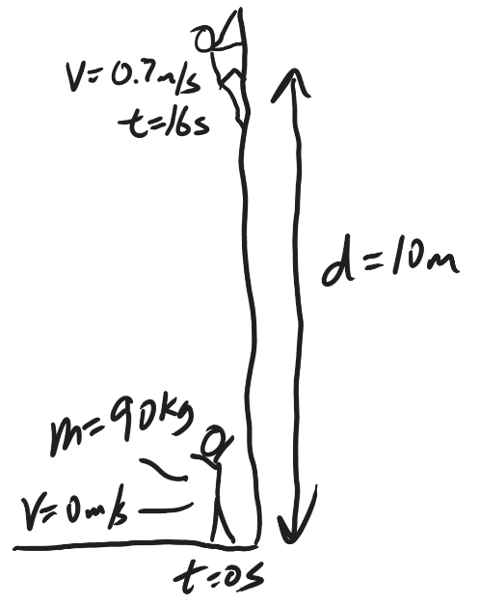
15. Starting from rest, a 90kg student climbs a vertical distance of 10m in a time of 16s, ending with a final velocity of 0.7m/s. Calculate the student’s average force and average power output. Convert the power output to horsepower.
  - Step 1: Find the student’s starting and ending KE and PE.

  - Step 2: use the law of conservation of energy to find the work that was done by the student.

  - Step 3: use the work formula (and the distance) to calculate force.

  - Step 4: use the power formula to calculate power in Watts.

  - Step 5: convert from Watts to horsepower.

