Physics 100 Practice Quiz Name: _______________________
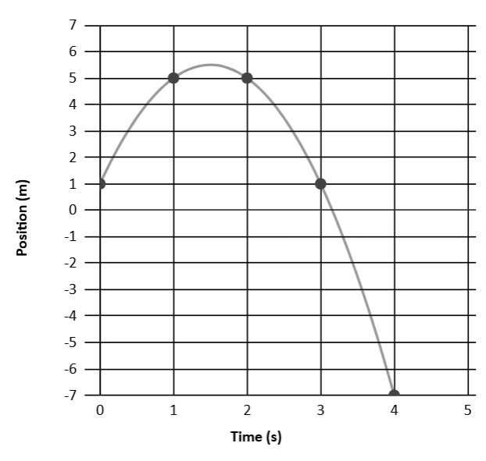
1. What is the displacement during the time interval from 2s to 3s?

2. What is the velocity for the time interval from 2s to 3s?

3. What is the velocity for the time interval from 3s to 4s?

4. What is the acceleration displayed by this graph?

More on the back…

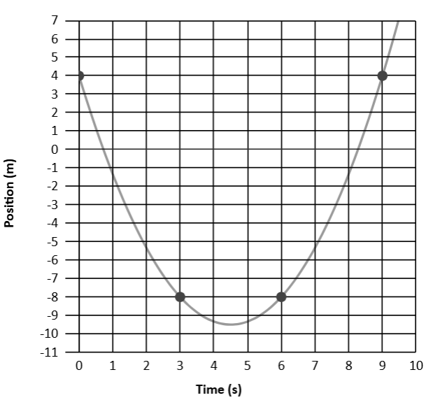
5. What is the acceleration of the object with these position vs time data?

