Physics 100 Names: ______________________________________________
Rocket Analysis and Improvement

Part 1: Getting Started In The VideoAnalysisApp
- Find the launch videos in Google Classroom.
- Watch the videos and find yours.
- Download the video. If you are on a school computer, you can download it to the desktop.
- Find the video analysis link in Google Classroom, and open it
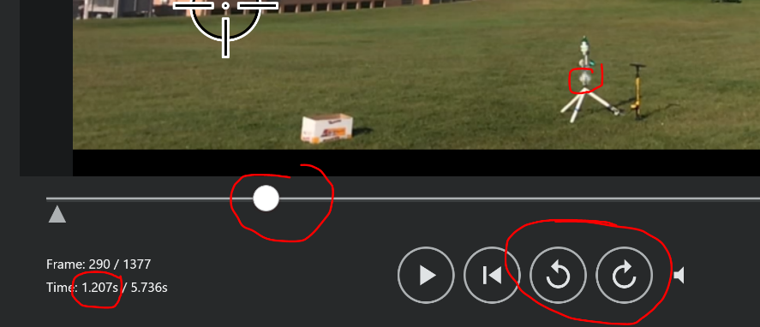
- Import the video that you just downloaded

Part 2: Finding Time Aloft
- Use the slider and the frame-by-frame buttons to get to the moment when you first see a puff of water leaving the rocket.
- This is the start time. Write it down.

Start Time = _________

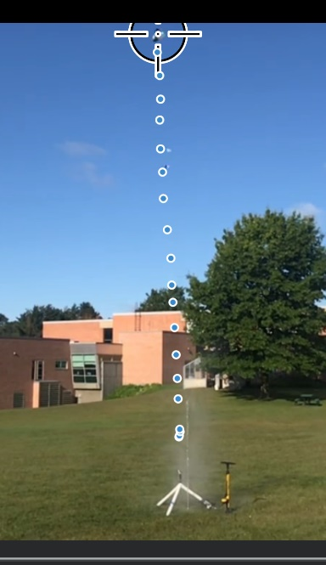
- Advance the video to the moment when the rocket first touches the ground. This is the end time.

End Time = _________

- Find the time aloft (time spent in the air) by subtracting the start time from the end time.

Time Aloft = __________

Part 3: Finding Maximum Velocity (a.k.a. “burnout velocity”) [Ask about auto-tracking.]
- Click the “system” button, and then click “scale.” Use the height of your rocket to set the scale. Do this by dragging the center of one circle to the bottom of your rocket and dragging the other to the top of your rocket. Then type your rocket height in meters.
- Use the slider and frame-by-frame buttons to get to the beginning of your rocket’s launch.
- Click the “Add” button. The put the crosshairs on the top tip of your rocket. Click. That will make a dot and collect data for that point.
- Advance the rocket enough with the frame-by-frame buttons so that you can clearly see the tip again. When you can see it clearly, click on it again.
- Repeat this until your rocket leaves the screen.
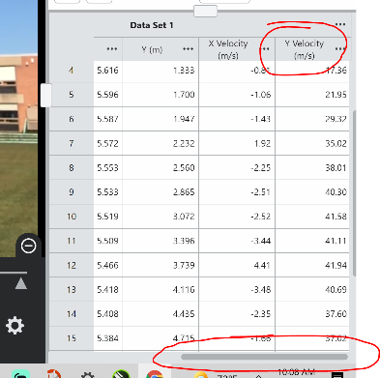
- Look at your data set in the bottom right of your screen. Use its slider to see the “Y velocity” column.
- Find the highest velocity in the Y velocity column. This is your rocket’s maximum velocity. Write it down.

Maximum (burnout) Velocity = __________m/s

Multiply by 2.24 to convert to mph. Max Velocity = _________ mph

Part 4: Comparison with the simulation
- Use data from your “Water Rocket Design” sheet to re-run Clifford Heath’s water rocket simulation. You can find the link on the class website or in Google Classroom.
- Don’t forget to add some extra “dry mass” to account for the foam and sensor.
- According to the simulation, what time aloft and burnout velocity should your rocket have had?

Simulation Time aloft: ___________ Simulation Burnout Velocity: ___________

Actual Time Aloft: __________ Actual Burnout Velocity: ____________

Part 5: Rocket Rebuild Planning

Describe some changes that you plan to make to your rocket as your rebuild it and plan for the 2nd launch.

Change | Reason

Part 6: Rebuild your rocket! The next launch is your last chance.

