Physics 100 Name: ____________________
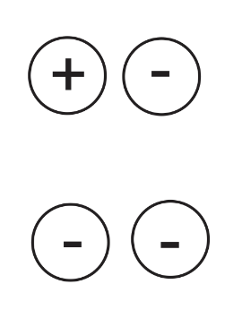
Unit 2: Electricity
Practice Quiz 1

1. For each of the pairs of charges on the right, tell whether the charges repel or attract one another.

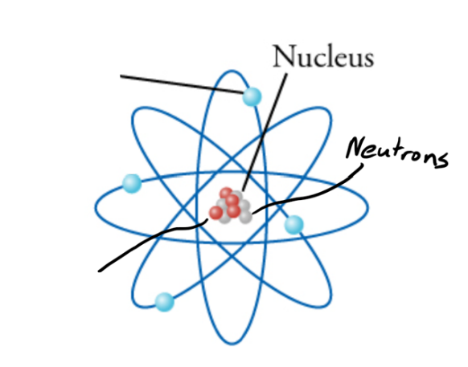

3. On the diagram to the right, write “proton” next to the line that points to a proton.

4. Write “electron” on the line that points to an electron.

5. Label the proton and the electron with appropriate charges (+ or -)

6. When two objects are rubbed together, and static electricity is created, which type of particle gets transferred?

7. Which has a stronger charge?
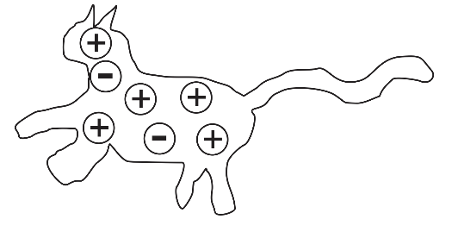
a. a proton b. an electron
c. neither, they’re equally strong

8. What is the net charge of the object on the right?

9. Why is static electricity called “static?”
a. It looks like static on a T.V.
b. When someone “gives you static,” it’s irritating, like a shock from static electricity.
c. The existence of static electricity was proven by using statistics.
d. Static charges don’t generally move. They don’t flow like electric current.

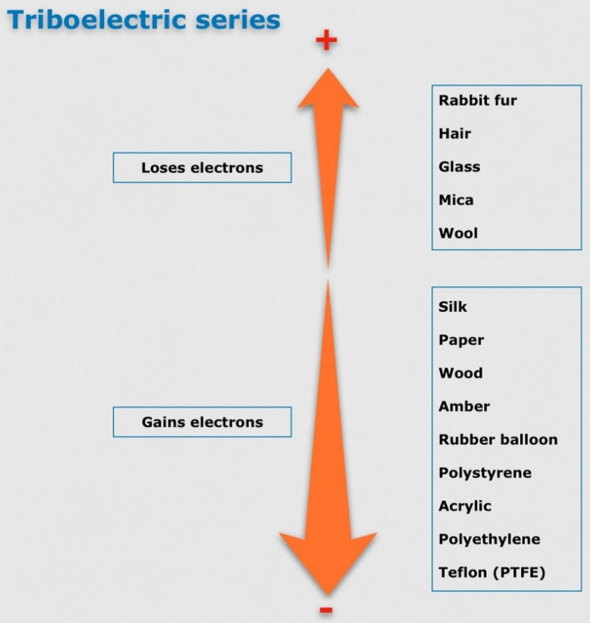
10. Sketch a simple picture of a neutral glass rod and a neutral rubber balloon. Draw some charges in each of them.

11. Refer to the diagram on the right, and then draw what the charges in the balloon and glass rod might look like after you rub them together.

12. What does the “Law of Conservation of Charge" tell us will happen when the balloon and the glass rod are rubbed together?

13. Draw a diagram showing how a balloon with a strong net charge (either positive or negative) can stick to a wall that has zero net charge.

14. When electric charge is able to move easily through a material, that material is called

a(n) _____________________________.

15. When electric charge is not able to move easily through a material, that material is

called a(n) _____________________________.

16. Suppose it’s winter, and you have been building up some static charge. When you get out of your car at a gas station, you touch the metal of your car door and get a shock.

a. When you feel the shock, there are two possible causes for the shock. What are they?

b. Is it now safe to pump your gas? Explain.

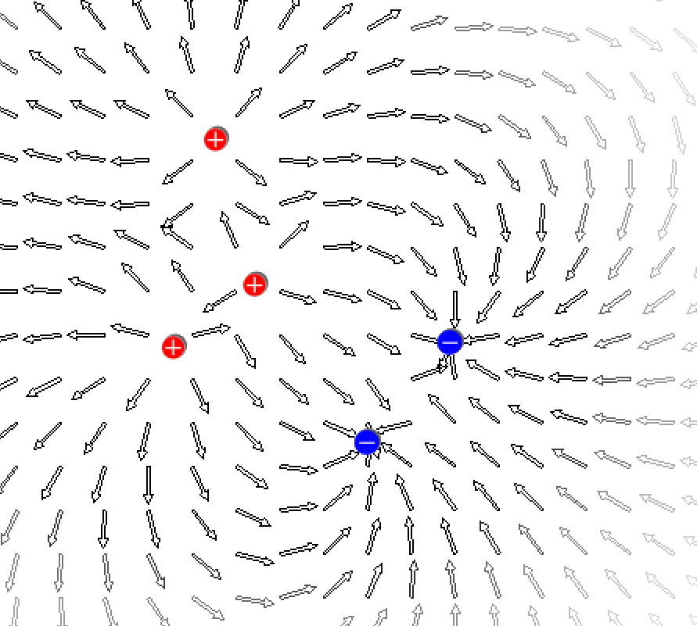
17. In the diagram on the right, the arrows show an area where electric force can push or pull a charged particle.

a. The arrows in this diagram are illustrating an

area called a(n) _______________________

b. What type of charge would travel in the direction shown by the arrows?

18. Why do the makers of Van de Graaff generators and power lines try to make sure that these objects have smooth surfaces?

19. During a lightning storm, is the inside of a metal cage (like a car) a safe place to hide? Explain why or why not.

