ESS 200 (Stapleton) Name: _________________________________________
Solutions to Practice Test Version 2: Experimental Design and Climate Change
**The only section of this practice test that is different from the first practice test is part 1**

Part 1: Designing experiments, Analyzing Data, Writing Lab Reports

Directions for #1-6: Your responses in this section will be graded based on the guidelines you have been given in class. The required elements are not spelled out below, because this test section is testing your knowledge of what should go in each of these sections of a quality lab report.

Suppose you are trying to answer the question, “Do students eat more if they have A lunch or if they have D lunch?” To answer this question, you measured the mass of food eaten by 6 students who had A lunch and 6 other students who had D lunch. For each student, you first recorded the mass of the student’s food before the student ate, and later you recorded the new mass after the student was finished. The mass eaten was the difference between the two masses.

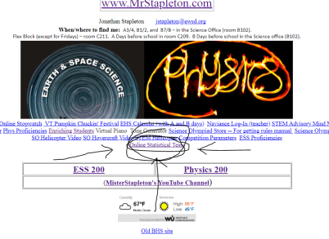
1. Write a hypothesis for this question.
I think D lunch students will eat more food than A lunch students, because they have to wait longer to eat lunch. That will make them hungrier.
2. Identify the manipulated and responding variable. Manipulated: Lunch Period
Responding: amount of food eaten
3. Identify three important variables that should have been controlled in this experiment. 1) The food served 2) The length (time) of lunch
3) Students were of similar weight and height

Imagine that you have conducted this experiment and that you have recorded the following data:
A Lunch Data (grams): 200, 240, 430, 180, 250, 320
D Lunch Data (grams): 150, 200, 180, 300, 100, 60

4. Create a useful table to display your data.

 | Mass of food eaten (grams)
Trials | A Lunch | D Lunch
1 | 150 | 200
2 | 200 | 240
3 | 180 | 430
4 | 300 | 180
5 | 100 | 250
6 | 60 | 320
Average | 165 | 270

5. Use a T-Test to analyze these data. Describe your statistical test and share the results of the test. [The screen shot above shows where you can find a link to the statistical test on the home page at www.mrstapleton.com.]
I used a one-tailed T-Test for two independent means. [ It was one-tailed, because I chose sides in my hypothesis. I used the independent means test because the students in each group were entirely different people. ] My p-value was 0.015478
6. Write a conclusion for your experiment.
My hypothesis was supported. D lunch students ate an average of 270g of food, compared to an average of 165g for A lunch students. Furthermore, this difference is significant, because the p-value of my statistical test was 0.015, which is below the significance cutoff of 0.05. D lunch students do appear to eat more.

