ESS 200 (Stapleton) Name: _________________________________________
Practice Test Version 3: Experimental Design and Climate Change
**The only section of this practice test that is different from the first practice test is part 1**

Part 1: Designing experiments, Analyzing Data, Writing Lab Reports

Directions for #1-6: Your responses in this section will be graded based on the guidelines you have been given in class. The required elements are not spelled out below, because this test section is testing your knowledge of what should go in each of these sections of a quality lab report.

Suppose you are trying to answer the question, “Do students eat more if they have A lunch or if they have D lunch?” To answer this question, you measured the mass of food eaten by each student. First you recorded the mass of the food before the student ate, and later you recorded the new mass after the student was finished. The mass eaten was the difference between the two masses.

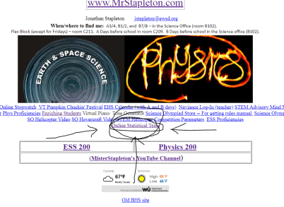
1. Write a hypothesis for this question.
2. Identify the manipulated and responding variable.
3. Identify three important variables that should have been controlled in this experiment.

Imagine that you have conducted this experiment and that you have recorded the following data:
A Lunch Data (grams): 150, 200, 180, 300, 100, 60
D Lunch Data (grams): 200, 240, 430, 180, 250, 320

4. Create a useful table to display your data.
5. Use a T-Test to analyze these data. Describe your statistical test and share the results of the test. [The screen shot above shows where you can find a link to the statistical test on the home page at www.mrstapleton.com.]
6. Write a conclusion for your experiment.

Part 2: Scientific Method Matching: Match each of the terms below to a description that follows. Most of the descriptions match up with exactly one term, but two of the descriptions will each be paired with two terms.

Manipulated Variable Responding Variable Controlled Variable Dependent Variable Independent Variable Sample Size Hypothesis Results Conclusion Procedure P-value
Precision

7. a measure of how many times measurements were repeated (how many trials were conducted) in an experiment.
8. When you are trying to find out if there is a difference between two groups, this is what you measure when you test each group.
9. This could be loosely defined as a number that tells you the likelihood that the results of your experiment were due to random chance, assuming that there is no actual difference between your test groups.
10. something that needs to be kept the same in an experiment
11. an “educated guess” regarding the answer to an experimental question. This guess is made before the experiment is conducted.
12. the data or observations recorded during an investigation
13. When your experiment involves a comparison of two groups, this is the one thing that should be different about the two groups.
14. the consistency of a measuring instrument
15. This is a detailed account of all of the methods and steps that an investigator followed when he/she conducted an experiment.
16. a statement, supported by citing data, about whether your hypothesis was supported or rejected.
Part 3: Climate Change Short Answer (from the climate change notes)

17. Why is it difficult to perform a valid scientific experiment to answer the question “is human activity contributing to global warming?”
18. Describe how climate scientists test whether or not a new climate model is valid, without waiting for years to see if the model has accurately predicted future climate change.
19. How do climate models support the assertion that humans are contributing to global warming?
20. What is the difference between global warming and climate change?
21. List the top 4 greenhouse gases, in order of impact, and describe at least one important source of each.
22. Explain how greenhouse gases contribute to global warming.
23. Describe two different ways in which deforestation can contribute to global warming.
24. Describe two natural causes of climate change.
25. Describe two different mechanisms for sea level rise resulting from global warming.
26. Describe two different positive feedback loops that can contribute to global warming, and briefly illustrate how they work.
27. Regarding the carbon cycle, describe identify two natural sources and two natural sinks of atmospheric carbon.
28. Some impacts of global warming are sea level rise and physical discomfort. List three other likely impacts of global warming.
29. Rank these storage banks of carbon from greatest (most carbon stored) to least:
Atmosphere, Surface Ocean, Soil, Deep Ocean, Plant Biomass, Fossil Pool

