ESS 200 (Stapleton) Name: _______________________________
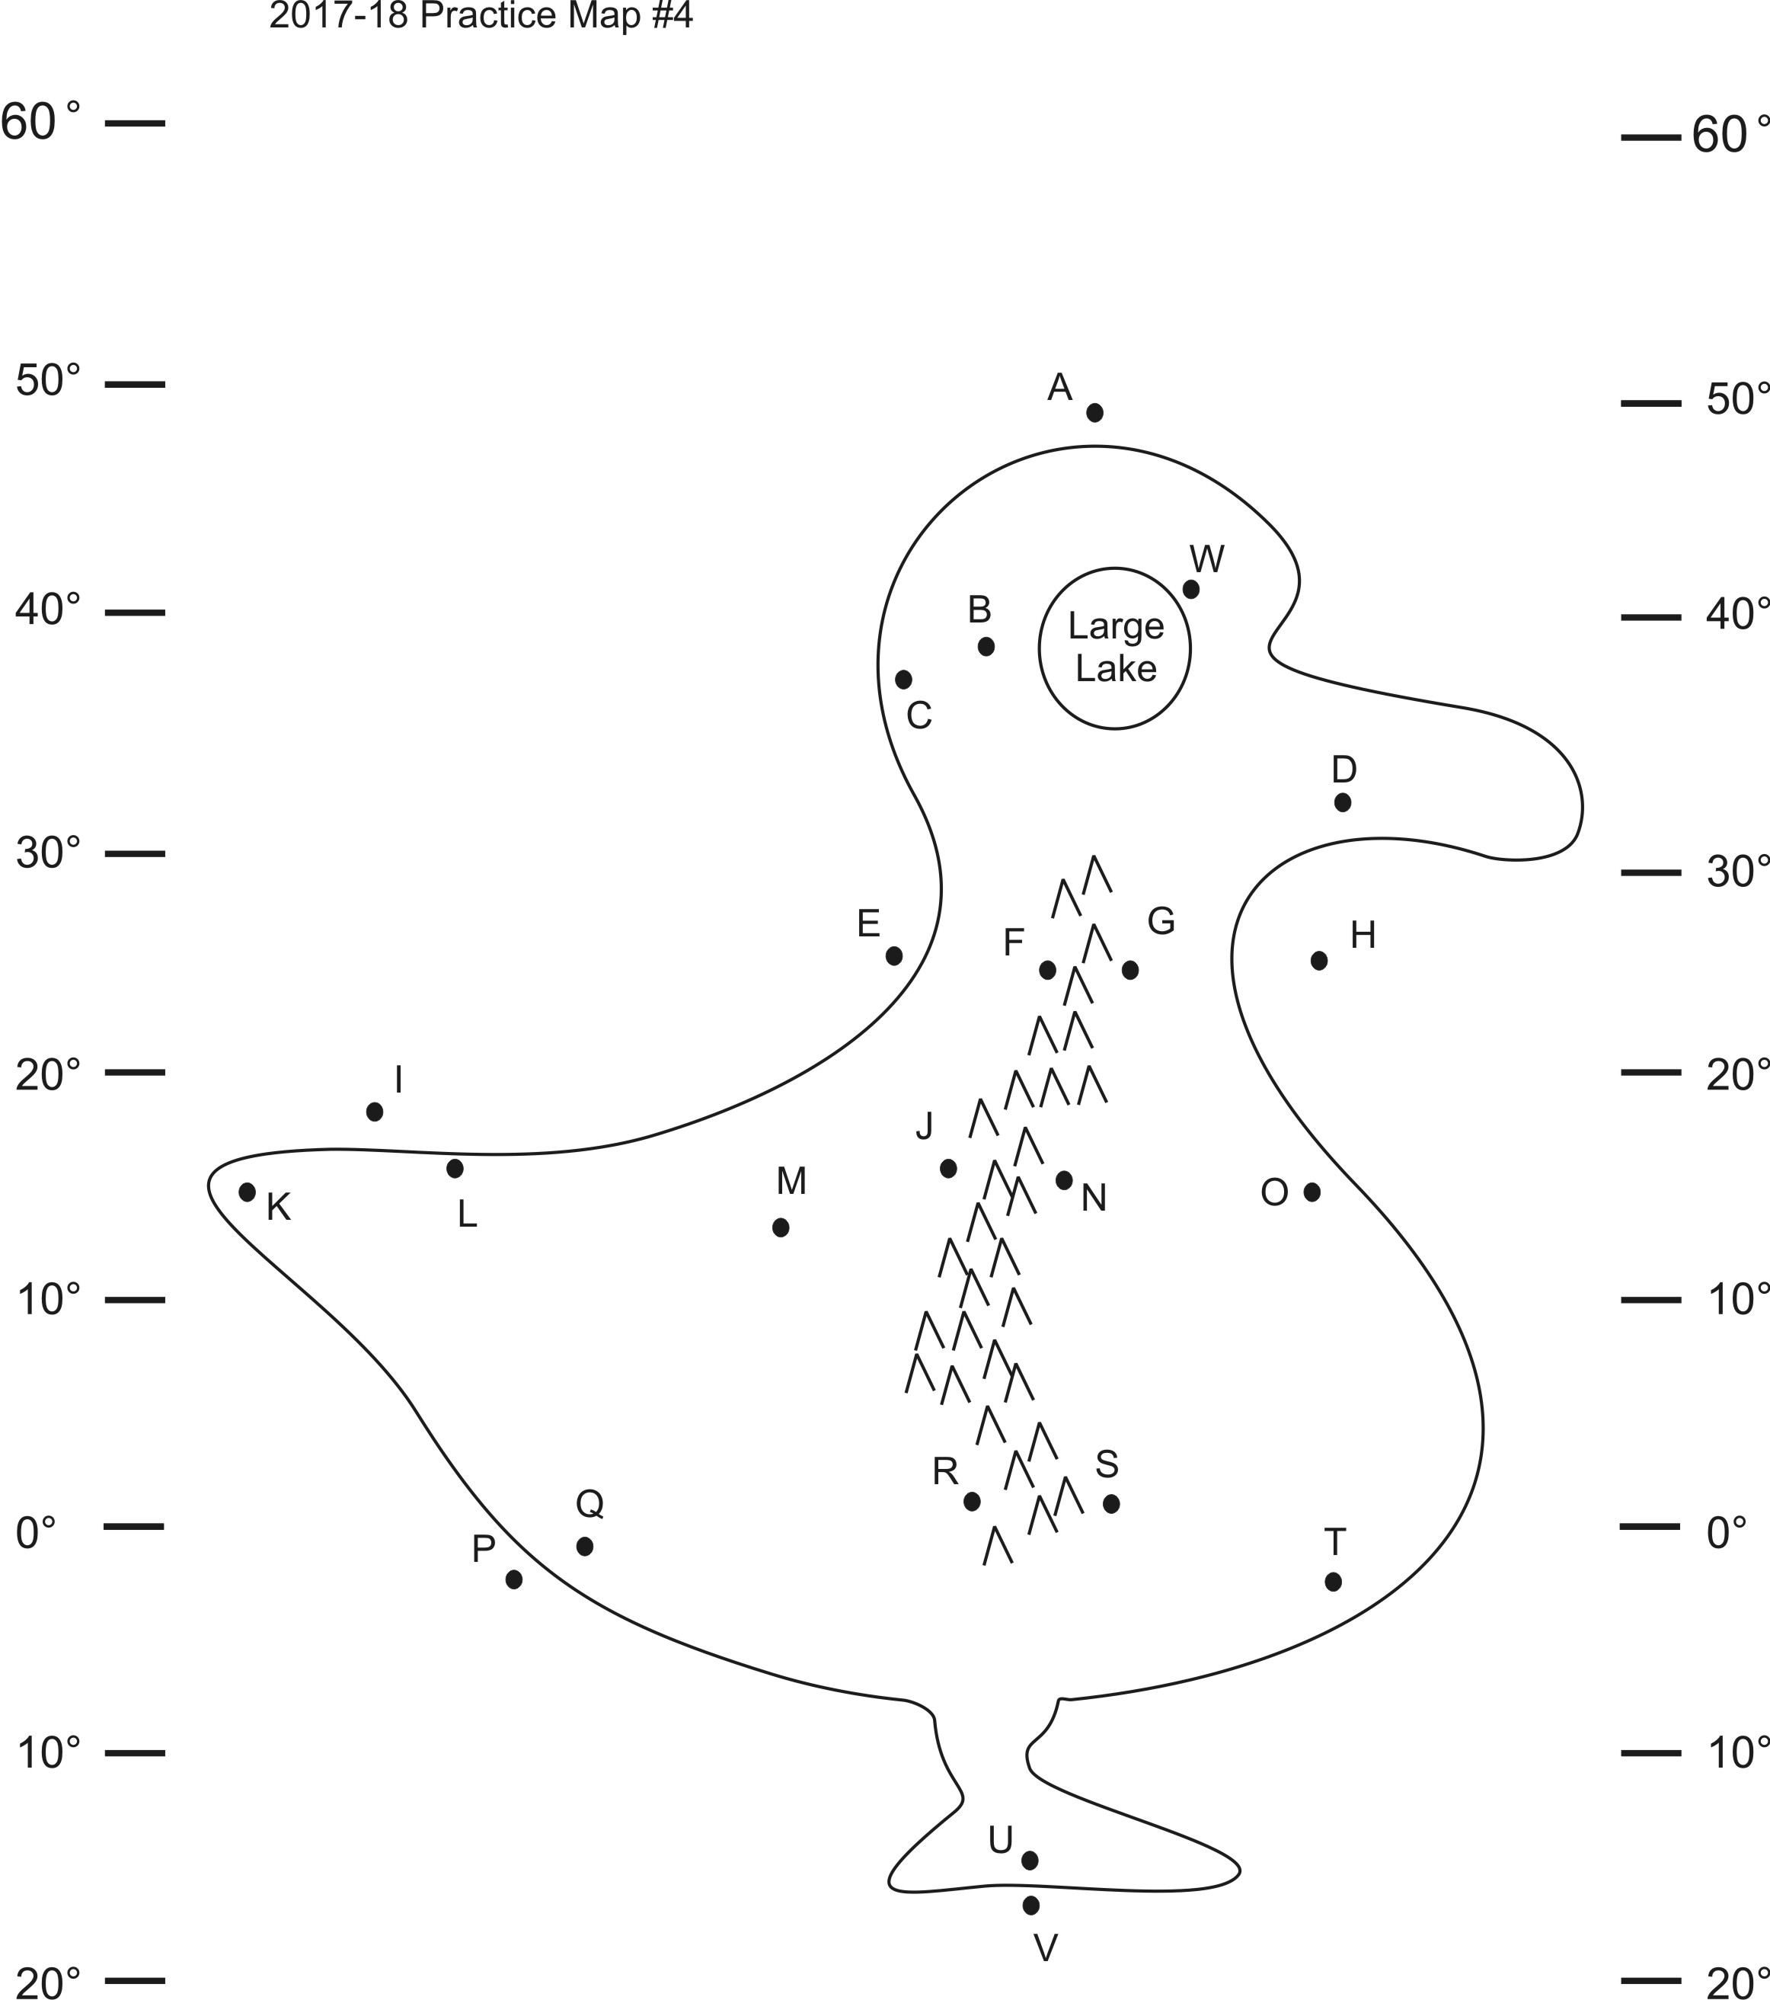
Climate Mapping Practice Test #1

Part 1: Multiple Choice. Complete the map on the right. Then answer the questions below. Choose all of the answer choices that apply.

1. Which letter(s) is(are) in a high pressure belt?
A C E L Q
2. At which letter(s) does the wind blow toward the northwest?
D G N S U
3. At which letter(s) is there a cold current?
A P E H V
4. Which letter(s) is(are) in a major rainforest?
W F M Q
5. Which letter(s) is(are) in a major desert?
W F M Q
6. Which letter(s) is(are) in a coastal wet climate?
D C Q C W
7. Which letter(s) is(are) in a wet climate caused by the rains shadow effect?
F J R G N S
8. Which letter(s) is(are) in a dry climate caused by the rains shadow effect?
F J R G N S
9. Which letter(s) is(are) in a summer wet/winter dry climate?
U Q M F B D
10. Which letter(s) is(are) in a summer dry/winter wet climate?
U Q M F B D
11. Which letter(s) is(are) in a humid climate?
U Q M F B D
12. At which letter does the ocean current flow most directly toward the equator?
A H V P I E

Part 2: Short answer Answer on a separate sheet of paper.

1. Describe the primary difference between weather and climate?
2. Define precipitation.
3. Why does the Earth’s atmosphere circulate? Specifically, what makes the air move in the first place?
4. Create a diagram showing how the air circulates in the Earth’s atmosphere. Use arrows to show the rising air, sinking air, and other movements in the atmosphere. To save time, you only have to draw ¼ of the overall pattern. Label the north and south poles and the equator.
5. Create another diagram showing how the atmosphere would circulate if the Earth did not rotate.
6. Explain briefly what causes the Coriolis Effect.
7. What is the ITCZ? How did it get its name?
8. Describe the Horse latitudes. What is the weather like? What does the air do there? Where are they?
9. Describe the Doldrums? What is the weather like? What does the air do there? Where is (are?) the Doldrums?
10. When you are drawing a climate map, how do you know which way the winds should go? What determines a prevailing wind’s direction?
11. What causes ocean surface currents?
12. What causes ocean currents to flow directly northward or southward?
13. On which coasts of continents are ocean currents usually warmer? Why are they warmer on that coast?
14. Which coasts of continents are usually drier and which are wetter? Why?
15. What type of pressure belt causes the driest conditions? Wettest conditions?
16. What causes the coastal wet climates that we have been drawing on climate maps?
17. Explain, briefly, what causes the rain shadow effect. Specifically, explain why the rain shadow effect causes some areas to be wet while others are dry.
18. What is latent heat?
19. When does water release latent heat? When water releases heat, what happens to the water’s surroundings?
20. When air rises, its temperature cools. Does rising air cool faster when it is forming clouds or when it is clear? Explain why.
21. Why do we have seasons? Give two reasons.
22. Provide two reasons explaining why summer is hotter than winter.
23. What causes summer wet/winter dry climates?
24. What causes the monsoon winds that bring rain to India late in the summer?

