ESS 200 (Stapleton) Name: _______________________________
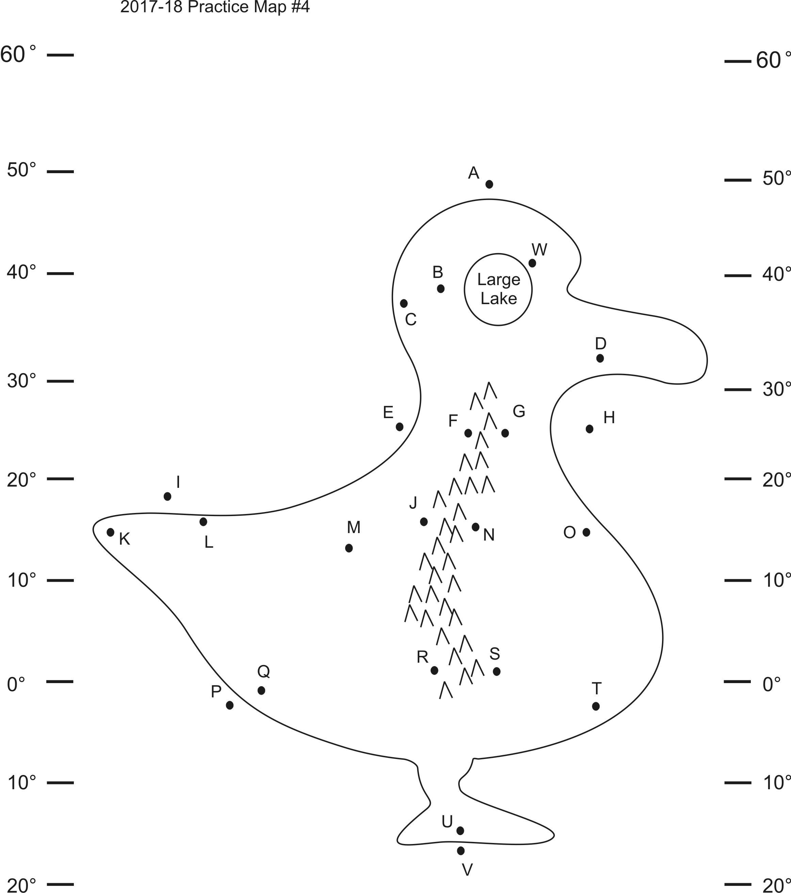
Solutions to Climate Mapping Practice Test #1

Part 1: Multiple Choice. Complete the map on the right. Then answer the questions below. Choose all of the answer choices that apply.

1. Which letter(s) is(are) in a high pressure belt?
E
2. At which letter(s) does the wind blow toward the northwest?
D
3. At which letter(s) is there a cold current?
A E
4. Which letter(s) is(are) in a major rainforest?
Q
5. Which letter(s) is(are) in a major desert?
F
6. Which letter(s) is(are) in a coastal wet climate?
C W
7. Which letter(s) is(are) in a wet climate caused by the rain shadow effect?
N
8. Which letter(s) is(are) in a dry climate caused by the rains shadow effect?
J
9. Which letter(s) is(are) in a summer wet/winter dry climate?
M
10. Which letter(s) is(are) in a summer dry/winter wet climate?
B
11. Which letter(s) is(are) in a humid climate?
D
12. At which letter does the ocean current flow most directly toward the equator?
E

Part 2: Short answer Answer on a separate sheet of paper.

1. Describe the primary difference between weather and climate? Climate is long term atmospheric conditions; weather is day-to-day
2. Define precipitation. Water that falls from the sky
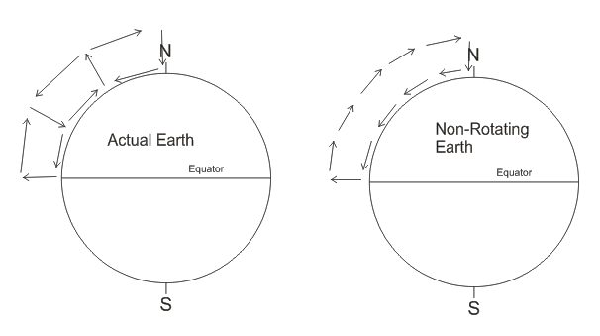
3. Why does the Earth’s atmosphere circulate? Specifically, what makes the air move in the first place? Hot air rises at the equator. Cold air sinks at the poles
4. Create a diagram showing how the air circulates in the Earth’s atmosphere. Use arrows to show the rising air, sinking air, and other movements in the atmosphere. To save time, you only have to draw ¼ of the overall pattern. Label the north and south poles and the equator.
5. Create another diagram showing how the atmosphere would circulate if the Earth did not rotate.
6. Explain briefly what causes the Coriolis Effect. As the Earth rotates, the equator moves faster than the poles. Objects flying toward or away from the poles appear to curve because the earth is moving beneath them.
7. Where is the ITCZ? How did it get its name? The Inter Tropical Convergence Zone is at the equator. It gets its name from the prevailing winds that converge at the equator.
8. Describe the Horse latitudes. What is the weather like? What does the air do there? Where are they? They are the area of dry, windless, sinking air between 20° and 30° latitude.
9. Describe the Doldrums? What is the weather like? What does the air do there? Where is (are?) the Doldrums? The Doldrums is the region of hot, rainy, rising air between 5°N and 5°S.
10. When you are drawing a climate map, how do you know which way the winds should go? What determines a prevailing wind’s direction? Winds blow from high pressure to low pressure. They curve clockwise in the northern hemisphere and counter-clockwise in the south.
11. What causes ocean surface currents? Prevailing winds
12. What causes ocean currents to flow directly northward or southward? Currents flow north or south only if they hit a continent and are forced to turn northward or southward. It is their momentum that keeps them moving.
13. On which coasts of continents are ocean currents usually warmer? Why are they warmer on that coast? West coasts are colder, because west coast currents generally come from the poles. East coast currents are warmer because they come from the equator.
14. Which coasts of continents are usually less humid and which are more humid? Why? West coasts are less humid due to colder ocean currents, and east coasts are more humid due to warmer ocean currents.
15. What type of pressure belt causes the driest conditions? Wettest conditions? High pressure = driest. Low Pressure = wettest.
16. What causes the coastal wet climates that we have been drawing on climate maps? Coastal wet climates occur near coasts where prevailing winds blow from the ocean to the land.
17. Explain, briefly, what causes the rain shadow effect. Specifically, explain why the rain shadow effect causes some areas to be wet while others are dry. Rising air produces clouds and precipitation and sinking air is dry. When winds blow across mountains, the air must first rise up the mountain on one side (causing it to be wet) and then descend down the mountain on the other (causing dryness).
18. What is latent heat? Heat (energy) that is used to change the phase of a substance (and not to change its temperature).
19. When does water release latent heat? When water releases heat, what happens to the water’s surroundings? Water releases latent heat when it condenses. Releasing latent heat into the surroundings warms up the surroundings.
20. When air rises, its temperature cools. Does rising air cool faster when it is forming clouds or when it is clear? Explain why. Clear air cools faster. When clouds are forming, water is condensing and releasing latent heat. This release of latent heat warms up the surrounding air, slowing its rate of cooling as it rises. When clouds are not forming, the air can cool off faster, since extra heat is not being added to the surrounding air by the process of condensation.
21. Why do we have seasons? Give two reasons. 1) The Earth is tilted on its axis. 2) The Earth revolves around the Sun.
22. Provide two reasons explaining why summer is hotter than winter. 1) We have more hours of daylight during the summer . 2) Sunlight is more direct during the summer.
23. What causes summer wet/winter dry climates? The sun’s position shifts during the year. Instead of always being directly overhead at the equator, in June the sun is directly overhead in the Northern hemisphere. This causes the wet ITCZ to shift north during June. In December the Sun is directly overhead south of the equator, so the ITCZ shifts south, taking its rains with it. It is the shifting of the ITCZ’s position that causes the SW/WD areas near the equator to have wetter and drier seasons.
24. What causes the monsoon winds that bring rain to India late in the summer? In late summer, the continent of Asia heats up much more than the surrounding ocean. The air over the continent is hotter and less dense than the air over the ocean, so the pressure is lower over the continent and higher over the ocean. The wind blows from the high pressure over the ocean toward the low pressure that is over the continent.

