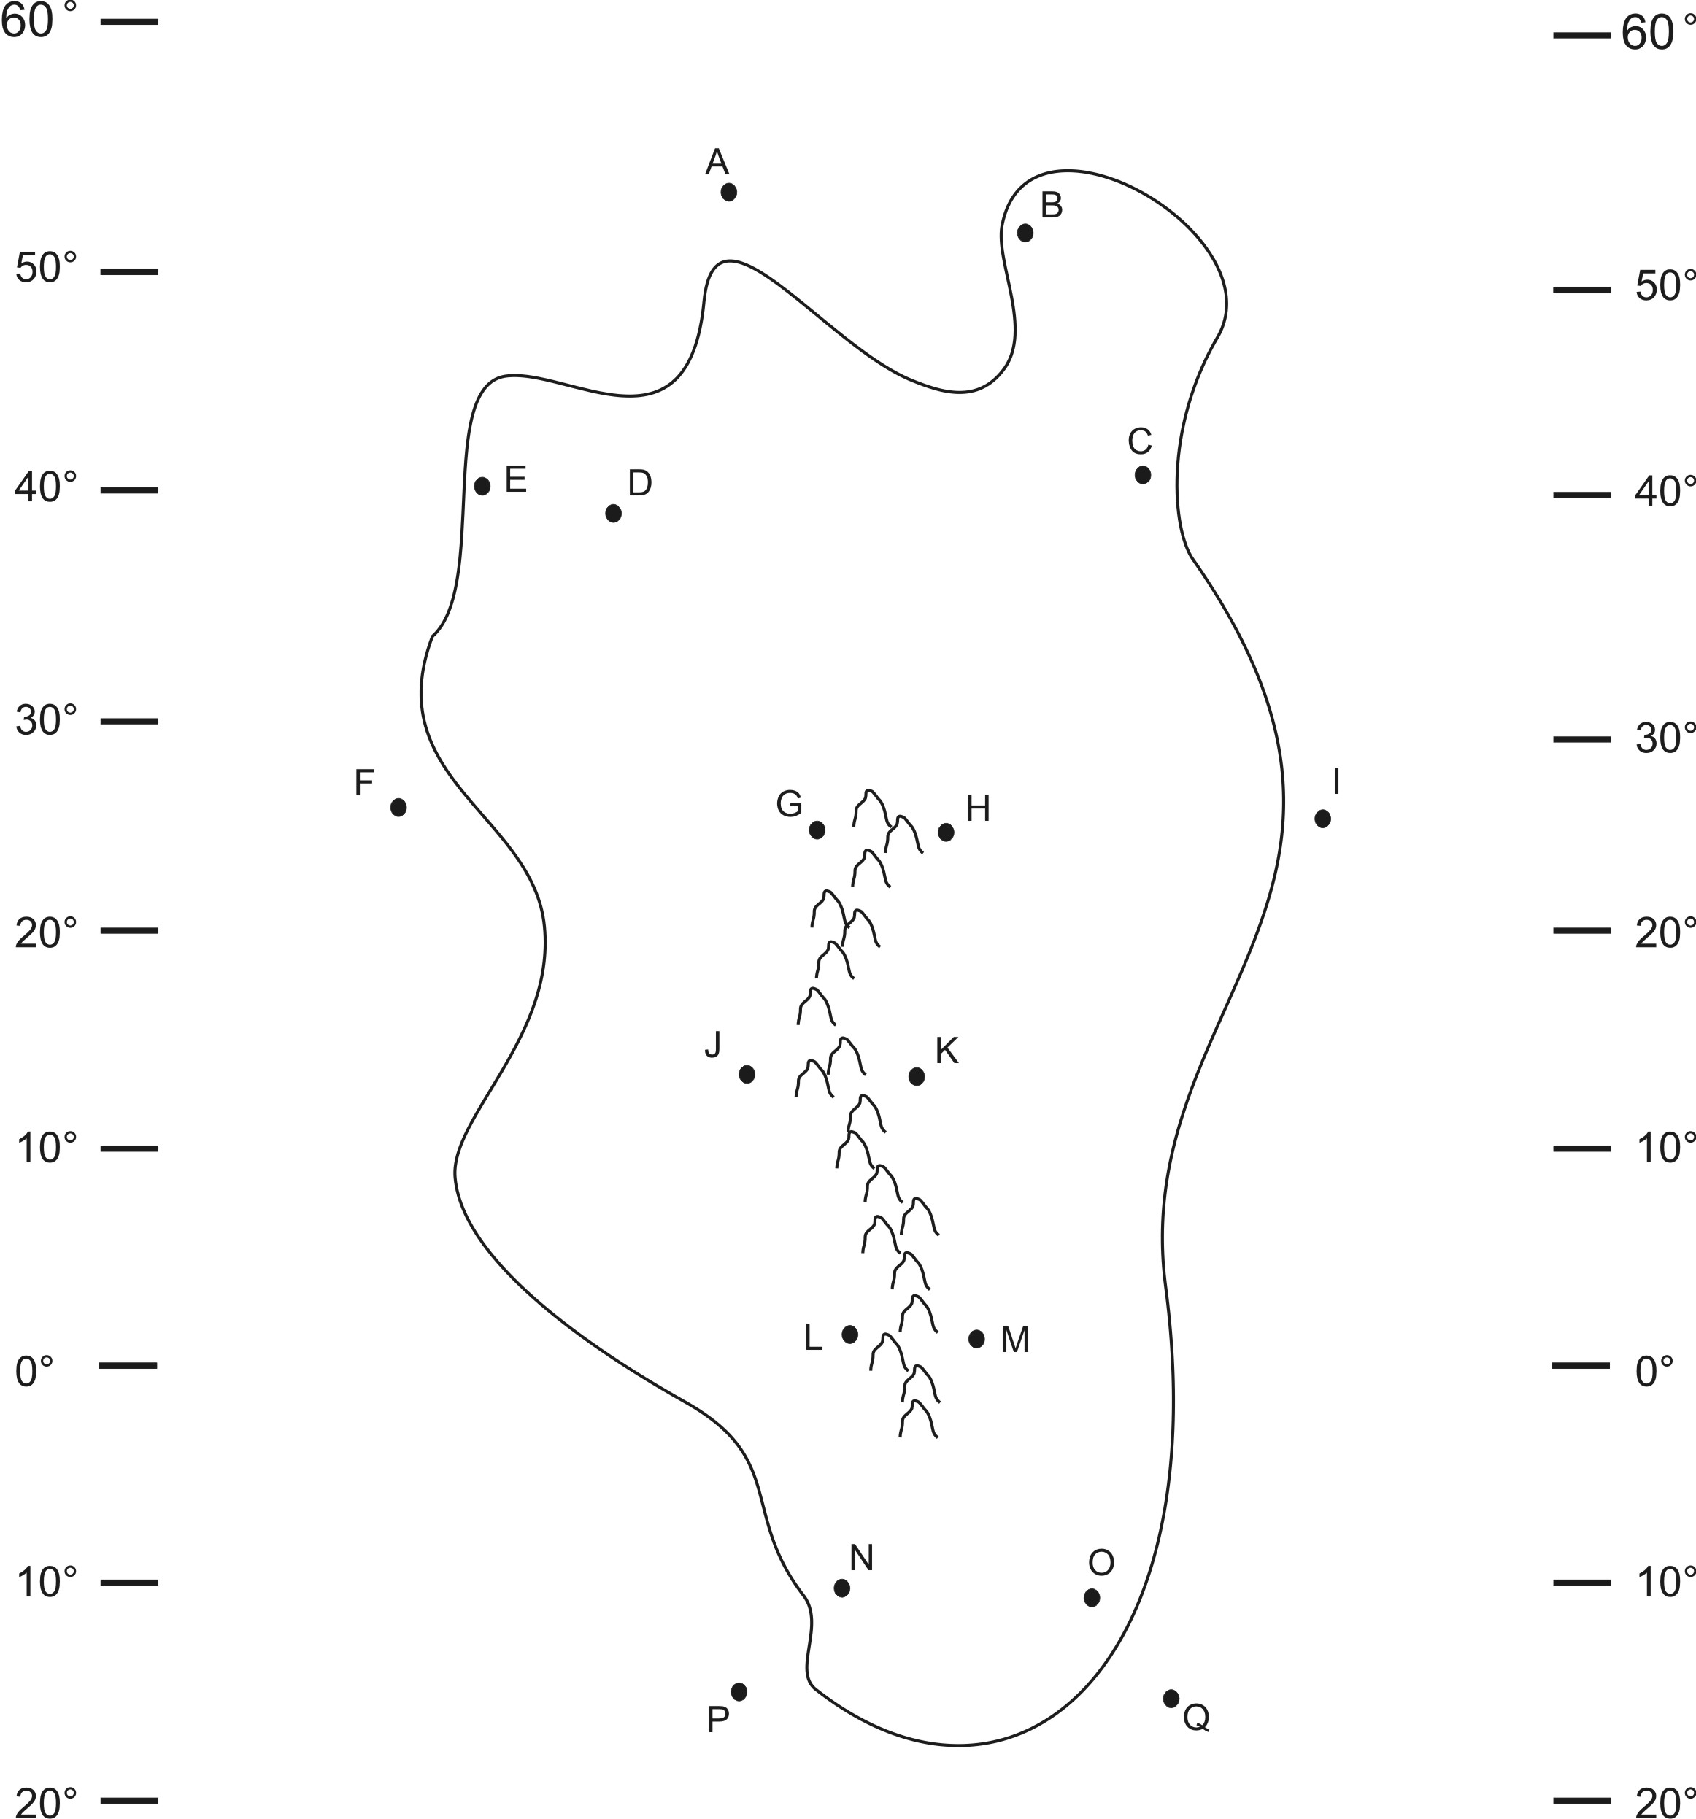
ESS 200 (Stapleton)
Climate Map Practice

Draw the climates of the continent on the right. Then answer these questions

1. Which letter(s) is(are) in a high pressure belt?

2. Which letter(s) is(are) in a low pressure belt?

3. Which letter(s) is(are) in a major (most of the year) rainforest?

4. Which letter(s) is(are) in a major (most of the year) desert?

5. Which letter(s) is(are) in a “coastal wet” climate?

6. Which letter(s) is(are) in a “rain shadow wet” climate?

7. Which letter(s) is(are) in a “rain shadow dry” climate?

8. Which letter(s) is(are) in a “humid” climate (that is not also wet for some other reason).

9. Which letter(s) is(are) in a Summer Wet / Winter Dry climate?

10. Which letter(s) is(are) in a Summer Dry / Winter Wet climate?

11. Which letter(s) is(are) in warm ocean water?

12. Which letter(s) is(are) in cold ocean water?

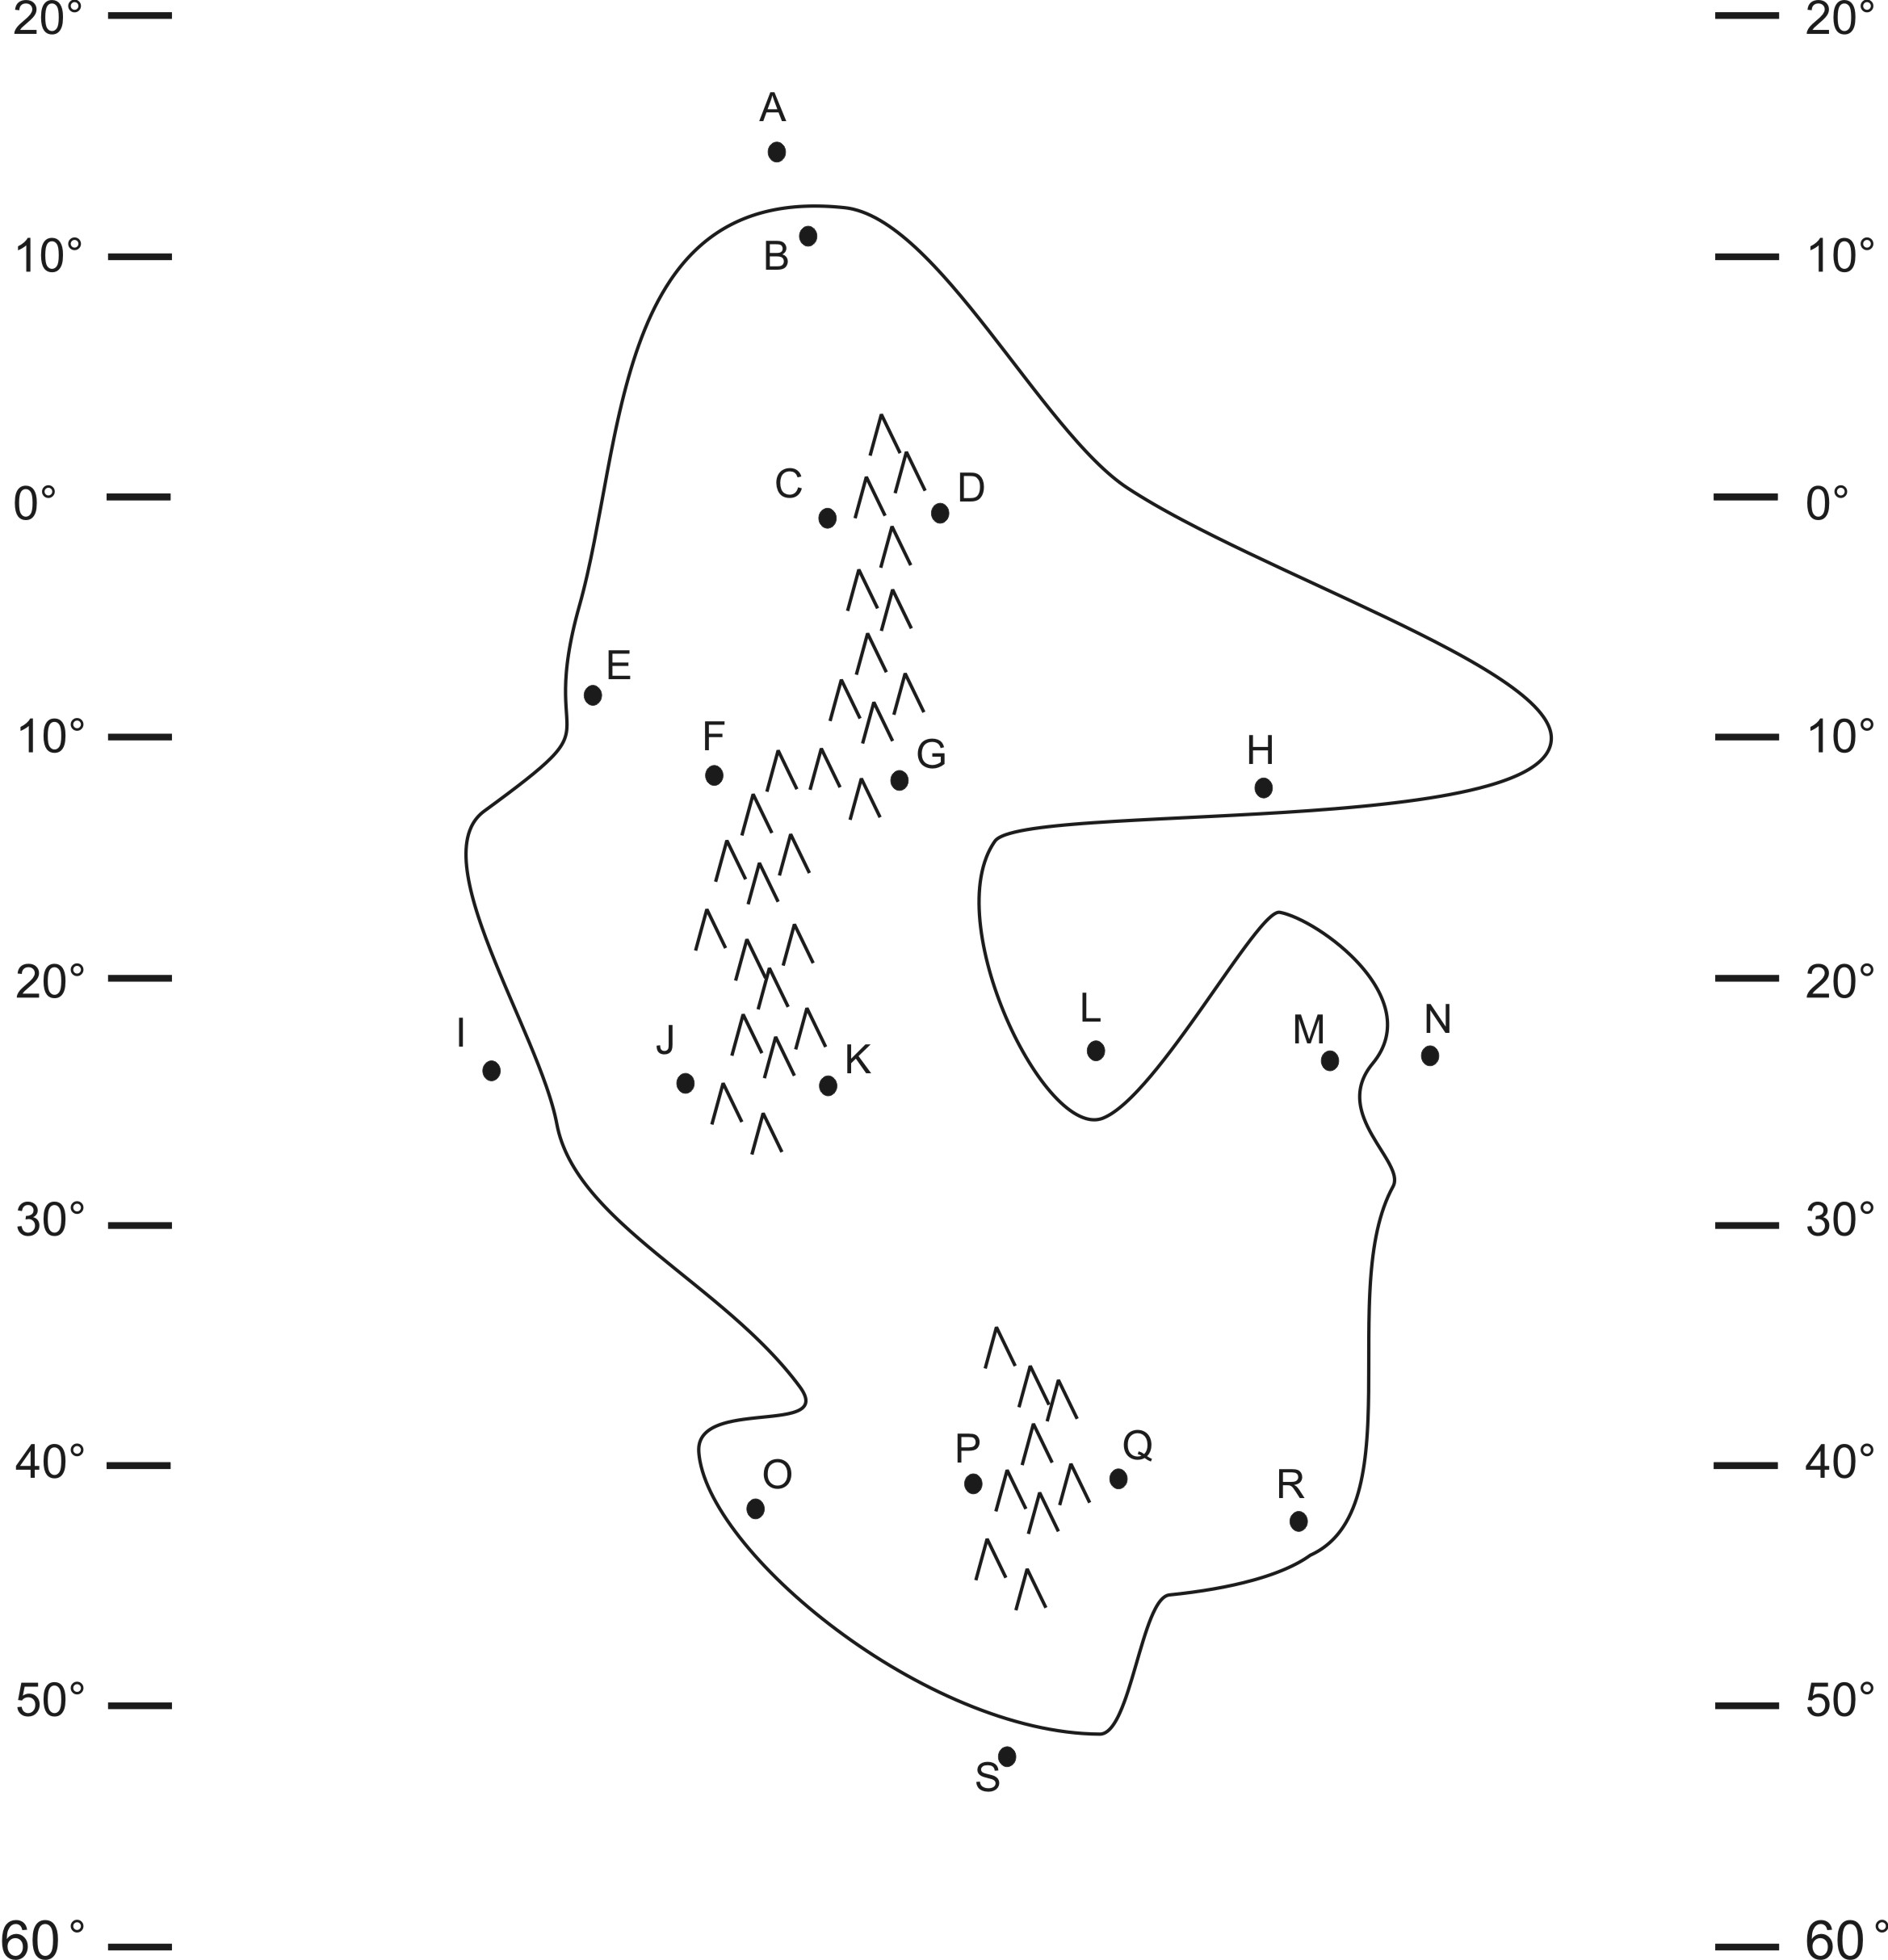
Draw the climates of the continent on the right. Then answer these questions.

1. Which letter(s) is(are) in a high pressure belt?

2. Which letter(s) is(are) in a low pressure belt?

3. Which letter(s) is(are) in a major (most of the year) rainforest?

4. Which letter(s) is(are) in a major (most of the year) desert?

5. Which letter(s) is(are) in a “coastal wet” climate?

6. Which letter(s) is(are) in a “rain shadow wet” climate?

7. Which letter(s) is(are) in a “rain shadow dry” climate?

8. Which letter(s) is(are) in a “humid” climate (that is not also wet for some other reason).

9. Which letter(s) is(are) in a Summer Wet / Winter Dry climate?

10. Which letter(s) is(are) in a Summer Dry / Winter Wet climate?

11. Which letter(s) is(are) in warm ocean water?

12. Which letter(s) is(are) in cold ocean water?

