ESS 200 (Stapleton) Name: _____________________________________
Rain Shadow Effect – Latent Heat and Adiabatic lapse Rates

Question: How will the forced melting of ice by ice melt (mostly sodium chloride) affect the temperature of the resulting mixture?

1. Your Hypothesis:

2. Your Reasoning:

3. Initial temperature of ice:

4. Final temperature of ice:

5. Draw a particle of salt with 2 Na atoms and 2 Cl atoms. Show the atoms’ charges.

6. Draw a water molecule, showing the charges of its individual atoms.

7. Draw water molecules in their liquid phase.

8. Draw water molecules in their solid phase.

9. Show/explain how salt melts ice.

10. You can melt ice by adding salt. What else does the ice need in order to turn from a solid to a liquid? Where does the ice get this?

11. Summarize what happens when salt is used to turn ice into slush

Latent Heat of Vaporization: the energy that must be added to a substance to allow it to turn from liquid to gas (and which must be removed in order for a gas to turn to a liquid). Heat of vaporization does not change a substance’s temperature; it only changes the substance’s phase (see diagram). Heat of vaporization does not give the particles more kinetic energy, it merely breaks the bonds that are holding the particles together.

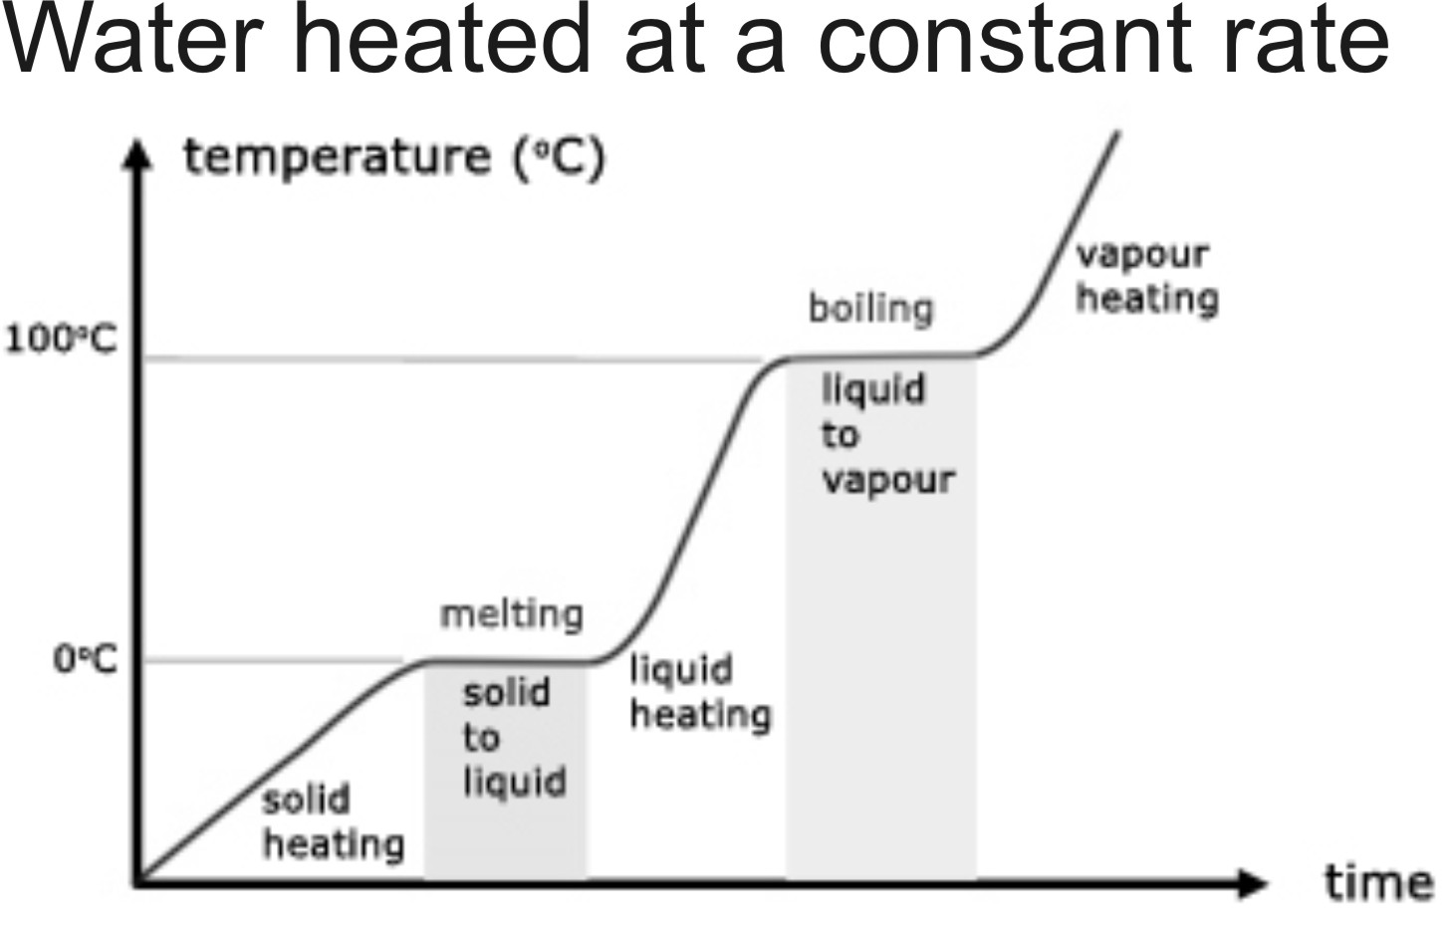
Latent Heat of Fusion: the energy that must be added to a substance to allow it to turn from solid to liquid (and which must be removed in order for a liquid to turn to a solid). Heat of fusion does not change a substance’s temperature; it only changes the substance’s phase. (see diagram).

“Latent” means existing but not yet revealed; hidden. As the diagram on the right shows, as latent heat is being added, there is no change in the temperature of the water, so the effect of the heat is (in a way) “hidden.”
12. When air rises the air _____ (heats or cools), causing water in the air to _____ (condense or evaporate).
13. This change in the water that is in rising air requires the water to _______ (gain or lose) latent heat of vaporization.
14. Where does this latent heat go?

15. What effect does this transfer of latent heat have on the rate at which the air temperature is changing? Why?

16. According to the diagram on the upper right, the “wet” adiabatic lapse rate is 5°C/1000m. What does that mean?

17. What does a dry adiabatic lapse rate of 10°C/1000m. What does that mean?

18. If the air temperate at A = 30°C, what are the temperatures at the other letters?

A. 30°C B. C. D. E. F. G. H.

