EPS 200 (Stapleton) Name: _______________________________
Plate Tectonics

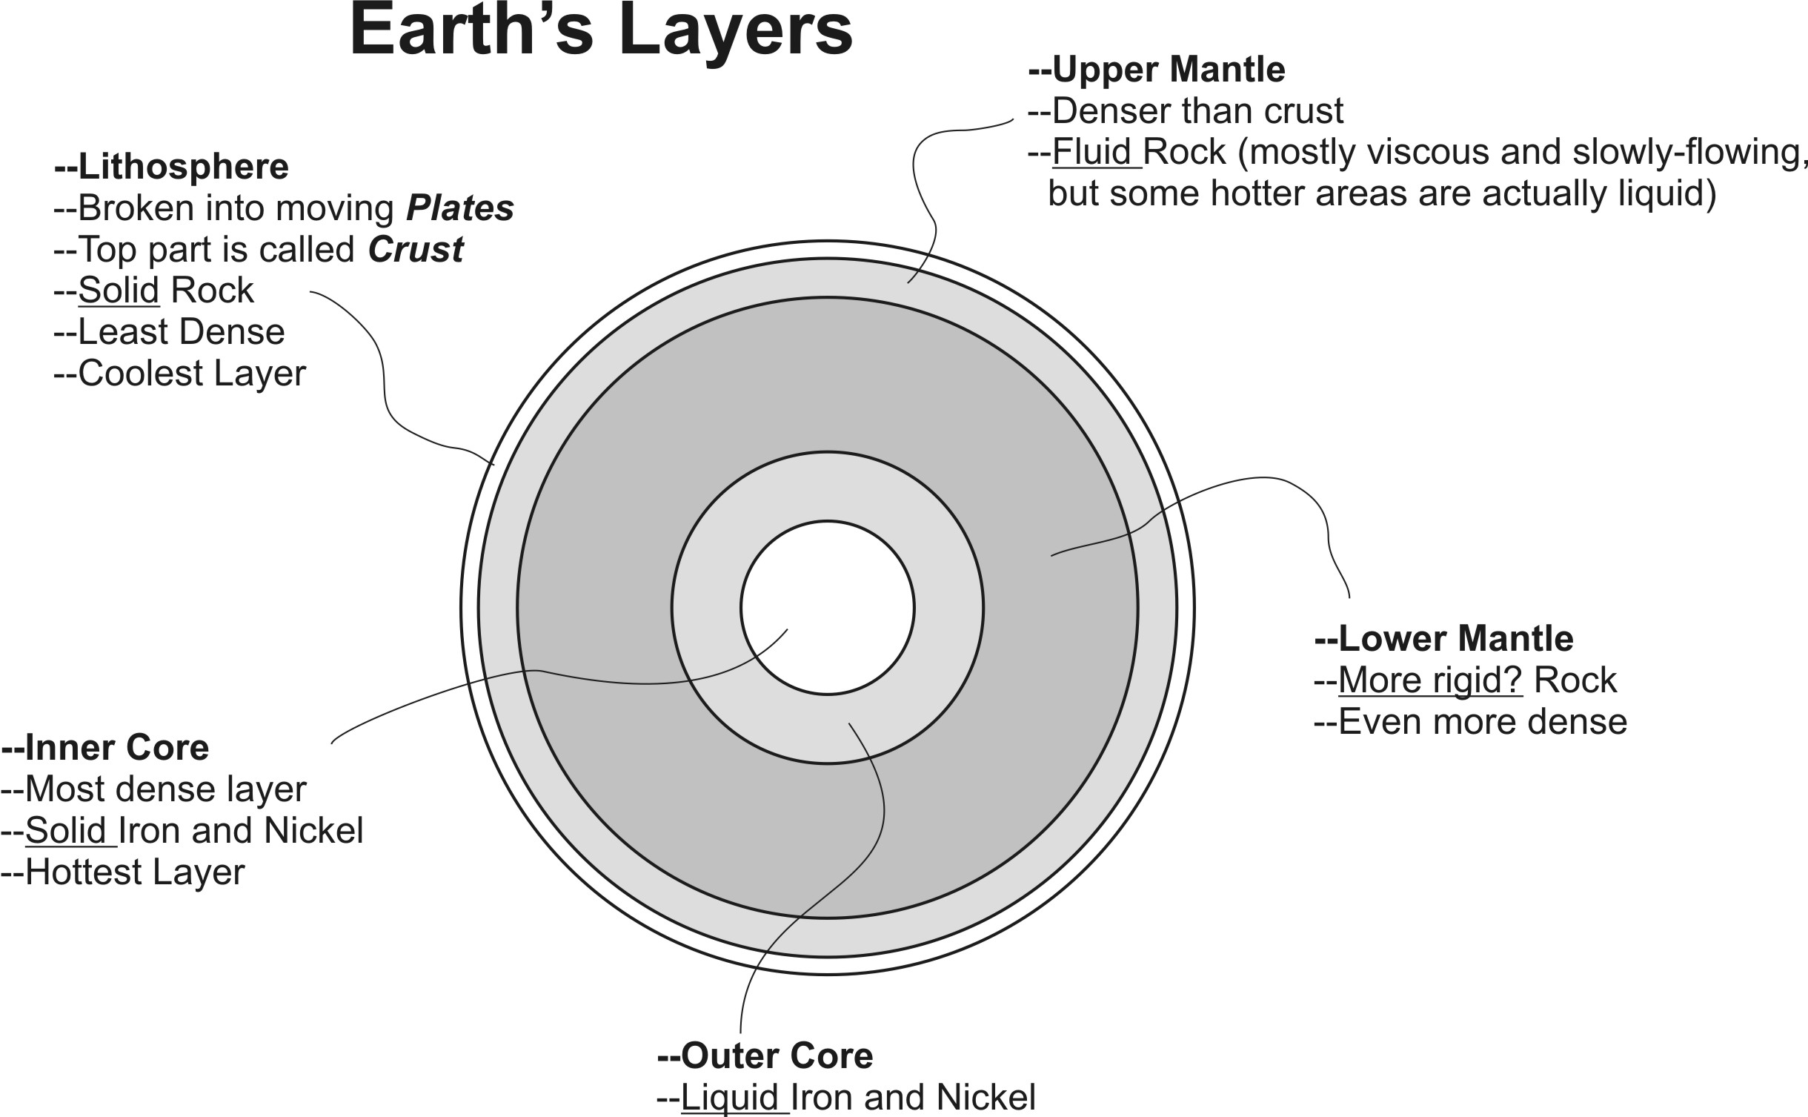

Why is the inside of the Earth Hot?
- Collisions during Earth’s formation (when many small pieces crashed into one another to form the Earth)
- Friction from heavier materials sinking to the center of the Earth, and rubbing against other materials on their way
- Heat released by radioactive elements inside the Earth
- Compression during the Earth’s formation
Plate: A piece of the Earth’s Lithosphere. If you crack an egg, each of the pieces of the fractured shell is like one plate.
Plate Boundary: where two plates meet
Plate Boundary Types:
- Convergent Boundary: →←
- Divergent Boundary: ←→
- Transform Boundary: ↑↓

Convection Currents: Currents in the upper mantle that are caused by temperature differences. These currents cause the lithospheric plates to move. Convection currents begin when hot material rises and cooler material sinks.
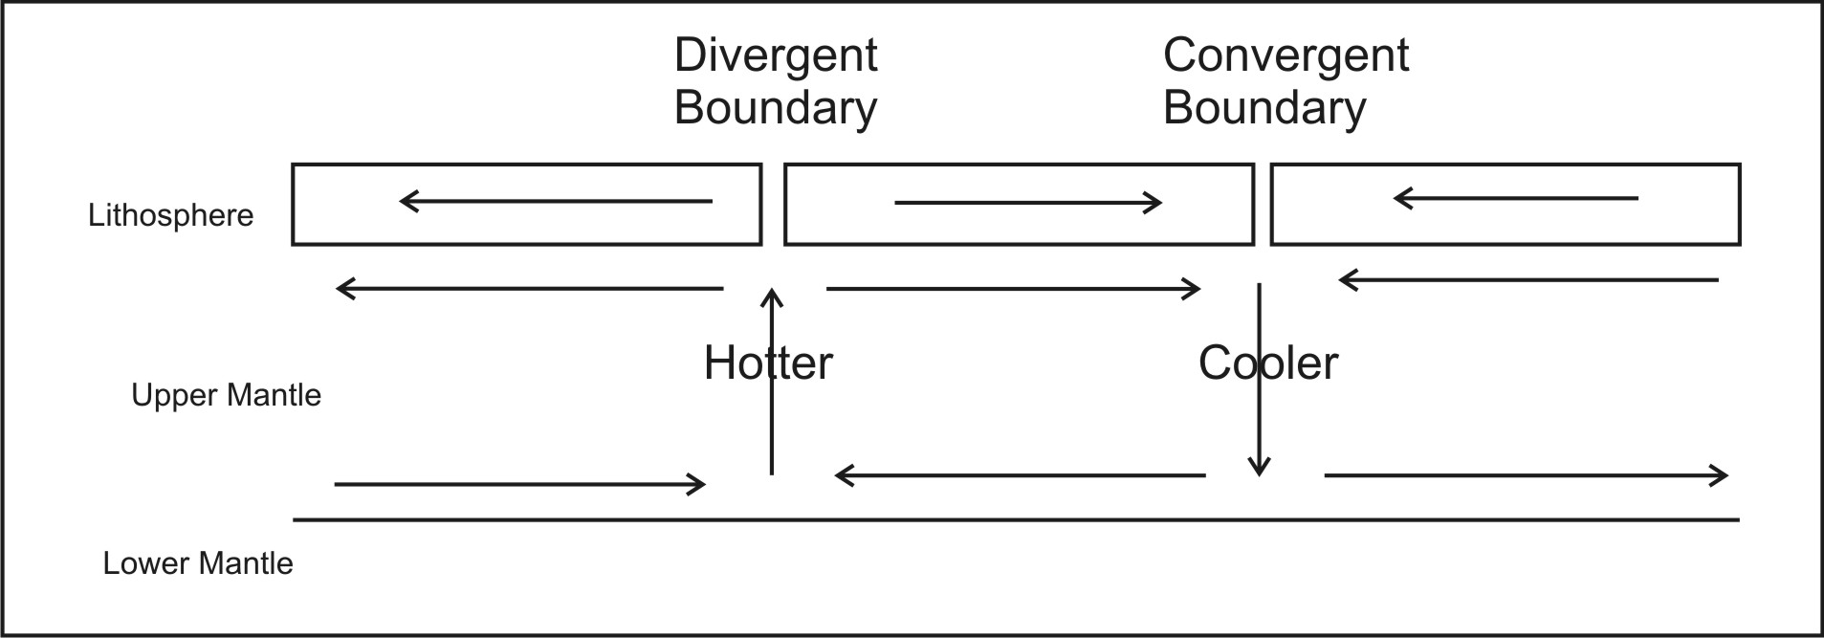
1. On the cross-section diagram below, use arrows to show the convection currents and plate movements that result from temperature differences in the mantle. Then identify and label the three plate boundaries in the picture.
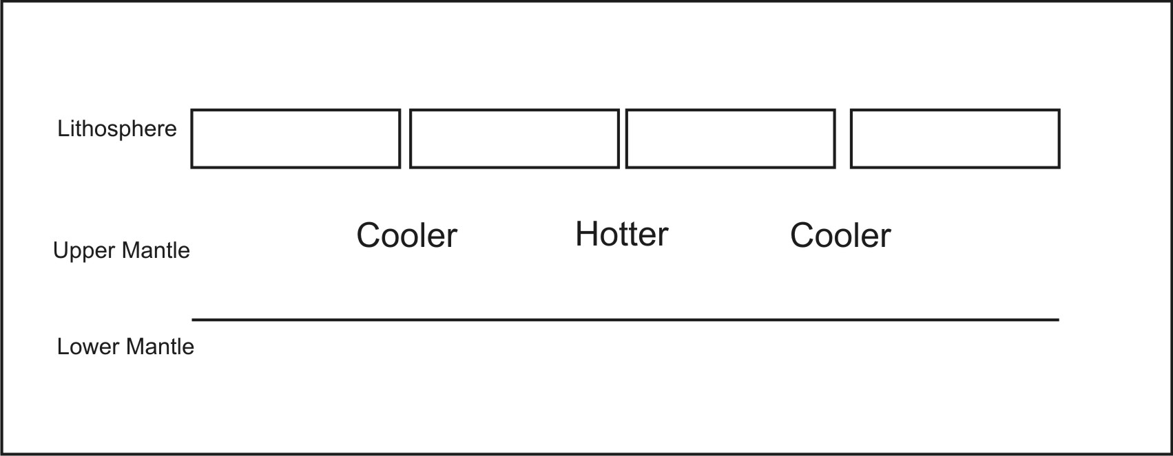
2. On the plate boundary map below, find, circle, and label at least one convergent plate boundary, one divergent plate boundary, and one transform plate boundary.
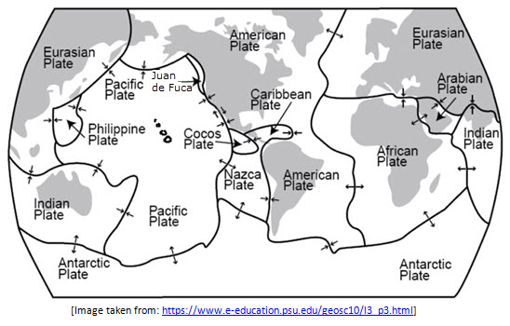
3. On the plate boundary map below, find at least one plate boundary that is situated on top of an especially hot part of the mantle. Label it “hot.”
4. On the plate boundary below, find at least one plate boundary that is situated on top of an especially hot part of the mantle. Label it “cool.”

Characteristics of Crust, Magma, Lava, and Sediment:
Continental Crust:
- Rocks in this layer are typically Felsic (Fe – Feldspar sic – silica)
- Light in color
- Less dense
- High Viscosity (gooey) when turned to magma
  - Builds up pressure and makes volcanoes more explosive
  - Piles up, so it makes volcanoes steeper
- Example Rock -- Granite
Ocean Crust (similar to mantle):
- Rocks in this layer are typically mafic (Ma – magnesium F – iron)
- Dark in color
- More Dense
- Low Viscosity (runny) when turned to magma
  - Does not build up high pressure, so it roduces gentler eruptions
  - Does not pile up, so volcanoes are lower and rounder
- Example Rock -- Basalt
Mantle:
- Similar to ocean crust (mafic or ultramafic)
- Dark in color
- Very Dense
- Low Viscosity (runny) when turned to magma
- When mantle material melts and solidifies, it turns into ocean crust.
Seafloor Sediment:
- More similar to Continental Crust (Felsic). Comprises eroded continental crust, but can also include biological deposits and chemical precipitates.
- Thicker over older ocean crust. Thinner over younger ocean crust.
Magma:
- Molten rock inside the earth
- High gas content (trapped gas)
Lava:
- Molten rock outside the Earth
- Low gas content (gas escapes)

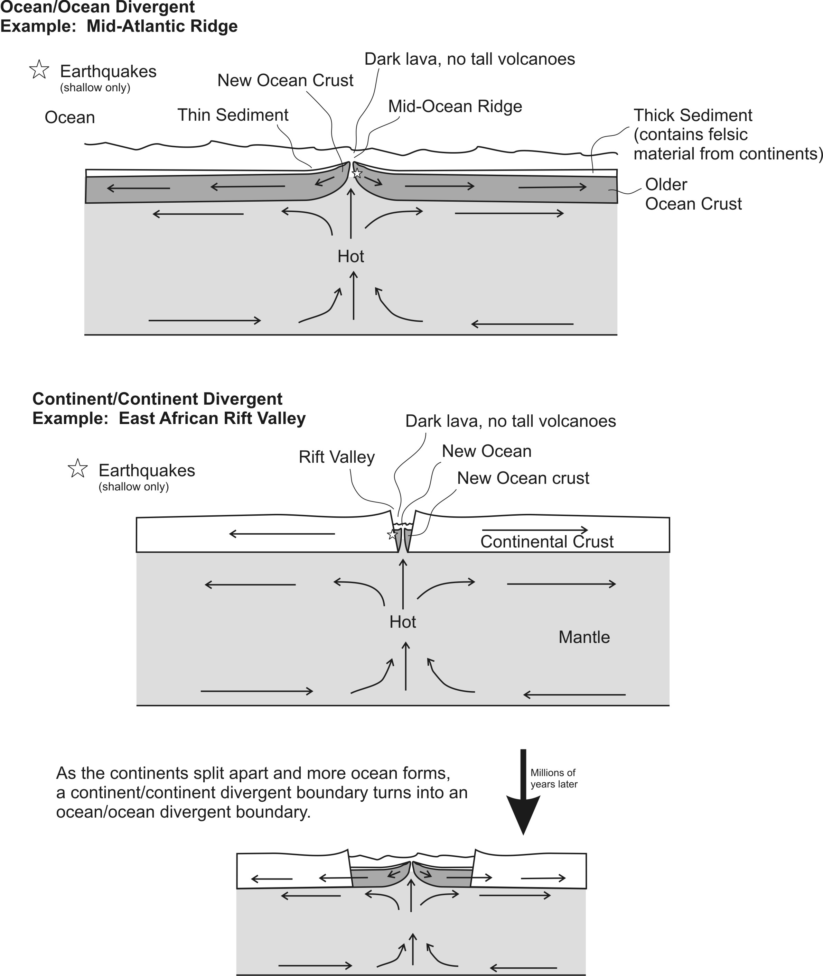

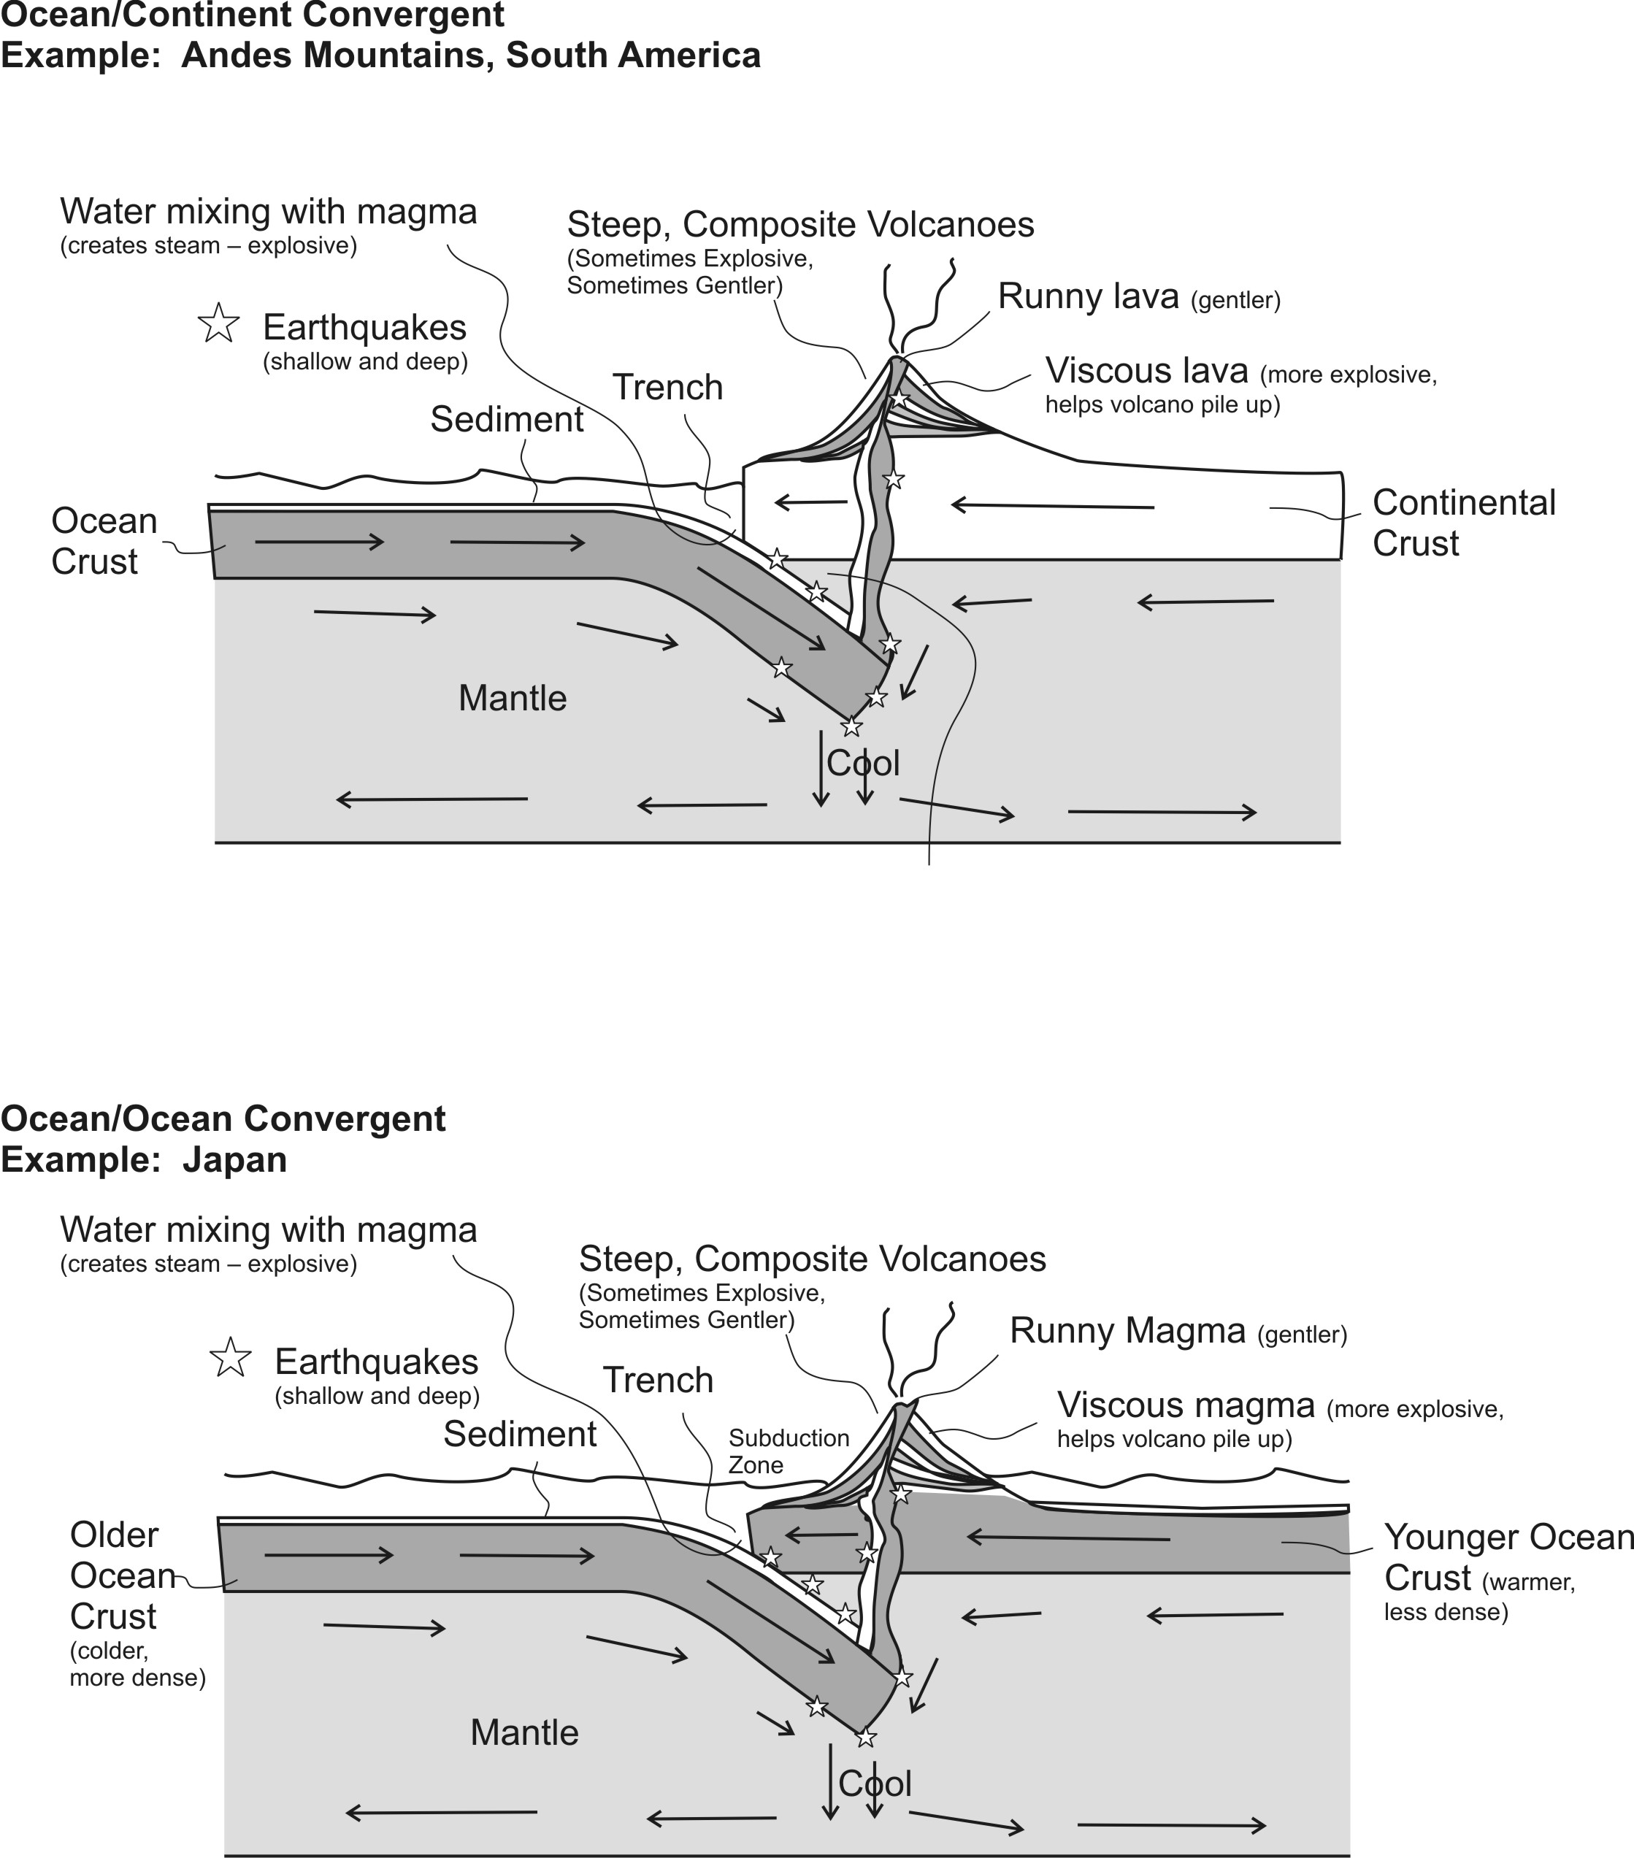

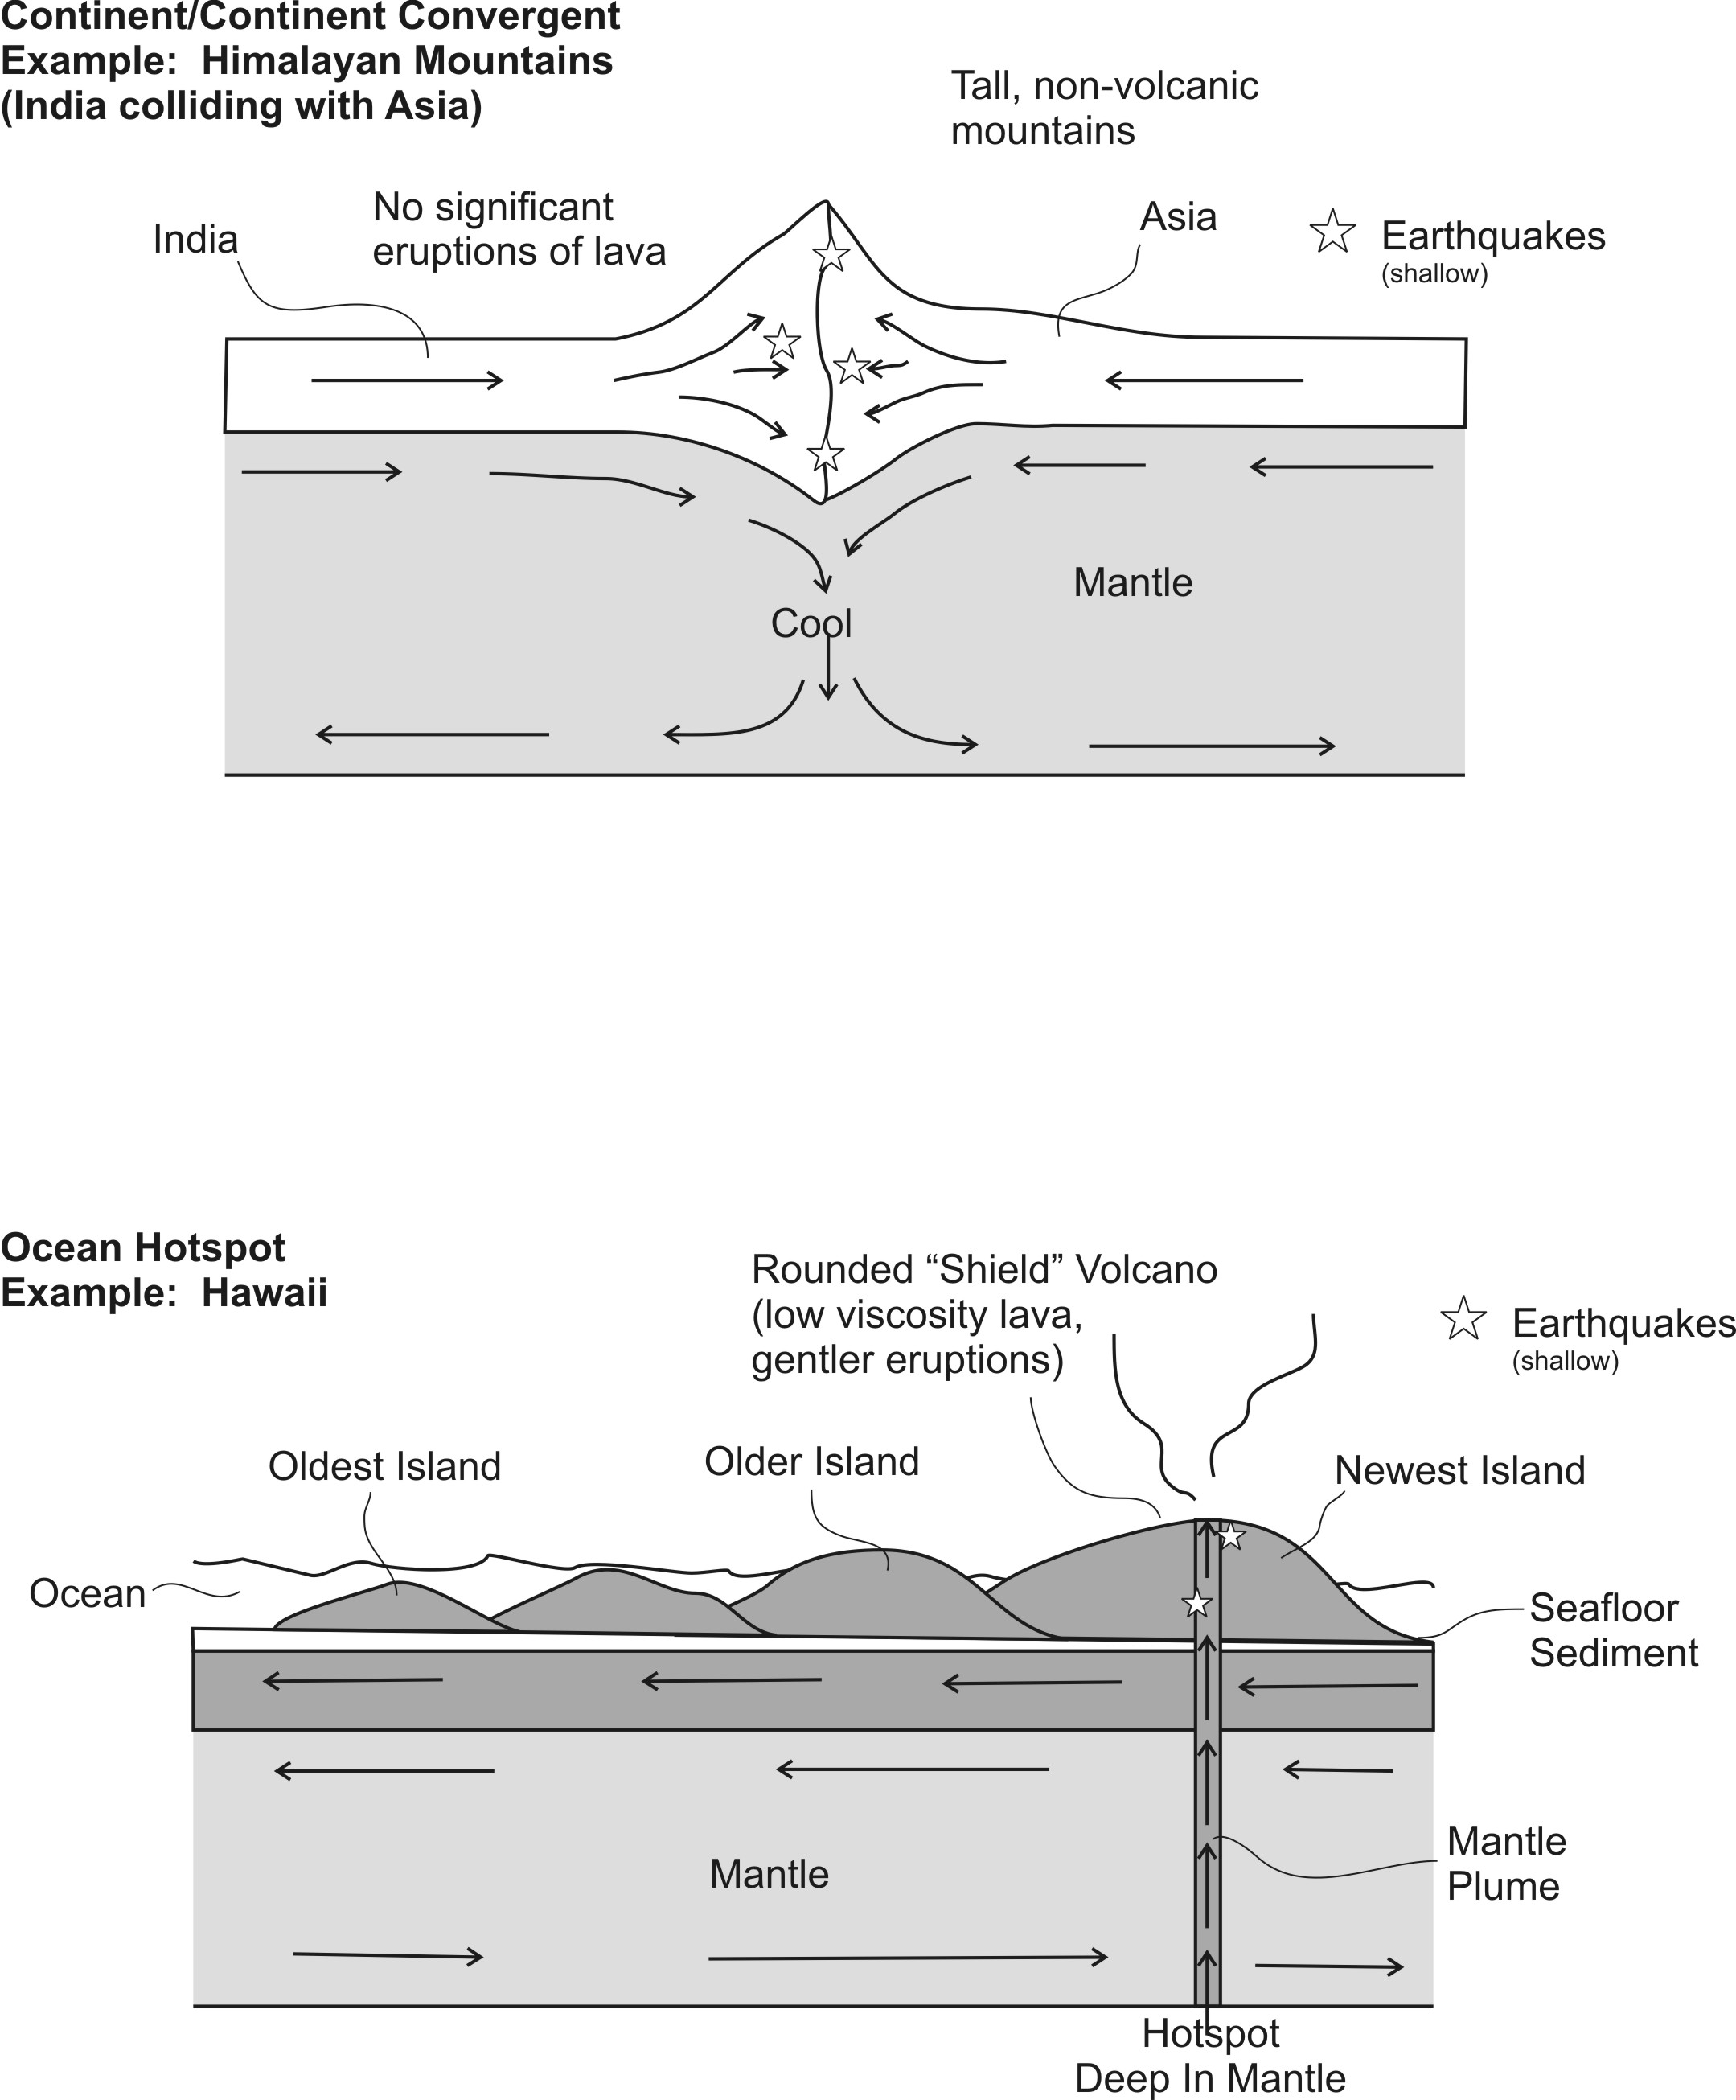

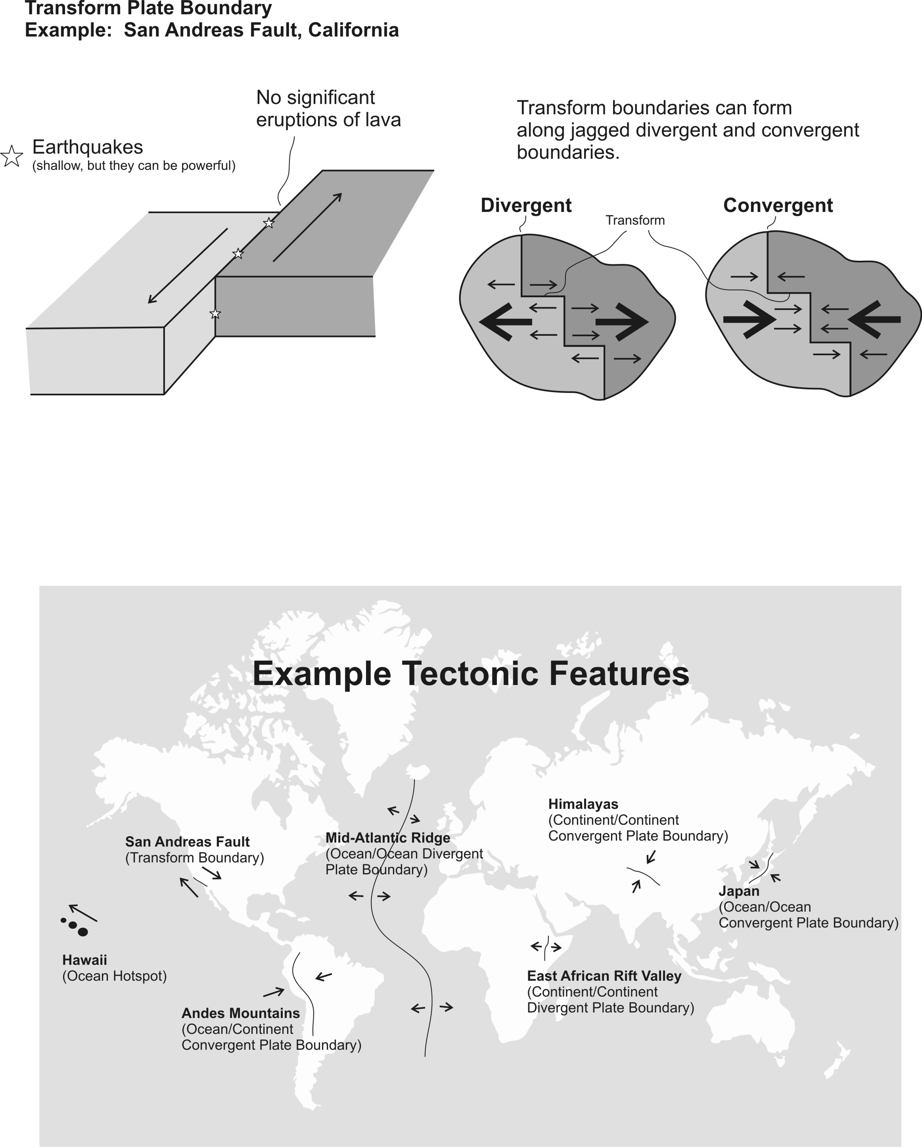
Practice 3

PLEASE DARKEN THE CORRECT ANSWER CHOICES.

Match each description to the appropriate crust type. Choices: A= Continental Crust B = Ocean Crust

1. A B Relatively light in color/shade
2. A B Relatively high viscosity (runny) when molten=
3. A B Similar to the material in the mantle
4. A B The most explosive volcanoes have this type of rock.
5. A B When this type of lava creates volcanoes, those volcanoes are steep.
6. A B An example of this rock type is called basalt.

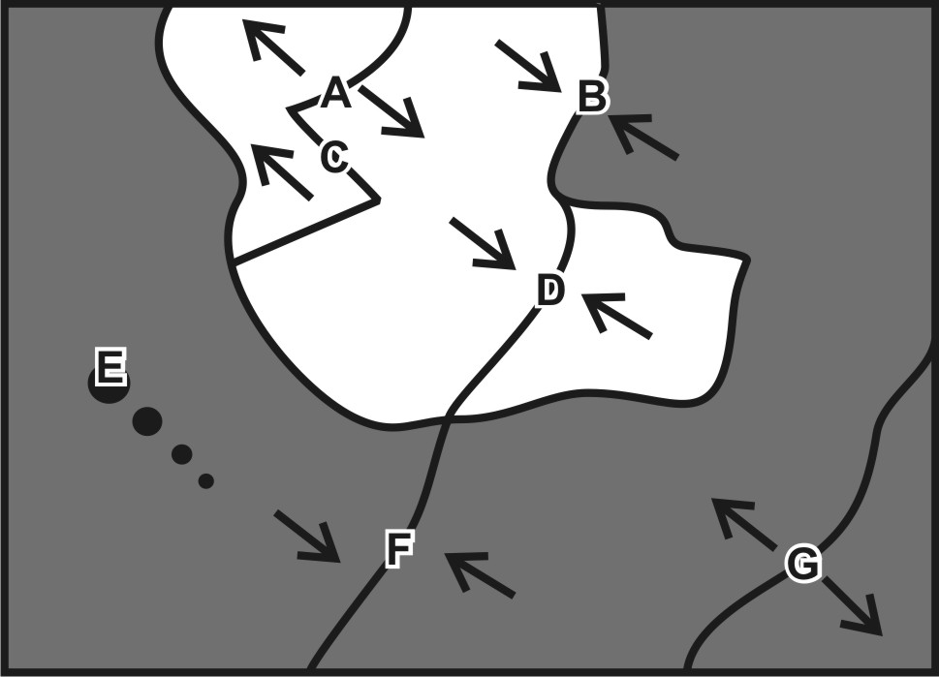
Match each feature name to the corresponding feature on the plate map on the right.

7. A B C D E F G Ocean/Continent Convergent
8. A B C D E F G Transform Boundary
9. A B C D E F G Continent/Continent Convergent
10. A B C D E F G Hotspot
11. A B C D E F G Ocean/Ocean Divergent
12. A B C D E F G Ocean/Ocean Convergent
13. A B C D E F G Continent/Continent Divergent

Each of the real-world locations below forms in an area that is similar to one of the lettered locations on the map. Match each real-world location to its corresponding map location.

14. A B C D E F G Mid-Atlantic Ridge
15. A B C D E F G San Andreas Fault, California
16. A B C D E F G East Africa
17. A B C D E F G Andes Mountains (South America)
18. A B C D E F G Himalayas (Mt. Everest)
19. A B C D E F G Japan
20. A B C D E F G Hawaii

For each lettered feature on the map above, darken all of the descriptions below that apply. [Suggestion: start with letter A. Darken that letter for all of the descriptions that apply to location A on the map. Continue the process one map feature at a time.]

21. A B C D E F G Steep, composite cone volcanoes
22. A B C D E F G Relatively violent eruptions of lava can occur.
23. A B C D E F G Relatively gentle eruptions of lava can occur.
24. A B C D E F G Shallow earthquakes (in lithosphere – crust)
25. A B C D E F G Deep earthquakes (in mantle)
26. A B C D E F G Situated over a relatively cool part of the mantle
27. A B C D F G New ocean crust is being created here.
28. A B C D E F G Situated over a relatively hot part of the mantle
29. A B C D E F G Tall mountains that have never been volcanoes
30. A B C D E F G Rounded, shield volcanoes

