EPS 200 (Stapleton) Name: _________________________________
Practice Quiz: Earth Rotation and Moon Phases

1. The Earth’s rotation is best described as a(n) __________ rotation.
a. Eastward b. westward c. clockwise d. counter-clockwise

2. If you are looking downward from above the Earth’s north pole, in which direction does everything in the solar system appear to rotate and revolve?
- Clockwise b. Counter-Clockwise

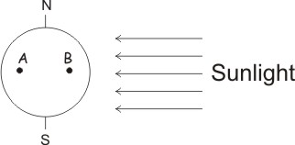
3. On the diagram to the right, carefully shade only the dark part of the Earth.

4. In the diagram on the right, which letter is experiencing a later time of day?

5. In the diagram, what is the approximate hour at letter A?

Questions 6-11 refer to the diagram below. Assume for all questions that the two moons are being viewed from the Earth’s Northern Hemisphere.

6. On the diagram to the right, carefully shade only the dark parts of the Earth and Moons. Assume that there is no eclipse.

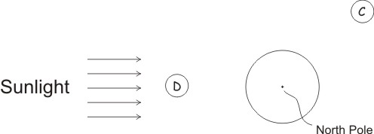
7. Draw what an observer would see if he/she were standing on the Earth and looking at moon C.

8. What is the name of moon phase C?

9. What is the name of moon phase D?

10. Approximately how many weeks does it take the moon to move from position C to position D?
0.5 1 1.5 2 2.5 3 3.5 4

11. At what approximate time of day does moon C rise?

Continued on the back ↓

12. At what approximate time of day does a first quarter (waxing quarter) moon rise?

13. Provide the names of exceptionally high and low tides, and tell which moon phases are associated with each type of tide.

14. If you are in a coastal town, about how often will you experience a low tide? Explain why.

15. Name the two types of eclipses and identify the moon phase during which each occurs. For each type of eclipse, describe what observers of the eclipse would see from Earth.

Bonus: A full, 360° orbit by the moon is called a sidereal month, and it takes 27.3 days. There are 29.5 days between one full moon and the next. Use words and a diagram to explain why these lengths of time differ in this way.

