ESS 200 Name: ________________________________
Astronomy Test (Stapleton)
Answers to Extended Response Questions

** In some cases, where the answer provided here felt a little too wordy, I underlined what represents the bare minimum that might be accepted. It is still better to know the full answer.

1. Solar System Formation
Five billion years ago, our solar system was a cold, slowly-turning cloud of dust and frozen gases (a nebula). Today our solar system is a star (our sun) surrounded by four rocky inner planets and four gas giant outer planets. Describe and explain each of the steps in the process that has transformed our solar system in the manner described above. For each step in the solar system’s formation, identify the change that occurred and the cause of that change.

Change | Cause
The nebula contracted (pulled together) | Gravity
The rate of spinning increased | Contraction (pulling together)
The nebula heated up | Compression
The nebula formed a disk | Increased spinning speed caused momentum to stretch it out at its middle
Nuclear fusion began in the center (the sun was born) | Pressure/high temperatures in the center of the nebula caused hydrogen to fuse
Frozen gases near the center of the solar system were vaporized and blown away | The newborn sun’s heat and solar wind vaporized and blew away the gases.
Planets clumped together | Gravity
Inner planets formed as rocky spheres, while outer planets have rocky cores surrounded by large gas layers | Frozen gas near the sun was vaporized and blown away, so there was no gas to be collected by the inner planets. But there was frozen gas where the outer planets were forming.

2. Earth Systems Formation
Scientists believe that, early in its formation, the Earth was homogeneous (materials mixed evenly together) and liquid (due to its high temperature), and that the Earth had no surface water and no atmosphere. Today we understand that the Earth has a solid surface and interior layers of different materials. Most of the Earth’s surface is now covered with water, and our atmosphere has a great deal of oxygen. Identify the cause of each of the changes described above.

Change | Cause
Separate layers formed inside the Earth | Denser materials sank to the center. Less dense materials floated to the surface.
The surface solidified. | Outer space cooled the Earth’s surface.
Oceans formed. | Meteorites brought water.
Oxygen was added to the atmosphere | Blue-green algae (cyanobacteria) produced oxygen.

3. Our Sun’s Life Cycle
Tell the story of our Sun from the present through its final fate. Name each of its stages and explain what causes each transition between stages. For each stage, identify the Sun’s primary energy source (if any). [You can leave out the planetary nebula stage.]

Time | Stage | Energy Source (fuel) | What causes the transition to this stage?
Present | Main sequence star | Mostly Hydrogen fusion near the sun’s core | NA
Future | Red Giant | Hydrogen fusion in a shell farther from the sun’s core. (Shell hydrogen fusion) Possibly some Helium fusion in the core. | 1. Helium sinks to the core, pushing the fusing hydrogen outward.  2. Hydrogen fusion farther from the core (shell hydrogen fusion) is less intense, so it produces a red (cooler) color.
More Distant Future | White Dwarf | Compression | 1. Fusion stops.  2. Gas pressure decreases.  3. The sun shrinks.  4. Compression heats it up, so it turns white (a hotter color).
Final Stage | Final Stage -- Black Dwarf | Nothing | The star is fully compressed. It is not generating energy from compression. It is only losing energy. Over time, the star cools down until it no longer glows.

4. Life Cycle of a Massive Star
Identify ways in which the life cycle of a very large star (25 solar masses) is different from our Sun’s life cycle (see previous question).

- As a main sequence star, a very large star is blue, because it has more pressure and heat.
- The sun only fuses hydrogen (and some helium). A 25 solar mass star fuses elements up to the weight of iron.
- Instead of becoming a white dwarf, a very large star “dies” by exploding as a supernova.
- Instead of becoming a black dwarf in its final state, the leftover material from a very large dead star can become…
  - A black hole
  - A neutron star
  - Part of a new nebula, that can form another solar system like ours

5. The Big Bang
Briefly describe the Big Bang Theory and provide two pieces of evidence supporting the theory.

Big Bang Theory: The Universe began to form 13.8 billion years ago, as it expanded from an infinitely small point. It continues to expand today.

Evidence #1: The Universe is expanding. We know this because other galaxies have red-shifts, which means that they are moving away from us.

Evidence #2: We can use special telescopes to look into space and “see” heat that was released in the Big Bang. This energy is in the form of Microwaves, so we can’t really see it with our eyes. It is called the Cosmic Microwave Background Radiation (CMBR).

6. HR Diagrams
Sketch a Hertzsprung-Russel diagram. Label the axes to show the directions of increasing/decreasing values. On your diagram, label examples of all of the specific stars, and classes of stars, that we have discussed in class.

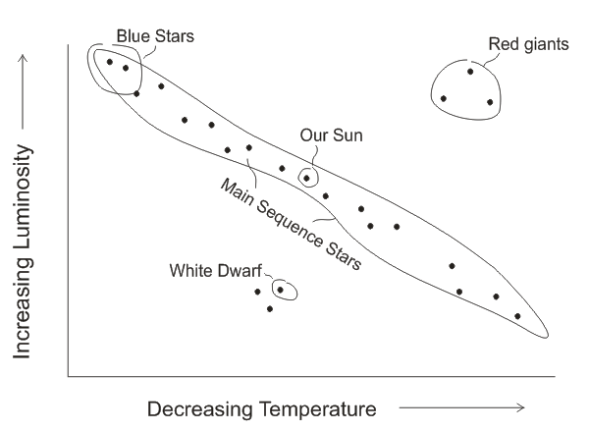

7. The Origins of Matter
Where did matter come from? Describe all of the important sources of the matter that exists on the Earth today. Identify the specific process that created each category of matter.

Type of Matter | How it was created
Hydrogen and most of the Helium in the Universe | Formed in the first few seconds after the Big Bang
Elements from the weight of Helium up to the weight of Iron | Formed by nuclear fusion in stars.
Elements heavier than iron | Formed in Supernovae explosions

