ESS 200 Name: _____________________________________
Practice Quiz – Stars and The Universe, Part 1

z1. What is visible light?
a. All radiation
b. Cosmic rays that are visible to human eyes
c. Electromagnetic waves that can be seen by humans
d. Waves that can be seen by an animal
e. All of the electromagnetic waves that are given off by the sun
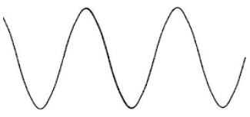
2. What is the wavelength of the wave on the right, in centimeters?

3. Arrange these colors according to wavelength, from shortest to longest: red, blue, green

4. Arrange these colors according to their energy, from highest to lowest: orange, violet, indigo

5. What is the relationship between wavelength and energy?
a. longer wavelength = greater energy
b. shorter wavelength = greater energy
c. wavelength is not related to energy

6. White light ___.
  - Is a combination of all of the different colors, or wavelengths, of visible light
  - Is emitted by stars
  - Can be separated using a spectroscope
  - All of the above
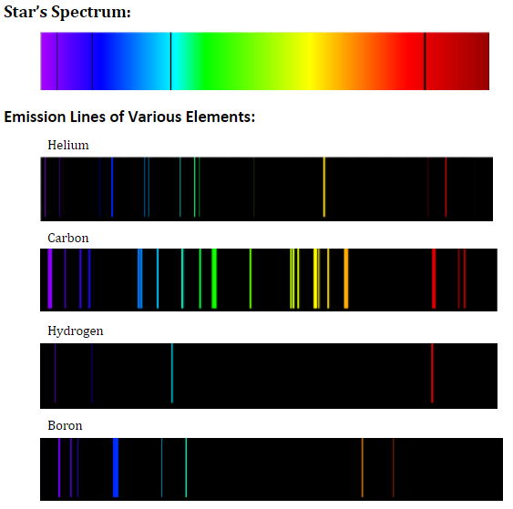
7. The diagram on the right shows a star’s spectrum and the emission lines of different elements. Use these diagrams to identify the element that is present in the star’s atmosphere.
  - Helium
  - Carbon
  - Hydrogen
  - Boron

8. List the colors of stars from hottest to coolest.

9. Suppose an object is, and has always been, moving away from us at the speed of light. If we see the object in the night sky and we measure its distance at 5 light years from Earth…
a. How old is the image of the object that we are seeing? In other words, how long ago did the light that we are seeing leave the object?

b. What is the actual present distance of the object from the Earth?

10. When you look at any object, you are seeing:
a. The object as it appears in the present
b. the object as it appeared in the past
c. the object as it will appear in the future
d. none of these
e. all of these (a-c)

11. Why do we need spectroscopes in order to determine what is in a star?
a. We need to see farther than the human eye can see
b. We need to know the wavelengths of the different colors in the rainbow
c. We need to amplify the light from objects that are very dim
d. We need to separate the individual wavelengths of light that come from the star

12. Which star colors are ordered from hottest to coolest?
a. Hottest -- Blue, White, Yellow, Orange, Red -- Coolest
b. Hottest -- Red, Orange, Yellow, white, blue – Coolest
c. Hottest -- Orange, Red, Yellow, Blue, White -- Coolest
d. Hottest -- Green, Red, Yellow, white, Orange – Coolest

13. List the stages of our sun’s life-cycle, in order.

14. What do all main sequence stars have in common?
a. They are creating iron in their cores. b. Their nuclear fuel is hydrogen.
c. They all die as supernovae. d. They are medium sized stars.
e. They are white dwarfs.

15. Our sun is currently a(n):
a. Main sequence star b. Red giant c. White dwarf
d. Black dwarf e. Yellow giant

16. Which of the following represents the latest (final) stage of our Sun’s life?
a. Black Hole b. Supernova c. Neutron Star
d. White Dwarf e. Red Giant

17. Very massive stars become supergiants. After the supergiant stage, what happens next in a massive star’s life?
a. Black Hole b. Supernova c. Neutron Star
d. White Dwarf e. Red Giant

18. What is the heaviest element that can be produced by fusion in a star?
a. Helium b. Hydrogen c. carbon d. iron e. gold

19. In a main sequence star, there is a balance between which of the following? Circle them both.
a. Momentum b. Velocity c. Gravity d. Gas Pressure e. Centrifugal force

20. Suppose some strange event caused our sun’s gravity to suddenly increase.
a. What effect would this have on our Sun?
b. Explain how and why the effects of this gravity increase then would be counteracted.

21. True or false: Some of the materials in our bodies was once in a large, blue star.

22. Every element on Earth that is heavier than iron (e.g. nickel, copper, lead, mercury, gold, etc.) was created by:
a. The Big Bang b. Nuclear fusion in main sequence stars
c. a Supernova d. Neutron stars e. Black holes

23. A supernova can be thought of as a sequence of events culminating (ending) in an explosion. What is the direct cause of the explosion:
a. gravity
b. extreme gas pressure from nuclear fusion
c. falling matter colliding with a star’s iron core
d. hydrogen fusion

24. When a star becomes a red giant, why does it expand?

25. The surface of a red giant is:
a. hotter than an ordinary star, because it is bigger
b. hotter than an ordinary star, because the fusing hydrogen is spread out
c. cooler than an ordinary star, because hydrogen is no longer fusing
d. cooler than an ordinary star, because hydrogen is fusing a lower pressure

26. When a star is destroyed in a supernova, which of the following is not a possible fate of the leftover material?
a. It can turn into a red supergiant. b. It can form a neutron star.
c. It can form a black hole. d. It can be recycled into another nebula.

27. What is “1 solar mass?”
a. the mass of our sun b. the mass of any star
c. the mass of sunlight given off in one year d. the mass of one photon of light

28. After a supernova occurs, what happens if there is more than 3 solar masses of material left behind?
a. The mass will turn into a red supergiant.
b. The mass will form a neutron star.
c. The mass will form a black hole.
d. The mass will recycled into another nebula.

29. After a supernova occurs, what happens if there is between 1.4 and 3 solar masses of material left behind?
a. The mass will turn into a red supergiant.
b. The mass will form a neutron star.
c. The mass will form a black hole.
d. The mass will recycled into another nebula.

