ESS 200 Name: _______________________________
Notes: Stars and The Universe, Part 2

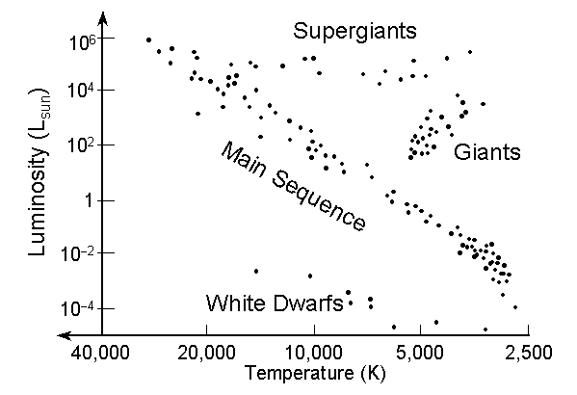
- Hertzsprung-Russell diagrams:
  - What do the axes of an H-R diagram tell us? X axis? Temperature (high to low) Y axis? Brightness (low to high)
  - What does “luminosity” mean? brightness
  - What is a main sequence star? A star whose current energy sources is primarily the fusion of Hydrogen into Helium; a middle-aged star.
  - In an H-R diagram, where are the main sequence stars located? Along a diagonal from the top left to the bottom right
  - In an H-R diagram, what kinds of stars are on the top right? Red giants or red supergiants.
  - In an H-R diagram, what kinds of stars are on the top right? White dwarfs.
  - Where are the largest stars usually located in an H-R diagram? The top
- The Doppler Effect:
  - Describe the change in wavelengths observed when the source of the waves is moving toward an observer. Do the same for a wave source moving away from an observer. When the source is moving toward the observer, the wavelengths become shorter (compressed). When the source is moving away from the observer, the wavelengths become longer (stretched out).
  - How do red and blue shifts occur? When an object is moving toward an observer, the observed waves become compressed, thus shortening their wavelengths and shifting them toward the shorter (blue) end of the electromagnetic spectrum. When an object is moving away, the observed waves become stretched out, thus increasing their wavelengths and shifting them toward the longer (red) end of the electromagnetic spectrum.
- The Big Bang Theory
  - How long ago did the Big Bang occur? (i.e. what is the age of the universe?) About 13.8 billion years ago
  - How big was the Universe at the first moment of the Big Bang? smaller than a Planck Length (1.6x10⁻³⁵m) in diameter
  - Important Aspects of the Big Bang Theory:
    - What happened during the first few seconds after the Big Bang? In the first few seconds of the Universe, light elements were created (about 73% Hydrogen and 25% Helium)
    - In degrees Kelvin, what are the temperatures of: a) absolute zero b) the freezing point of water? c) the boiling point of water? d) the early universe? A) 0°K B) 273°K C) 373°K D) 10^{32◦}K
    - Describe the density of space in the early universe. It was so dense that light could not travel through it. It was opaque.
    - How did the Universe change about 380,000 years after the Big Bang? How hot was the universe at this time? The universe first became transparent to light 380,000 years after the Big Bang. At this time, everything was about 3,000◦K(as hot as a red star) so the whole universe glowed like a red star. [This is the microwave radiation that we can still see today.]
    - How has the temperature of the Universe changed between the Big Bang and today? The temperature has cooled to about 2.7°K (2.7° above absolute zero).
    - True or false: as the Universe expands, galaxies spread outward through space. Explain your answer. False: As the Universe expands, it does not expand into space or through space; space within the universe grows. When the Universe was smaller, there was no space outside the universe for the universe to expand into. All of space was already here; it has simply inflated.
    - When we look at the most distant objects that we can possibly, we are seeing light that left those objects long ago. How long has that light been traveling? How do you know? 13.8 billion years. The light left them just after the big bang, and it has been travelling toward us ever since.’
    - The most distant objects in the Universe are not where they appear to be. Where are they? Explain why. They are farther away. The light that we see left them 13.8 billion years ago. Since that time, those objects have continued to move away from us.
- Describe the evidence for the Big Bang.
  - We can see heat that was produced during the Big Bang. This heat is called the Cosmic Background Radiation. The Big Bang Theory postulated that high energy radiation should have been emitted from every part of the hot, young Universe (like light from a 3,000◦K red star). This radiation would have filled the Universe. Over time, as the Universe has stretched out, the theory holds that this radiation should have stretched out along with the rest of the Universe. Today, that radiation should have a wavelength in the microwave region of the electromagnetic spectrum. These microwaves should have a wavelength similar to those that would be emitted from a very cold, 2.7◦K object. After this prediction was made, scientists have confirmed that the sky is filled with this radiation, and it has the predicted wavelength.

  - Hubble’s Law: Almost all galaxies are moving away from us. When galaxies’ speeds and distances are graphed, we see that more distant galaxies are moving away from us faster. This suggests that space is expanding.
    - How did Hubble get his data? He examined the Doppler shifts of distant galaxies. The extent of their red shifts told him how fast the galaxies were moving away from us.
  - The Universe’s Composition: The Big Bang theory predicted the Universe’ composition to be approximately 73% Hydrogen and 25% Helium. This has been confirmed by recent measurements.
- The origin of matter:
  - Where did Hydrogen and Helium come from? They formed a few seconds after the Big Bang.
  - Where did elements between the weights of Helium and Iron come from? These elements were created in stars, by the fusion of Hydrogen and Helium into heavier elements.
  - Where did elements heavier than iron come from? Supernovae (explosive deaths of large stars) provided enough pressure to fuse atoms into even heavier elements.

