ESS 200 Name: _______________________________
Notes: HR Diagrams, Doppler, and The Big Bang

Part 1. Hertzsprung-Russel Diagram

0. What is the point of an HR diagram? What is luminosity?

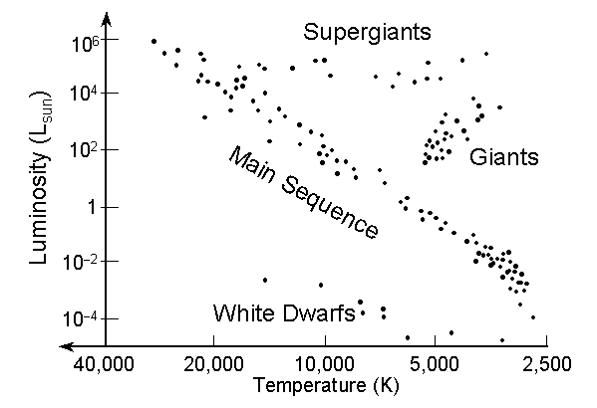

Part 2: The Doppler Effect:

1. Draw some sound waves that are being created by noisy people whose voices have different pitches.

2. Frequency is the number of waves that reach a listener each second. The units are Hertz (Hz). 1Hz equals one wave per second.
3. When frequency is higher, pitch is (higher or lower).

4. Show what sound waves look like when they are created by the horn of a car that is moving to our right.
5. Which listener in the diagram will hear a higher frequency sound?

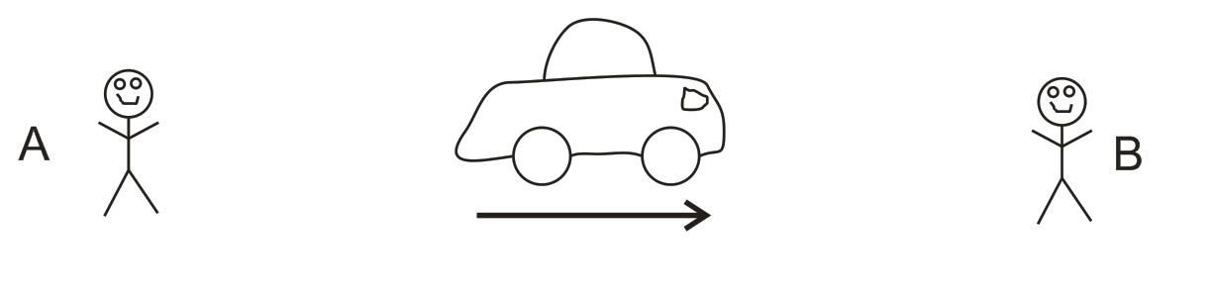

6. Show what sound waves look like when a car is honking its horn and traveling at the speed of sound.
7. Label a place where you would need to stand in order to hear a sonic boom.

8. Draw light waves leaving a stationary white star
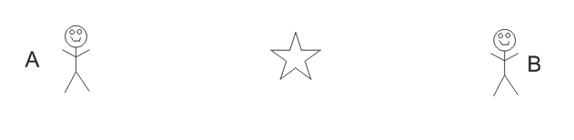
9. Draw light waves leaving a white star that is moving to the left.
10. Label the person who sees a slightly bluer version of the star. Label the person who sees a slightly redder

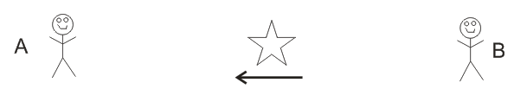

11. A red shift is a (shortening or lengthening) of wavelengths indicating that the source of the waves is getting (closer to or farther from) the observer. A blue shift is a (shortening or lengthening) of wavelengths indicating that the source of the waves is getting (closer to or farther from) the observer.

Part 3: The Big Bang

12. How long ago did the Big Bang occur? (i.e. what is the age of the universe)

13. How big was the Universe at the first moment of the Big Bang?

14. Big Bang Timeline:

a. What happened during the first few seconds after the Big Bang?

b. What was the temperature of the Universe in the first few seconds?

c. What did space look like 380,000 years after the Big Bang?

d. What happened about 380,000 years after the Big Bang?

e. When did the first stars and galaxies form?

15. When we look out into space, we are looking back into time. As we look farther away, we look further back in time.

a. Describe the most distant thing we can see. How old is what we are seeing?

b. This ancient image does not look like it actually looked long ago. How and why does it look different now?

17. List and explain two pieces of evidence for the Big Bang.

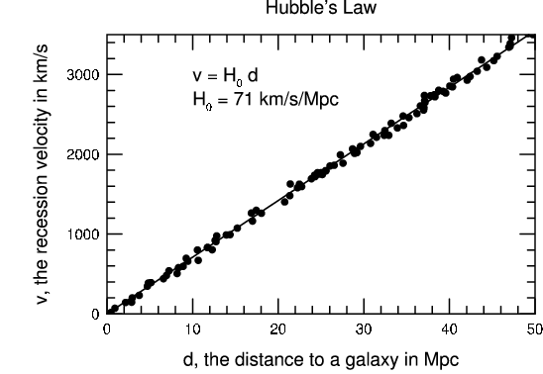
18. Summarize what is shown by the graph on the right.

19. Describe how Edwin Hubble created this graph.

20. What are the two diagrams below supposed to show, and how are they related to one another?
