ESS 200 Name: _______________________________
Notes: Stars and The Universe, Part 1

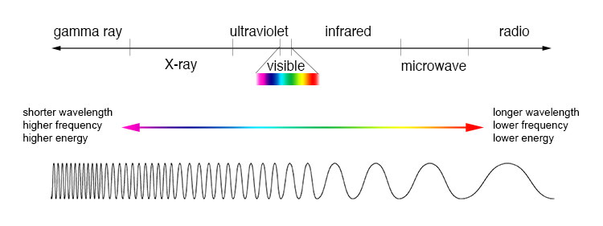
- Electromagnetic radiation:
  - What is visible light? Electromagnetic waves with wavelengths that allow them to be seen by human eyes.
  - Define Wavelength: The distance from the crest of one wave to the crest of the next wave.
  - Order the colors of visible light according to their wavelength. Longest wavelength to shortest wavelength: ROYGBIV (Red, orange, yellow, green, blue, indigo, violet)
  - Which wavelengths of electromagnetic radiation have more energy, shorter wavelengths or longer wavelengths? Shorter wavelength = higher energy
  - Objects give off radiation with wavelengths that depend on the objects’ temperature. This is true for stars, hot metal, humans, and all other objects. The wavelength of this radiation is based on the temperature of the object. Rank these star colors from hottest to coolest. Red, Blue, Orange, Yellow, White. Hottest to Coolest: Blue, White, Yellow, Orange, Red
  - Some objects are just a little too hot for their radiation to be visible. Others are a little too cool for us to see their radiation. What type of electromagnetic radiation do these slightly-too-hot objects emit? Ultraviolet radiation What type of radiation do these slightly-too-cool objects emit? Infrared radiation
  - What is the speed of light? 671 million miles per hour
  - What is special about the speed of light?
    - All electromagnetic radiation travels at this speed in a vacuum.
    - Nothing can travel through space faster than the speed of light.
    - And there’s more (for later).
  - What is a light year? The distance light travels in one year (5.879x10¹² miles). A Light year is a unit of distance, not a unit of time.
  - The distance from the Earth to the Sun is about 8 light minutes. What does that mean? It means light takes 8 minutes to travel from the sun to the Earth.
  - We always see things as they were in the past. The farther away we look, the farther into the past we see. Explain why. Light travels fast, but it does not travel instantaneously. We see an object as it looked when the light that is now reaching our eyes left that object.
- How we know what elements are in stars:
  - What is an element’s absorption spectrum? An absorption spectrum is a fingerprint of specific wavelengths of light that are absorbed by that element.
  - How can we tell which elements are in stars? Stars emit radiation because they are hot, but some of that radiation gets absorbed by the elements in the star. We look at the absorption spectra of the light that is coming from stars and use those fingerprints to identify the elements in the stars.
  - What does a spectrometer do? A spectrometer works like a prism. It separates light into individual wavelengths so that we can see the spectrum of wavelengths coming from a star.
- Star Life Cycles
  - Small to Medium Stars (less than 1.4 solar masses):
    - Describe the stages:
      - Nebula – cold cloud of dust and frozen gas
      - Main Sequence Star – Hydrogen is fusing to Helium
      - Red Giant – Hydrogen fusion moves outward into an expanding “shell” outside the core. Helium and other elements are fusing in the core.
      - White Dwarf – Nuclear fusion stops. The star collapses but then heats back up due to compression. This heating causes the color to change from red to white.
      - Black Dwarf – Eventually the star radiates all of its heat into space . It is cold and dark.
    - When a star is “on the main sequence” there is a balance keeping its energy output fairly constant.
      - What are the forces that are balanced? Gravity ( causing the star to contract) is balanced by pressure (pushing outward).
      - Which force changes first? Why? As the star uses up fuel, it cools, so its particles move more slowly and their pressure decreases. As pressure decreases, fusion decreases, and more cooling occurs. Pressure drops more.
      - How does the second force react when the first force changes? When the gas pressure decreases, it no longer pushes outward with as much force, so gravity is now able to further compress the star, heating it back up and again raising the pressure. The star is stabilized.
    - When a star turns into a red giant, why does it get bigger? Helium is building up in the star’s core. As hydrogen fusion stops in the core (because there is only helium there), hydrogen begins to fuse in a shell outside the core.
    - When a star turns into a red giant, why does it turn red? When hydrogen fusion takes place farther from the star’s core, there is less pressure, so the fusion is less intense. The surface of the star is cooler, so it turns red (a cooler color, for stars).
  - Large Stars (1.4 solar masses or greater):
    - Nebula – cold cloud of dust and frozen gas
    - Main Sequence Star – Hydrogen is fusing to Helium
    - Red Supergiant – Fusable Hydrogen is used up. Helium and other elements are fusing into elements up to the weight of iron.
    - Supernova – Nuclear fusion stops. The star collapses and slams into its iron core with explosive pressure. This compression fuses elements heavier than iron and blasts material into space.
- Describe the three possible fates of stellar material after a supernova occurs.
  - Recycling: Some matter is blasted into space and incorporated into new nebulas, like ours.
  - Black Hole: If the matter left behind is more than 3 solar masses, a black hole will form.
  - Neutron Star: If the matter left behind is between 1.4 and 3 solar masses, a neutron star will form.

