EPS 200 Name: ________________________________
Practice Quiz: Formation of The Solar System

** This practice quiz does not ask all of the questions that may appear on the quiz. To prepare for the quiz you should study the notes from class. Study the typed portion of the notes as well as the information that you wrote on the notes. Do not simply study this quiz. **

1. What is the name for the giant, amorphous cloud of dust and frozen gases that eventually turned in to the solar system that we have today?

2. 4.6 Billion years ago, much of the solar system was frozen gas. Name an element that was part of this so-called frozen gas.

3. Describe the motion of the early Solar System, and explain how that motion changed.

Motion:

How the motion changed:

4. The early solar system had no particular shape. In the early part of its evolution, the shape changed. What shape did it become?

5. Newton’s 1st Law is also called the law of _____________________.

6. The Earth is spinning.

- What part of the Earth has the most momentum?

- Why?

7. Even before the sun was born, the solar system was beginning to heat up. Why?

Continue on back ↓

8. a. What is the name of the process that produces most of the sun’s energy?

b. The formula E=mc² can be used to explain how this process produces energy. In this formula…

E stands for:

m stands for:

c stands for:

c. What type of atoms serve as the fuel for this process?

d. What type of atoms does the sun produce during this process?

9. Explain why the outer planets of the Solar System have thick gas layers, while the inner planets do not.

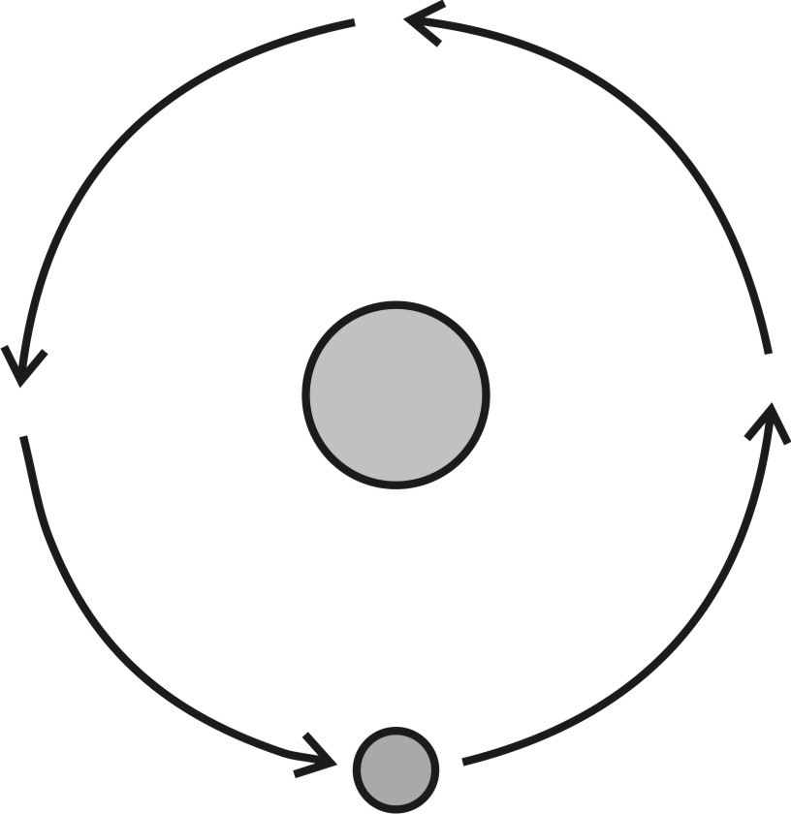

10. The diagram to the right shows the Earth orbiting the Sun. Use an arrow to show the path that the Earth would follow if suddenly there were no gravitational attraction between the Sun and Earth.

11. The Earth would travel in this direction due to the Earth’s

______________________.

