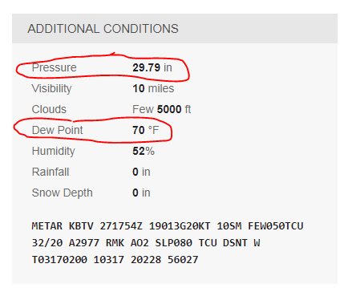
Hot Air Balloon Practice Problem #3

1. Suppose the temperature of the air in the classroom is 75°F. Open the online air density calculator link from on today’s cell of the class website. Enter the classroom temperature and the circled data on the right into the calculator. Set the density units to g/cm³. Record the air density provided by the calculator.

Room Air Density = ________ g/cm³

2. Suppose these are the balloon data you collect as you measure and fly your balloon:
- Inflated balloon volume = 250,000cm3
- Empty mass of balloon = 40g
- Total mass of string and weight tied to balloon = 102g
- Electronic balance reading while the balloon is flying = 82g.

a. How many grams of mass can your balloon lift?

b. How much mass would need to be added to your balloon to make it neutrally buoyant?

c. If mass were added to make your balloon neutrally buoyant, what total mass would it have?

d. If mass were added to make your balloon neutrally buoyant, what would be the mass of the hot air inside the balloon?

e. What would be the density of that hot air?

f. What would be the temperature of that hot air?

