ESS 100 (Stapleton) Name: ___________________________________
Test Review: Physical Properties and Structure of Matter

1. Define mass.

2. Define volume.

3. Define density.

4. Define weight.

The objects on the right are mostly empty space. The circle is the edge of each object. The dots inside represent all of each object’s mass. The empty space inside the objects has no air or mass of any kind.

5. Which object has the most weight? ___
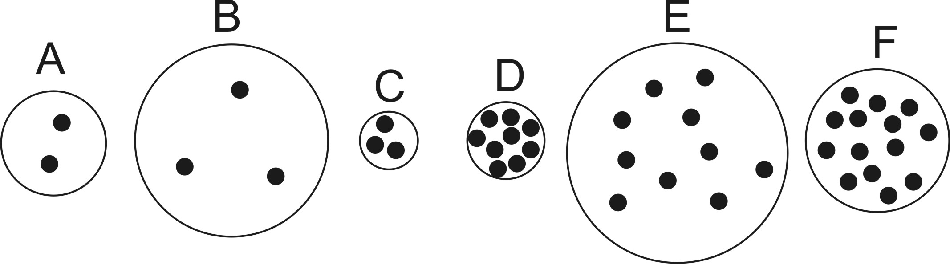6. Which object has the least weight? ____
7. Which object has the most volume? ____
8. Which object has the least volume? ____
9. Which object is most dense? ____
10. Which object is least dense? ____
11. Which object has the most mass? ___
12. Which object has the least mass? ____
13. Which object is most likely to sink? ____
14. Which object is most likely to float? ____

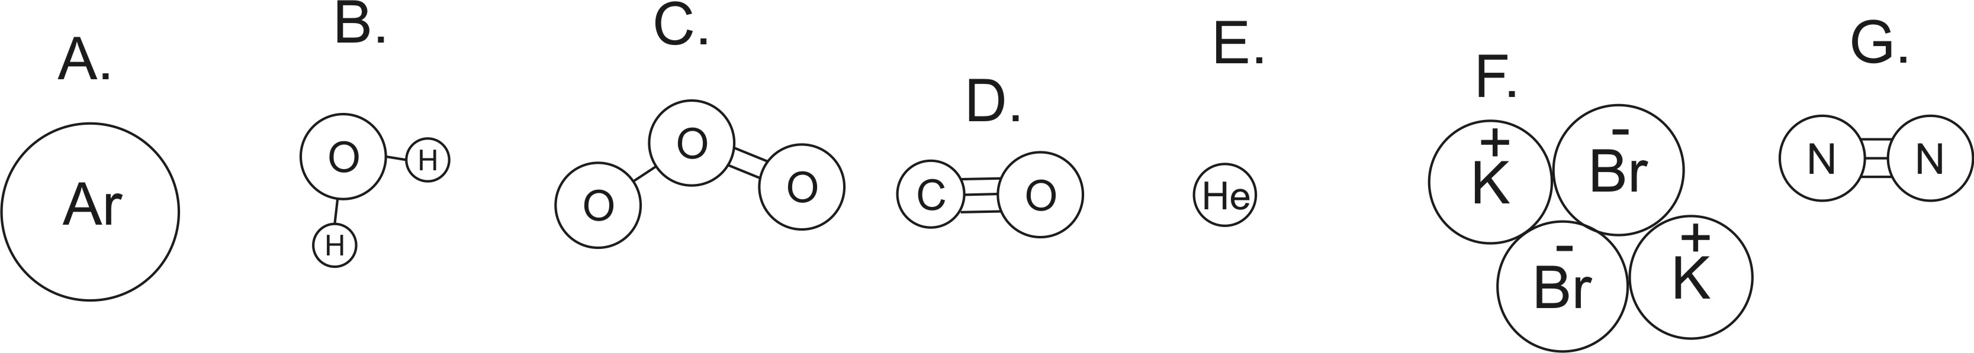

15. How many atoms are shown in the diagrams above?

16. How many elements are shown in the diagrams above?

17. How many ions are shown in the diagrams above?

18. Which lettered items are compounds?

19. Which lettered items are molecules?

For #20-35, fill in the blanks.

20. ________________ : Energy of motion.

21. ___________________ A measure of the average kinetic energy of the particles (atoms and/or molecules) in a substance. This is higher when the particles are faster.

22. ____________________ The total of all of the kinetic energies of the particles (atoms and/or molecules) in a substance.

23. _________________ This is the state of matter in which molecules (or individual atoms) are touching one another, but they are sliding, bumping, moving around and changing positions.

24. _________________ This is the state of matter in which molecules (or individual atoms) are flying free, but they occasionally bump into one another.

25. _________________ This is the state of matter in which molecules (or individual atoms) are locked in place, touching one another, and vibrating.

26. _________________ Heat transfer by touch

27. _________________ Heat transfer by electromagnetic waves

28. _________________ Heat transfer by warm currents flowing from one place to another

29. _________________ The process of turning from a gas to a liquid

30. _________________ The process of turning from a solid to a liquid

31. _________________ The process of turning from a liquid to a gas

32. _________________ The process of turning from a liquid to a solid

33. _________________ This is the temperature at which all molecular motion stops.

34. _________________ This is any transfer of thermal energy from a warmer object to a colder object

35. _________________ This describes a molecule that has a positive end and a negative end.

36. An iceberg has more thermal energy than a hot cup of coffee. Explain why.

37. Draw one water molecule. Label the atoms. Show and explain why water is called a polar molecule.

38. Draw 6 water molecules as they arrange themselves in their solid form. Use your diagram to explain why ice is less dense than liquid water.

39. Humans sweat in order to stay cool. Explain how sweating keeps us cool.

40. Explain why air expands when you heat it up.

41. The chemical formula for table salt is Na⁺Cl⁻. Draw some table salt ions and some water molecules, and show how the salt ions attach themselves to water molecules.

42. What causes the air pressure we experience every day?

43. What is the approximate strength of the air pressure in this room? ______________

44. Where is air pressure stronger, at higher altitudes or at lower altitudes? Explain why.

45. Explain why your ears hurt when you rise quickly to a higher altitude.

46. When you squeeze a sealed plastic bottle containing smoke, air, and a little bit of water…

a. What happens to the temperature of the air in the bottle?

b. Does water in the bottle condense or evaporate? Explain why.

c. Is the air in the bottle clear when you squeeze, or is it cloudy?

47. When you make a cloud in a bottle, why is it necessary to add smoke?

48. A blob of air rises up into the sky.

a. What happens to the volume of the air as it rises?

b. Explain why the volume of the air changes in this way.

c. If there is water in the rising air, is that water more likely to evaporate or condense as the balloon rises?

d. Provide a reason for your answer to part c.

e. Is this air in the balloon more likely to become clearer or cloudier?

49. When air sinks down from high in the sky, that air becomes clear, rather than cloudy. Explain why.

.

