ESS 200 (Stapleton)
2nd Semester Exam Review Answers

- Weight: the force of gravity pulling an object toward a planet
- Volume: the size of something
- Mass: the amount of stuff in an object
- Density: the crowdedness of the stuff inside an object; a measure of how well something will sink
- D
- E
- A
- D
- E (most density)
- 7
- 5. Br, Cl, O, C, and Na
- An element is a type of atom. In the picture, there are 7 atoms in all, but there are only 5 different types of atom.
- 4. An ion is an object with a charge (+ or – sign). There are 4 atoms with charges in the picture. 2 are positive, and 2 are negative.
- 3.
- A compound is two or more types of atoms (elements) connected together. O-O would not be a compound, because the two atoms (both O) are the same type.
- 1
- A molecule is atoms connected with lines (covalent bonds).
- N
- D
- K
- I
- M
- B
- C
- P
- E
- G
- A. Even though the lake molecules have lower average energies, there are many more of them, so their total energy is greater.
- D
- A. The positive hydrogens are attracted to the negative oxygens.
- C. Same as number 30, except that, when water freezes, its molecules arrange themselves into hexagonal rings. That is why ice is less dense; it takes up more space.
- A
- D
- B
- D Actually, it’s 14.7
- D
- B
- D
- C

- a. Volume increases
b. As the air rises, it moves into an area of lower pressure, so it expands.
c. Condense
d. As air rises it expands. Expansion causes air to cool off. Cooling water vapor cause it to condense.
e. When water condenses, it becomes visible, and a cloud forms
- 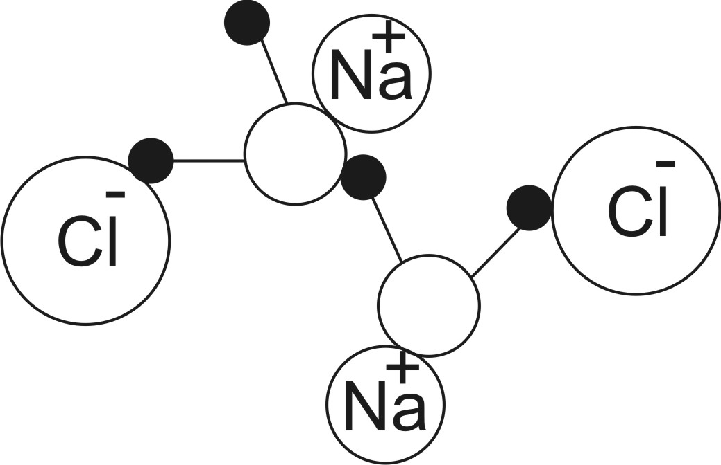 Positive Na touches a negative Oxygen of a water molecule. Negative Cl touches a positive Hydrogen of a water molecule.
- M
- O
- H
- D
- U
- G
- I
- R
- L
- N
- C
- A
- D
- B
- B
- D
- B
- A
- C
- B. Water vapor has the greatest impact, but our best hope for reducing the Greenhouse effect lies in reducing CO2.
- E

