ESS 100 (Stapleton) Name: _______________________________
Pressure Practice Questions

1. Right now, we are experiencing air pressure. It is pressing against every inch of our skin. Where is that air pressure coming from? What’s causing it?

2. a. Where in our world is air pressure strongest, at lower altitudes or at higher altitudes?

b. Why?

3. The average value of air pressure at sea level is approximately

_________psi.
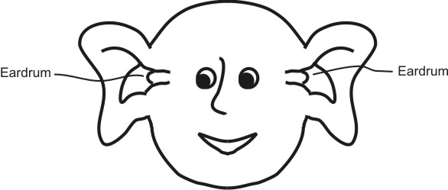
4. The person on the right is experiencing ear pain. According to the diagram, has the person just moved to a higher altitude or to a lower altitude? Explain how you know.

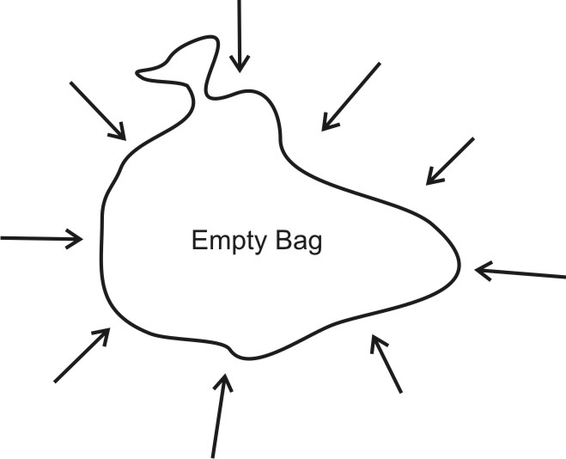

5. The picture on the right shows a trash bag full of air. If you consider all of the air pressure that is squeezing the outside of the bag, the total force is about 45,000 pounds! Show and explain why the bag is not being squeezed into a tiny lump.

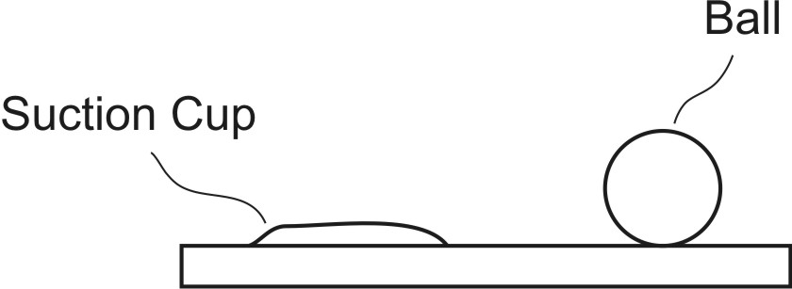
6. The diagram on the right shows a ball sitting on a table, and it also shows a suction cup that is stuck to the table. Explain why suction cups stick to tables and why balls don’t. Explain by using words and by drawing on the diagram.

7. Suppose you want to lift your friends by having them sit on a bag that you are going to inflate with a shop vac.

a. If you are using the same shop vac with the same amount of pressure, will you produce more lifting force with a big bag or a little bag?

b. Explain why.

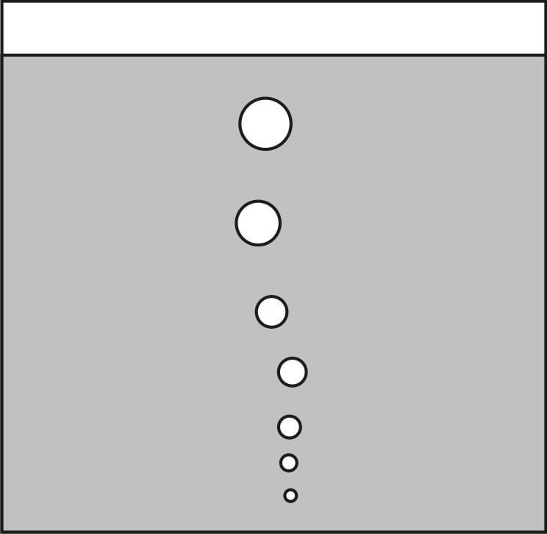
8. The diagram on the right shows a tank full of water. Bubbles are rising in the tank.

a. Show and/or explain why bubbles and all other less dense objects rise in a denser liquid.

b. Why do the bubbles get larger as they rise?

