ESS 100 Name: _______________________________
Structure of Matter – Vocabulary Practice

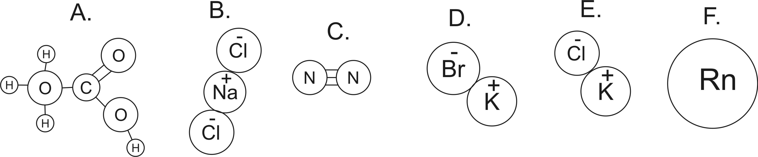
C

1. How many atoms are shown in the diagrams above?

2. How many elements are shown in the diagrams above?

3. How many ions are shown in the diagrams above?

4. Which lettered items are molecules?

5. How do you know that those are molecules? What makes them molecules?

6. Which lettered items are compounds?

7. How do you know that those are compounds? What makes them compounds?

8. Which items are neither molecules nor compounds?

9. Which (if any) of the substances are in the top three most common particles found in “air?” (darken all that apply)

10. Write the molecular formula for substance A, above.

