EPS 200 (Stapleton) Name: __________________________
Plate Tectonics Test Part 1, V4

1. On the diagram below, label each Earth layer, and describe its composition.

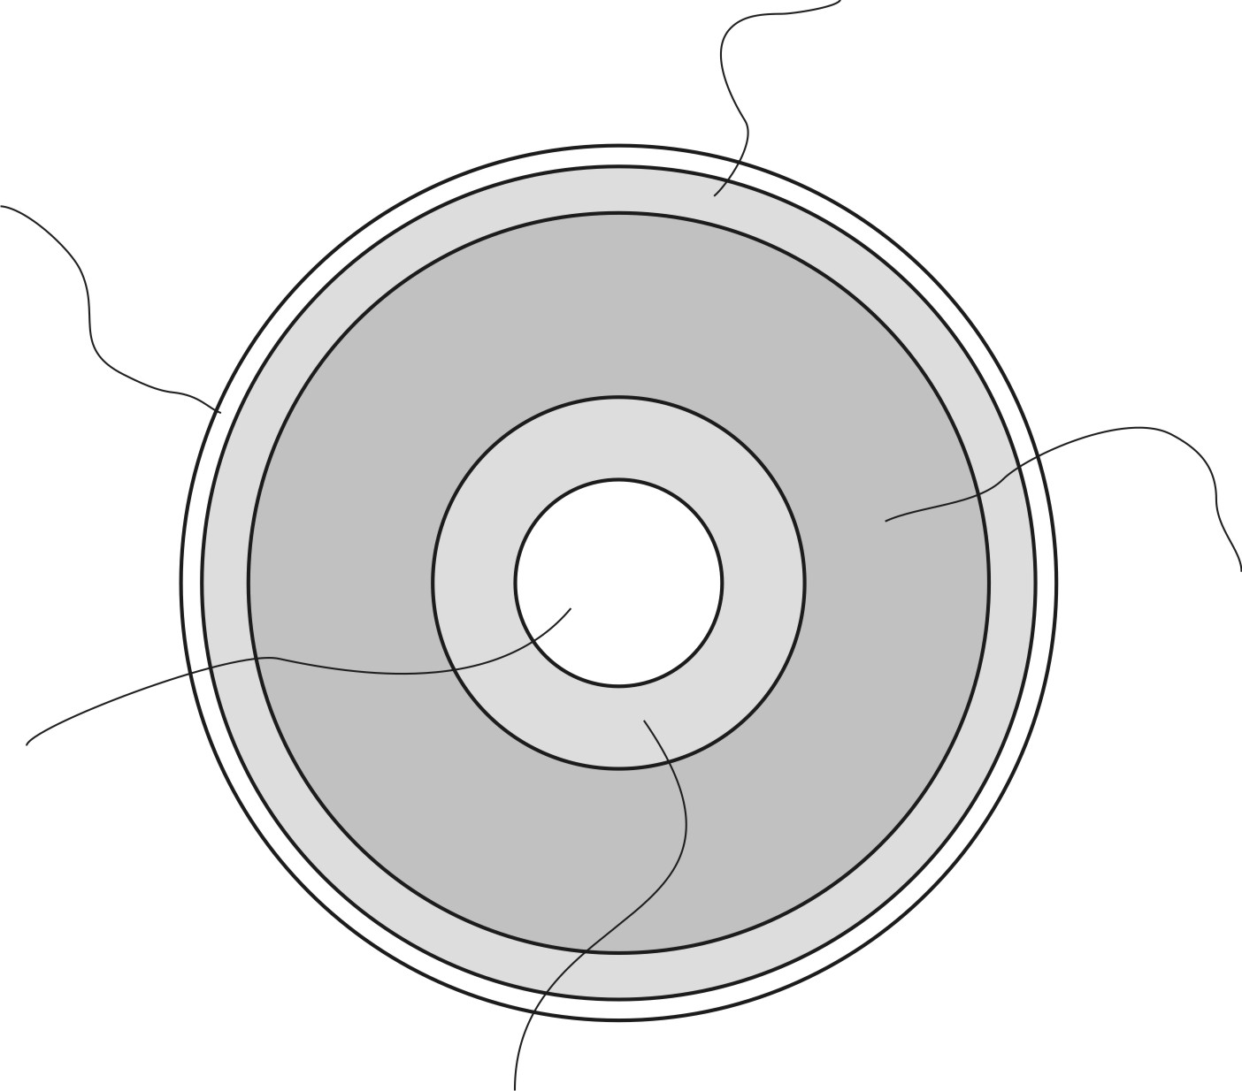

2. Why is the inside of the Earth hot? Provide three reasons.

3. On the diagram below, use arrows show the circulation of the Earth’s upper mantle and the movement of crustal plates. Then correctly label each type of plate boundary (convergent, divergent, or transform).

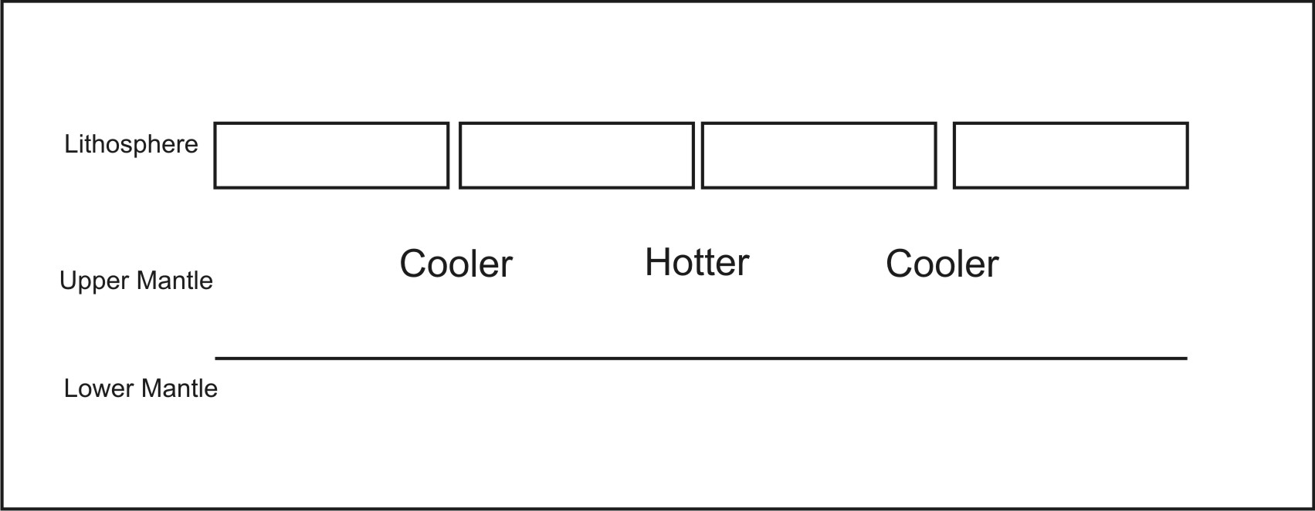

PLEASE DARKEN THE CORRECT ANSWER CHOICES.
Match each description to the appropriate rock type. Choices: A= Mafic B = Felsic

4. A B The primary constituent of ocean crust
5. A B When piled up, tends to form steep volcanoes
6. A B Relatively light in color/shade
7. A B An example of this rock type is called basalt.
8. A B Seafloor sediment is primarily composed of this type of material.
9. A B The most explosive eruptions involve this type of material.
10. A B Low viscosity when molten
11. A B Contains relatively high amounts of iron
12. A B Contains relatively high amounts of silica

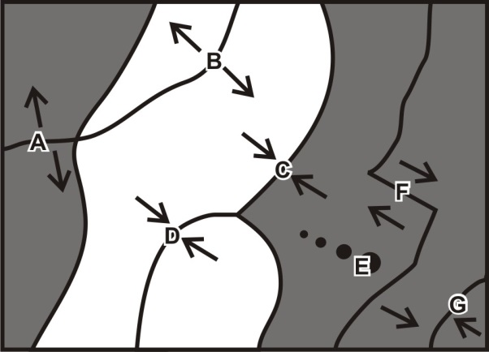
Match each feature name to the corresponding feature on the plate map on the right.

13. A B C D E F G Transform Boundary
14. A B C D E F G Hotspot
15. A B C D E F G Continent/Continent Convergent
16. A B C D E F G Continent/Continent Divergent
17. A B C D E F G Ocean/Continent Convergent
18. A B C D E F G Ocean/Ocean Convergent
19. A B C D E F G Ocean/Ocean Divergent

Each of the real-world locations below forms in an area that is similar to one of the lettered locations on the map. Match each real-world location to its corresponding map location.

20. A B C D E F G Mid-Atlantic Ridge
21. A B C D E F G Himalayas (Mt. Everest)
22. A B C D E F G Japan
23. A B C D E F G Andes Mountains (South America)
24. A B C D E F G East Africa
25. A B C D E F G Hawaii
26. A B C D E F G San Andreas Fault, California

For each lettered feature on the map above, darken all of the descriptions below that apply. [Suggestion: start with letter A. Darken that letter for all of the descriptions that apply to location A on the map. Continue the process one map feature at a time.]

27. A B C D E F G Some mafic magma may reach the surface.
28. A B C D E F G Some felsic magma may reach the surface.
29. A B C D E F G Steep, composite cone volcanoes
30. A B C D E F G Rounded, shield volcanoes
31. A B C D E F G Relatively violent eruptions can occur.
32. A B C D E F G Relatively gentle eruptions can occur.
33. A B C D E F G Ocean trench
34. A B C D E F G Deep-focus earthquakes
35. A B C D E F G Shallow-focus earthquakes
36. A B C D E F G Tall mountains that are not volcanoes
37. A B C D E F G New ocean crust is being created here.
38. A B C D E F G Situated over a relatively cool part of the mantle
39. A B C D E F G A line of volcanoes of diminishing size

