EPS 200 (Stapleton) Name: _______________________________________
2015-2016 Final Exam Review (most of it)

Matching Choices: Density, Mass, Weight, Volume

1. ________________ The amount of stuff in an object.

2. ________ ________ The size of an object.

3. ______ __________ The force of gravity pulling on an object. [The weight of an object depends on its mass and the strength of the surrounding gravity. If there is no nearby planet, then there is little or no gravity, so the object has little or no weight.]

4. _______ _________ A ratio of an object’s mass to its density; a measure of the crowdedness of the particles in an object; how compressed the mass in an object is; an indicator of whether an object will sink or float in a given fluid (less dense objects sink; more dense objects float).

The objects below are mostly empty space. The circle is the edge of each object. The dots inside represent all of each object’s mass. The empty space inside the objects has no air or mass of any kind.

5. Which object has the most weight? 6. Which object has the least weight?
7. Which object has the most volume? 8. Which object has the least volume?
9. Which object is most dense? 10. Which object is least dense?
11. Which object has the most mass? 12. Which object has the least mass?
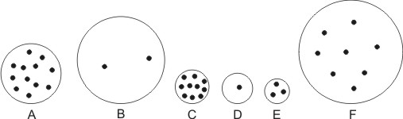

13. What causes the air pressure around us?

14. What is the average value of air pressure at sea level?

15. a. In which direction do your ear drums stretch when you go to a higher elevation?

b. Why?

16. What causes the force of buoyancy?

17. What is the density of water?

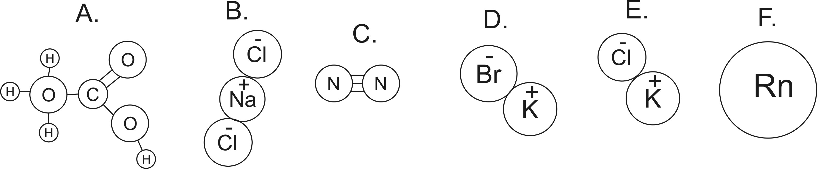
18. How many atoms are shown in the diagrams above?
19. How many elements are shown in the diagrams above
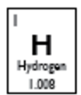
20. Which lettered items are molecules?
21. Which lettered items are compounds?
22. How many protons does a fluorine atom have?
23. How many neutrons does an average fluorine atom have?
24. How many electrons does an S⁻² ion have?

25. What are the three most common substances in air, by mass?
#1: __________________ (78%) N₂
#2: ___________________ (21%) O₂
#3: ____________________ (0.93%) Ar

26-37. Matching Choices: Dewpoint Temperature Kinetic Energy Thermal Energy
Convection Conduction Radiation Heat Latent Heat of Fusion Latent Heat of Vaporization
Relative Humidity Absolute Zero

26. ________________________ Heat transfer by touch
27. ________________________ Heat transfer by movement of fluid (gas or liquid)
28. ________________________ Heat transfer by electromagnetic waves (e.g. light, infrared, radio waves, x-rays…)
29. ________________________ Energy of motion. Calculated using KE = ½ mv²
30. ________________________ The average kinetic energy of the particles in a substance.
31. ________________________ The total kinetic energy of the particles in a substance.
32. ________________________ The transfer of thermal energy.
33. ________________________ Heat that causes the melting or freezing of a substance (but does not change its temperature). A substance melts when it gains heat of fusion and it freezes when it loses heat of fusion.
34. ________________________ Heat that causes the evaporation or condensation of a substance (but does not change its temperature). A substance evaporates when it gains heat of vaporization, and it condenses when it loses heat of vaporization.
35. ________________________ The temperature at which there is zero thermal energy; the coldest possible temperature.
36. ________________________ A ratio comparing the amount of water vapor in the air to the air’s water vapor capacity; a measure of the fullness of air, with respect to its water vapor content.
37. ________________________ The temperature to which a given parcel of air must be cooled in order for that air to reach 100% relative humidity.

38. Match the following descriptions of particles with their phase. Choices: Solid, Liquid, Gas

___________ Stuck in position, touching one another, vibrating (lowest energy)

___________ Flying free, but occasionally bumping into one another (highest energy)

___________ Touching one another, but able to move around (medium energy)

39. Suppose you have a sealed container full of air. Why does the air pressure in the container increase when you heat the container?

40. a. Which type of air can hold more water vapor, warm air or cold air?
b. Why?

41. Explain, in detail, why rising air produces precipitation. Tell what happens to pressure, volume, temperature, and relative humidity, and also describe any changes of state (phase) that occur.

42. Separate these words into two groups that go together…
Dry, Wet, Low Pressure, High Pressure, Sinking Air, Rising Air
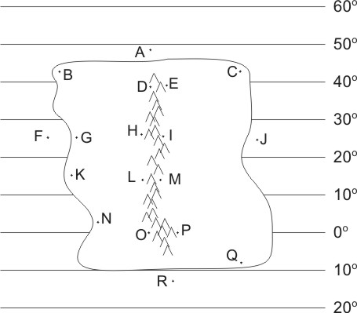

The descriptions below apply to locations on the climate map to the right. Identify all of the dotted map locations that meet each of the descriptions below.

43. In a high pressure belt
44. In a low pressure belt
45. In a major rainforest (not caused by a rain shadow or coastal breezes)
46. In a major desert (not caused by rain shadow)
47. Relatively warm ocean water
48. Wet due to breezes from the ocean
49. Wet due to rain shadow effect
50. Dry due to rain shadow effect

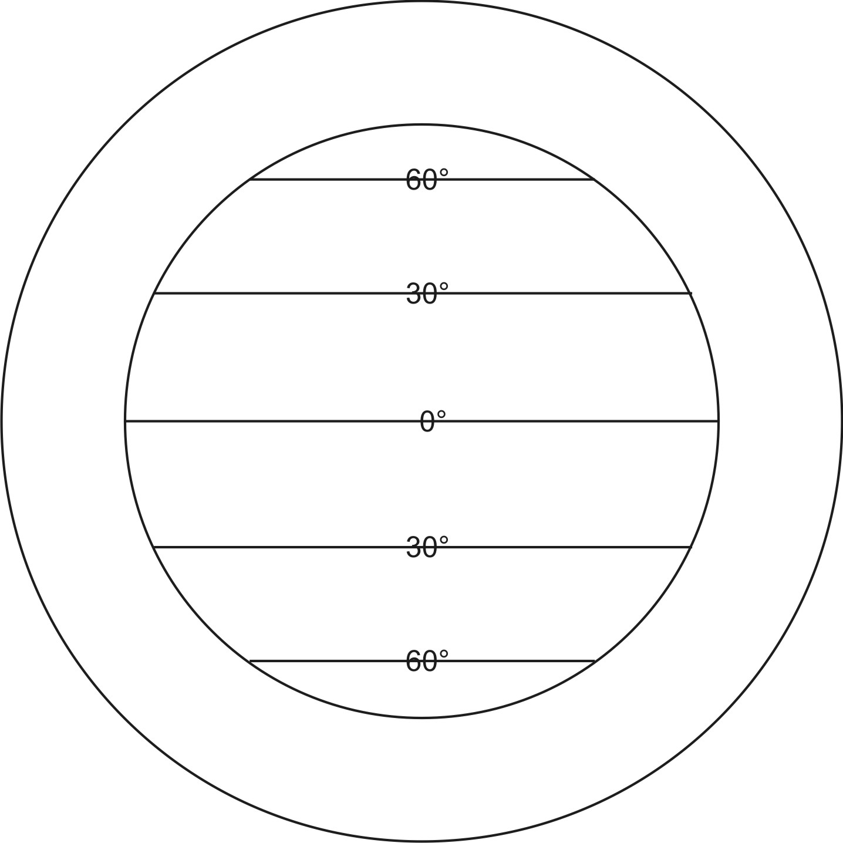
51. On the diagram to the right, sketch the pattern of air circulation in the Earth’s atmosphere. [This question is not asking you to draw the prevailing winds.]

52. Where are the Earth’s major deserts? Why are they in those locations?

53. Where are the Earth’s major rainforests? Why are they in those locations?

54. Identify each of these characteristics as generally belonging to mafic or felsic rocks or magma.
a. more dense b. more viscous (gooey) magma
c. produces gentler volcanic eruptions d. lighter in color/shade
e. found in continental crust f. found in the mantle

Match these layers of the Earth’s interior to the descriptions below:
a. outer core b. mantle c. crust d. inner core

55. mostly solid rock 55.5 solid iron
56. hot, “flowing” rock 56.5. liquid iron

57. Which of the following is not a major source of the heat inside our Earth?
- Friction during Earth’s formation (collisions and heavy elements sinking to the core).
- Radiation from radioactive elements inside the earth
- High pressure/compression
- The movement of plates
58. What type of heat transfer is responsible for the movement of material in the Earth’s mantle and atmosphere? (conduction, convection, or radiation)

Match each feature name to the corresponding feature on the plate map on the right. Mafic and felsic materials are indicated by shade (light/dark)

59. Ocean/Ocean Convergent Plate Boundary
60. Ocean/Continent Convergent Plate Boundary
61. Continent/Continent Convergent Plate Boundary
62. Ocean/Ocean Divergent Plate Boundary
63. Continent/Continent Divergent Plate Boundary
64. Transform Boundary
65. Hotspot

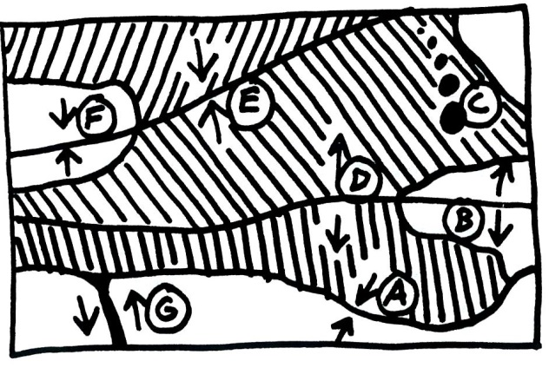
Each of the real-world locations below forms in an area that is similar to one of the lettered locations on the map. Match each real-world location to its corresponding map location.

66. Himalayas (Mt. Everest).
67. San Andreas Fault, California
68. Mid-Atlantic Ridge
69. Andes Mountains (South America)
70. East Africa
71. Japan
72. Hawaii

73. For each lettered feature on the plate boundary map (previous page), find the column of Xs that represents the characteristics of that feature. Then write the feature letter in the box at the top of that column. Some columns will be used more than once, because some plate features have the same characteristics.
 | Letters of Features Matching These sets of Characteristics↓
Characteristics ↓
Situated over a relatively cool part of the mantle | X | X
Some felsic magma may reach the surface. | X
Some mafic magma may reach the surface. | X |  | X |  | X
Steep volcanoes | X
large, rounded, gently sloping volcanoes |  |  |  |  | X
Relatively gentle eruptions can occur. | X |  | X |  | X
Relatively violent eruptions can occur. | X
New ocean crust is being created. |  |  | X
Deep-focus earthquakes | X
Shallow-focus earthquakes | X | X | X | X | X
Tall mountains, but no volcanoes |  | X

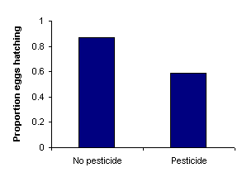
74. Frederick conducted a study that generated the data in the table on the right. Guess Frederick’s question. Write the question as you would write it at the beginning of a scientific study.

75. Identify the independent and dependent variables in your question.

76. Based on the question you just proposed, create a hypothesis section for a lab report. Make sure that your hypothesis lab report section satisfies the two major expectations that were set forth earlier in this class.

77. Describe one important variable that Frederick should have controlled in his study.

78. Write a brief but satisfactory conclusion to correspond with the question and hypothesis you have already written. Back up your conclusion with numerical evidence.

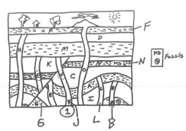
79. What p-value would Frederick need to find in order to demonstrate that his results are scientifically significant?
80. In the diagram on the right, which lettered sample is barely younger than the earthquake fault?
81. Which sample is barely younger than L?
82. Suppose sample N contains a radioactive element with a half-life of 5 million years. The sample contains 15 parent atoms and 35 daughter atoms.
- Add a curve to the graph below showing how the percentage of parent atoms changes over time (for this particular half-life).
- What percentage of the atoms in this sample are parent atoms? How old is the rock sample?
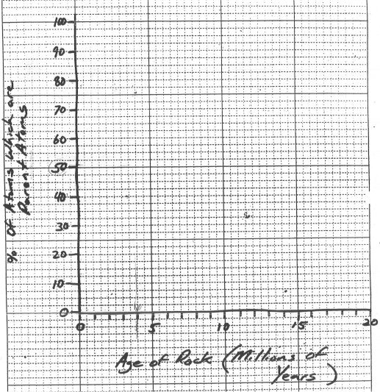
83. What was the name of the cloud of dust and frozen gases that eventually transformed into our present solar system?
84. What was the “dust” made of? What elements comprised the “frozen gases?”
85. Why do planets stay in stable orbits? Specifically…
a. What keeps them from flying away from the sun?
b. What keeps planets from falling into the sun?
86. In our solar system, why did some planets form as gas giants while others formed as terrestrial planets?
87. Explain how our sun produces energy…
- What is the “fuel?”
- What material is produced during the reaction?
- How does this reaction produce energy?
90. Right now, our sun is a “main sequence” star. What do all main sequence stars have in common?
91. After it leaves the main sequence, our sun will become a _________________.
92. After that stage, our sun will become a _________________.
93. Provide three pieces of evidence for the Big Bang.

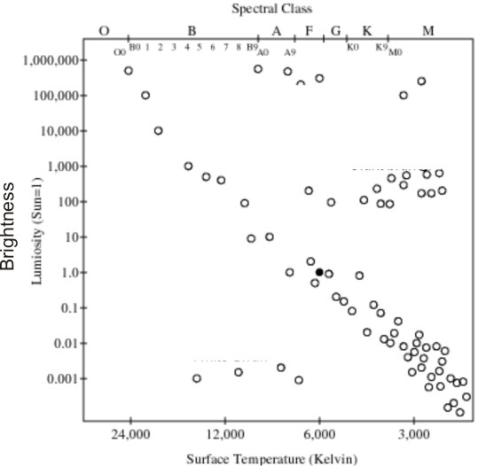
94. A _________________ is a device that we use to separate starlight into different wavelengths.
95. The diagram on the right is called a(n) ________________________________ diagram.
96. On the diagram, label…
- The main sequence
- Red supergiants
- White dwarves
- Red Giants
- Our sun
- A blue star
97. Using the Doppler Effect, how can scientists tell that our universe is expanding?

98. Where did the universe’s hydrogen and helium come from?

99. Where did elements heavier than helium but no heavier than iron come from?

100. Where did all elements heavier than iron come from?

