EPS 200 (Stapleton) Name: _______________________________________
2015-2016 Final Exam Review (most of it) -- answers

Matching Choices: Density, Mass, Weight, Volume

1. ________Mass________ The amount of stuff in an object.

2. ________Volume________ The size of an object.

3. ______Weight__________ The force of gravity pulling on an object. [The weight of an object depends on its mass and the strength of the surrounding gravity. If there is no nearby planet, then there is little or no gravity, so the object has little or no weight.]

4. _______Density_________ A ratio of an object’s mass to its density; a measure of the crowdedness of the particles in an object; how compressed the mass in an object is; an indicator of whether an object will sink or float in a given fluid (less dense objects sink; more dense objects float).

The objects below are mostly empty space. The circle is the edge of each object. The dots inside represent all of each object’s mass. The empty space inside the objects has no air or mass of any kind.

5. Which object has the most weight? A 6. Which object has the least weight? D
7. Which object has the most volume? F 8. Which object has the least volume? E
9. Which object is most dense? C 10. Which object is least dense? B
11. Which object has the most mass? A 12. Which object has the least mass? D
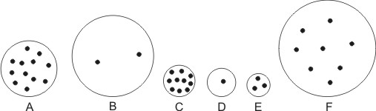

13. What causes the air pressure around us? The weight of the air that is stacked on top of us

14. What is the average value of air pressure at sea level? 14.7psi

15. a. In which direction do your ear drums stretch when you go to a higher elevation? outward

b. Why? As you ascend, the air pressure around you decreases. This means the air pressure inside your ears becomes stronger than the air pressure outside your ears.

16. What causes the force of buoyancy? The force created by the difference in the weaker pressure pushing down on the top of an object and the stronger pressure pushing up from below. Objects move from high pressure to low pressure, so buoyancy always pushes objects upward, from higher pressure areas at low elevations to lower pressures at high elevations. [All objects in air or water have buoyancy, but an object will only float if its force of buoyancy is stronger than its weight.]

17. What is the density of water? 1g/ml

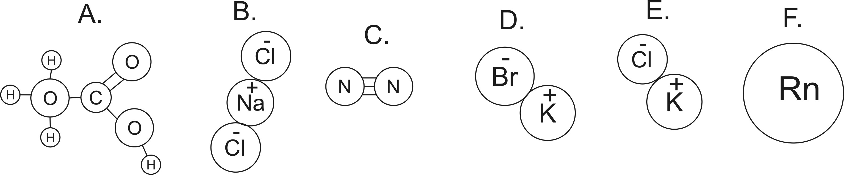
18. How many atoms are shown in the diagrams above? 18
19. How many elements are shown in the diagrams above? 9
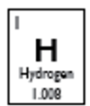
20. Which lettered items are molecules? A, C
21. Which lettered items are compounds? A, B, D, E
22. How many protons does a fluorine atom have? 9
23. How many neutrons does an average fluorine atom have? 10
24. How many electrons does an S⁻² ion have? 18

25. What are the three most common substances in air, by mass?
#1: __________________ (78%) N₂
#2: ___________________ (21%) O₂
#3: ____________________ (0.93%) Ar

26-37. Matching Choices: Dewpoint Temperature Kinetic Energy Thermal Energy
Convection Conduction Radiation Heat Latent Heat of Fusion Latent Heat of Vaporization
Relative Humidity Absolute Zero

26. Conduction Heat transfer by touch
27. Convection Heat transfer by movement of fluid (gas or liquid)
28. Radiation Heat transfer by electromagnetic waves (e.g. light, infrared, radio waves, x-rays…)
29. Kinetic Energy Energy of motion. Calculated using KE = ½ mv²
30. Temperature The average kinetic energy of the particles in a substance.
31. Thermal Energy The total kinetic energy of the particles in a substance.
32. Heat The transfer of thermal energy.
33. Heat of Fusion Heat that causes the melting or freezing of a substance (but does not change its temperature). A substance melts when it gains heat of fusion and it freezes when it loses heat of fusion.
34. Heat of Vaporization Heat that causes the evaporation or condensation of a substance (but does not change its temperature). A substance evaporates when it gains heat of vaporization, and it condenses when it loses heat of vaporization.
35. Absolute Zero The temperature at which there is zero thermal energy; the coldest possible temperature.
36. Relative Humidity A ratio comparing the amount of water vapor in the air to the air’s water vapor capacity; a measure of the fullness of air, with respect to its water vapor content.
37. Dew Point The temperature to which a given parcel of air must be cooled in order for that air to reach 100% relative humidity.

38. Match the following descriptions of particles with their phase. Choices: Solid, Liquid, Gas

Solid Stuck in position, touching one another, vibrating (lowest energy)

Gas Flying free, but occasionally bumping into one another (highest energy)

Liquid Touching one another, but able to move around (medium energy)

39. Suppose you have a sealed container full of air. Why does the air pressure in the container increase when you heat the container? When you heat up the container, the air molecules fly faster. This causes them to push against the walls of the container with more force.

40. a. Which type of air can hold more water vapor, warm air or cold air? Warm air.
b. Why? Warm air has more energy than cold air, so it can evaporate more water.

41. Explain, in detail, why rising air produces precipitation. Tell what happens to pressure, volume, temperature, and relative humidity, and also describe any changes of state (phase) that occur.
- When air rises, it encounters lower air pressure.
- The decrease in pressure allows rising air to expand.
- Expansion causes the temperature of rising air to decrease.
- As rising air cools off, its water vapor capacity decreases, so it becomes more full of water vapor, and its relative humidity increases.
- As air continues to rise and cool off, it eventually reaches its dew point (100% relative humidity), and water vapor begins to condense into liquid droplets.

42. Separate these words into two groups that go together…
Dry, Wet, Low Pressure, High Pressure, Sinking Air, Rising Air
Dry, High Pressure, Sinking Air Wet, Low Pressure, Rising Air

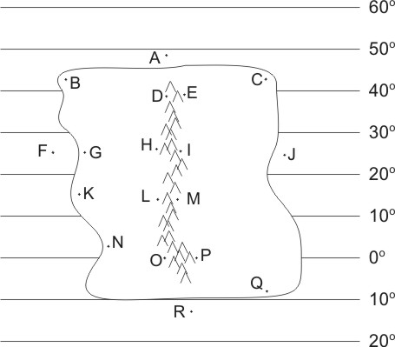
The descriptions below apply to locations on the climate map to the right. Identify all of the dotted map locations that meet each of the descriptions below.

43. In a high pressure belt F, G, H, I, J
44. In a low pressure belt N, O, P
45. In a major rainforest (not caused by a rain shadow or coastal breezes) O, P for sure (and possibly N and Q)
46. In a major desert (not caused by rain shadow) G, H, I
47. Relatively warm ocean water J, R
48. Wet due to breezes from the ocean Q, B
49. Wet due to rain shadow effect D, M
50. Dry due to rain shadow effect L, E
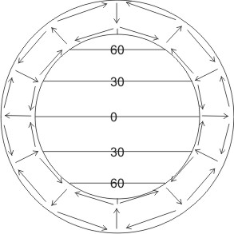

51. On the diagram to the right, sketch the pattern of air circulation in the Earth’s atmosphere. [This question is not asking you to draw the prevailing winds.]

52. Where are the Earth’s major deserts? Why are they in those locations?
The Earth’s major deserts are found in the Horse Latitudes, from 20-30 degrees latitude. This is a region of sinking air (see diagram with #81), and sinking air is dry.

53. Where are the Earth’s major rainforests? Why are they in those locations?
The Earth’s major rainforests are found at the equator. The air at the equator rises because it is hot. Rising air produces clouds.

54. Identify each of these characteristics as generally belonging to mafic or felsic rocks or magma.
a. more dense mafic b. more viscous magma felsic
c. produces gentler volcanic eruptions mafic d. lighter in color/shade felsic
e. found in continental crust felsic f. found in the mantle mafic

Match these layers of the Earth’s interior to the descriptions below:
a. outer core b. mantle c. crust d. inner core

55. mostly solid rock crust 55.5. solid iron inner core
56. hot, “flowing” rock mantle 56.5. liquid iron outer core

57. Which of the following is not a major source of the heat inside our Earth?
- Friction during Earth’s formation (collisions and heavy elements sinking to the core).
- Radiation from radioactive elements inside the earth
- High pressure/compression
- The movement of plates
58. What type of heat transfer is responsible for the movement of material in the Earth’s mantle and atmosphere? (conduction, convection, or radiation)
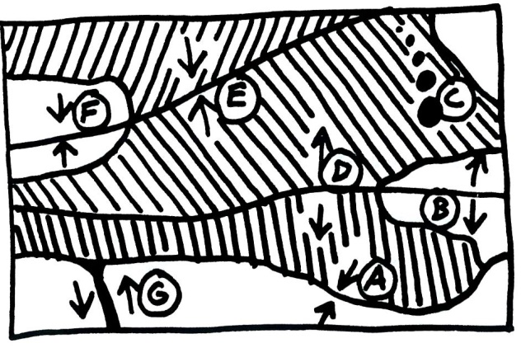
Match each feature name to the corresponding feature on the plate map on the right. Mafic and felsic materials are indicated by shade (light/dark)

59. Ocean/Ocean Convergent Plate Boundary E
60. Ocean/Continent Convergent Plate Boundary A
61. Continent/Continent Convergent Plate Boundary F
62. Ocean/Ocean Divergent Plate Boundary D
63. Continent/Continent Divergent Plate Boundary B
64. Transform Boundary G
65. Hotspot C

Each of the real-world locations below forms in an area that is similar to one of the lettered locations on the map. Match each real-world location to its corresponding map location.

66. Himalayas (Mt. Everest). F
67. San Andreas Fault, California G
68. Mid-Atlantic Ridge D
69. Andes Mountains (South America) A
70. East Africa B
71. Japan E
72. Hawaii C
73. For each lettered feature on the plate boundary map, find the column of Xs that represents the characteristics of that feature. Then write the feature letter in the box at the top of that column. Some columns will be used more than once, because some plate features have the same characteristics.

 | Letters of Features Matching These sets of Characteristics↓
Characteristics ↓ | A, E | F | D, B | G | C
Situated over a relatively cool part of the mantle | X | X
Some felsic magma may reach the surface. | X |  |  |  | maybe a tiny bit
Some mafic magma may reach the surface. | X |  | X |  | X
Steep volcanoes | X
large, rounded, gently sloping volcanoes |  |  |  |  | X
Relatively gentle eruptions can occur. | X |  | X |  | X
Relatively violent eruptions can occur. | X
New ocean crust is being created. |  |  | X
Deep-focus earthquakes | X
Shallow-focus earthquakes | X | X | X | X | X
Tall mountains, but no volcanoes |  | X

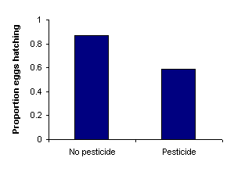
74. Frederick conducted a study that generated the data in the table on the right. Guess Frederick’s question. Write the question as you would write it at the beginning of a scientific study.

How do pesticides affect the hatch rates of eggs?

75. Identify the independent and dependent variables in your question.
Independent Variable: pesticide application (or not)
Dependent Variable : proportion of eggs hatching

76. Based on the question you just proposed, create a hypothesis section for a lab report. Make sure that your hypothesis lab report section satisfies the two major expectations that were set forth earlier in this class.

I believe that eggs exposed to pesticides will have a lower hatch rate. If pesticides kill bugs, they probably have negative effects on chicks as well. [A good hypothesis section includes an expected answer to the question and a sensible reason for choosing that hypothesis.]
77. Describe one important variable that Frederick should have controlled in his study. Frederick should have controlled the type of eggs. For example, he should have used chicken eggs for both the pesticide and non-pesticide group.
78. Write a brief but satisfactory conclusion to correspond with the question and hypothesis you have already written. Back up your conclusion with numerical evidence.

My hypothesis was supported. Pesticides reduce the proportion of eggs that hatch. Eggs that were not treated with pesticide had a nearly 90% hatch rate. Eggs treated with pesticide had only a 60% hatch rate. [A good conclusion should include at least two parts. It should… 1) provide an answer to the experimental question (with a statement concerning whether or not the hypothesis was supported, when appropriate), and 2) it provides numerical data to support the answer.]

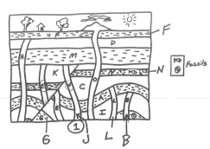
79. What p-value would Frederick need to find in order to demonstrate that his results are scientifically significant? 0.05
80. In the diagram on the right, which lettered sample is barely older than the earthquake fault? J
81. Which sample is barely younger than L? C
82. Suppose sample N contains a radioactive element with a half-life of 5 million years. The sample contains 15 parent atoms and 35 daughter atoms.
- Add a curve to the graph below showing how the percentage of parent atoms changes over time (for this particular half-life).
- What percentage of the atoms in this sample are parent atoms? 30% [50 atoms total; 15/50 = 0.3 = 30%.
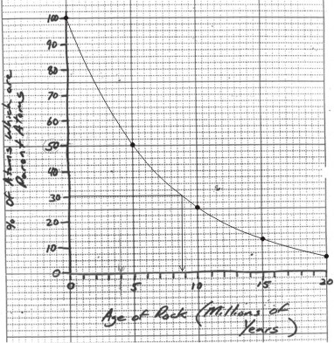
- How old is the rock sample? 8.7 million years

83. What was the name of the cloud of dust and frozen gases that eventually transformed into our present solar system? Nebula
84. What was the “dust” made of? Rock and metal What elements comprised the “frozen gases?” Hydrogen and Helium
86. What is the shape of our solar system, and why did it form that shape? It’s a disc. Rapid spinning caused it to spread out into a disc.
87. Why do planets stay in stable orbits? Specifically…
a. What keeps them from flying away from the sun? gravity
b. What keeps planets from falling into the sun? their momentum (or inertia)
88. In our solar system, why did some planets form as gas giants while others formed as terrestrial planets? During the solar system’s formation, the sun either “burned off” or “blew away” gases that were near it. The gas giants formed far away from the sun where the gases survived. The terrestrial planets formed near the sun, so there was little gas for them to accumulate.
89. Explain how our sun produces energy…
- What is the “fuel?” Hydrogen
- What material is produced during the reaction? Helium
- How does this reaction produce energy? When hydrogen fuses to form helium, the helium that is produced has less mass than the hydrogen that fused. Mass is “lost.” This “lost” mass is converted to energy.
90. Right now, our sun is a “main sequence” star. What do all main sequence stars have in common? They are all getting most of the energy by fusing hydrogen into helium.
91. After it leaves the main sequence, our sun will become a red giant.
92. After that stage, our sun will become a white dwarf.
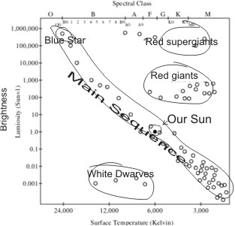
93. Provide three pieces of evidence for the Big Bang. 1) Almost all distant galaxies are moving away from us. We know this because of the Doppler Effect. 2) We can see (with special telescopes) energy that is left over from the big bang. This is called the “cosmic background radiation,” which is made up of microwaves. 3) The Big Bang theory predicted that the mass in the universe is approximately 73% H and 25% He. These percentages have since been confirmed.
94. A spectroscope is a device that we use to separate starlight into different wavelengths.
95. The diagram on the right is called a(n) Hertzsprung-Russel (or H-R) diagram.
96. On the diagram, label…
- The main sequence
- Red supergiants
- White dwarves
- Red Giants
- Our sun
- A blue star
97. Using the Doppler Effect, how can scientists tell that our universe is expanding? Almost all other galaxies have a red-shift. Their waves are stretched out, which means they are moving away from us.

98. Where did the universe’s hydrogen and helium come from? The Big Bang

99. Where did elements heavier than helium but no heavier than iron come from? Fusion in stars

100. Where did all elements heavier than iron come from? Supernovae

