EPS 200 Name: ___________________________________
Experimental Design
Practice Test

Consider this question: What’s the best way to get to school?

1. Focus and clarify the question. Rewrite the question so that it has very clear and testable independent and dependent variables.

Which is a faster mode of transportation for getting to school, riding a bus or traveling by car?

2. Briefly describe a logical way to test your question.

3. Identify your independent and dependent variables.

4. Describe a precise measurement device (or method) for measuring the dependent variable.

5. Explain how you know that this measuring device would be precise.

6. At the high school level, the hypothesis section of a lab report is typically expected to contain two pieces of information. Create a brief hypothesis lab report section for this question. Be sure to include both of those pieces of information.

7. Describe a good sample size for this study.

8. Describe three important variables that should be controlled in this experiment.

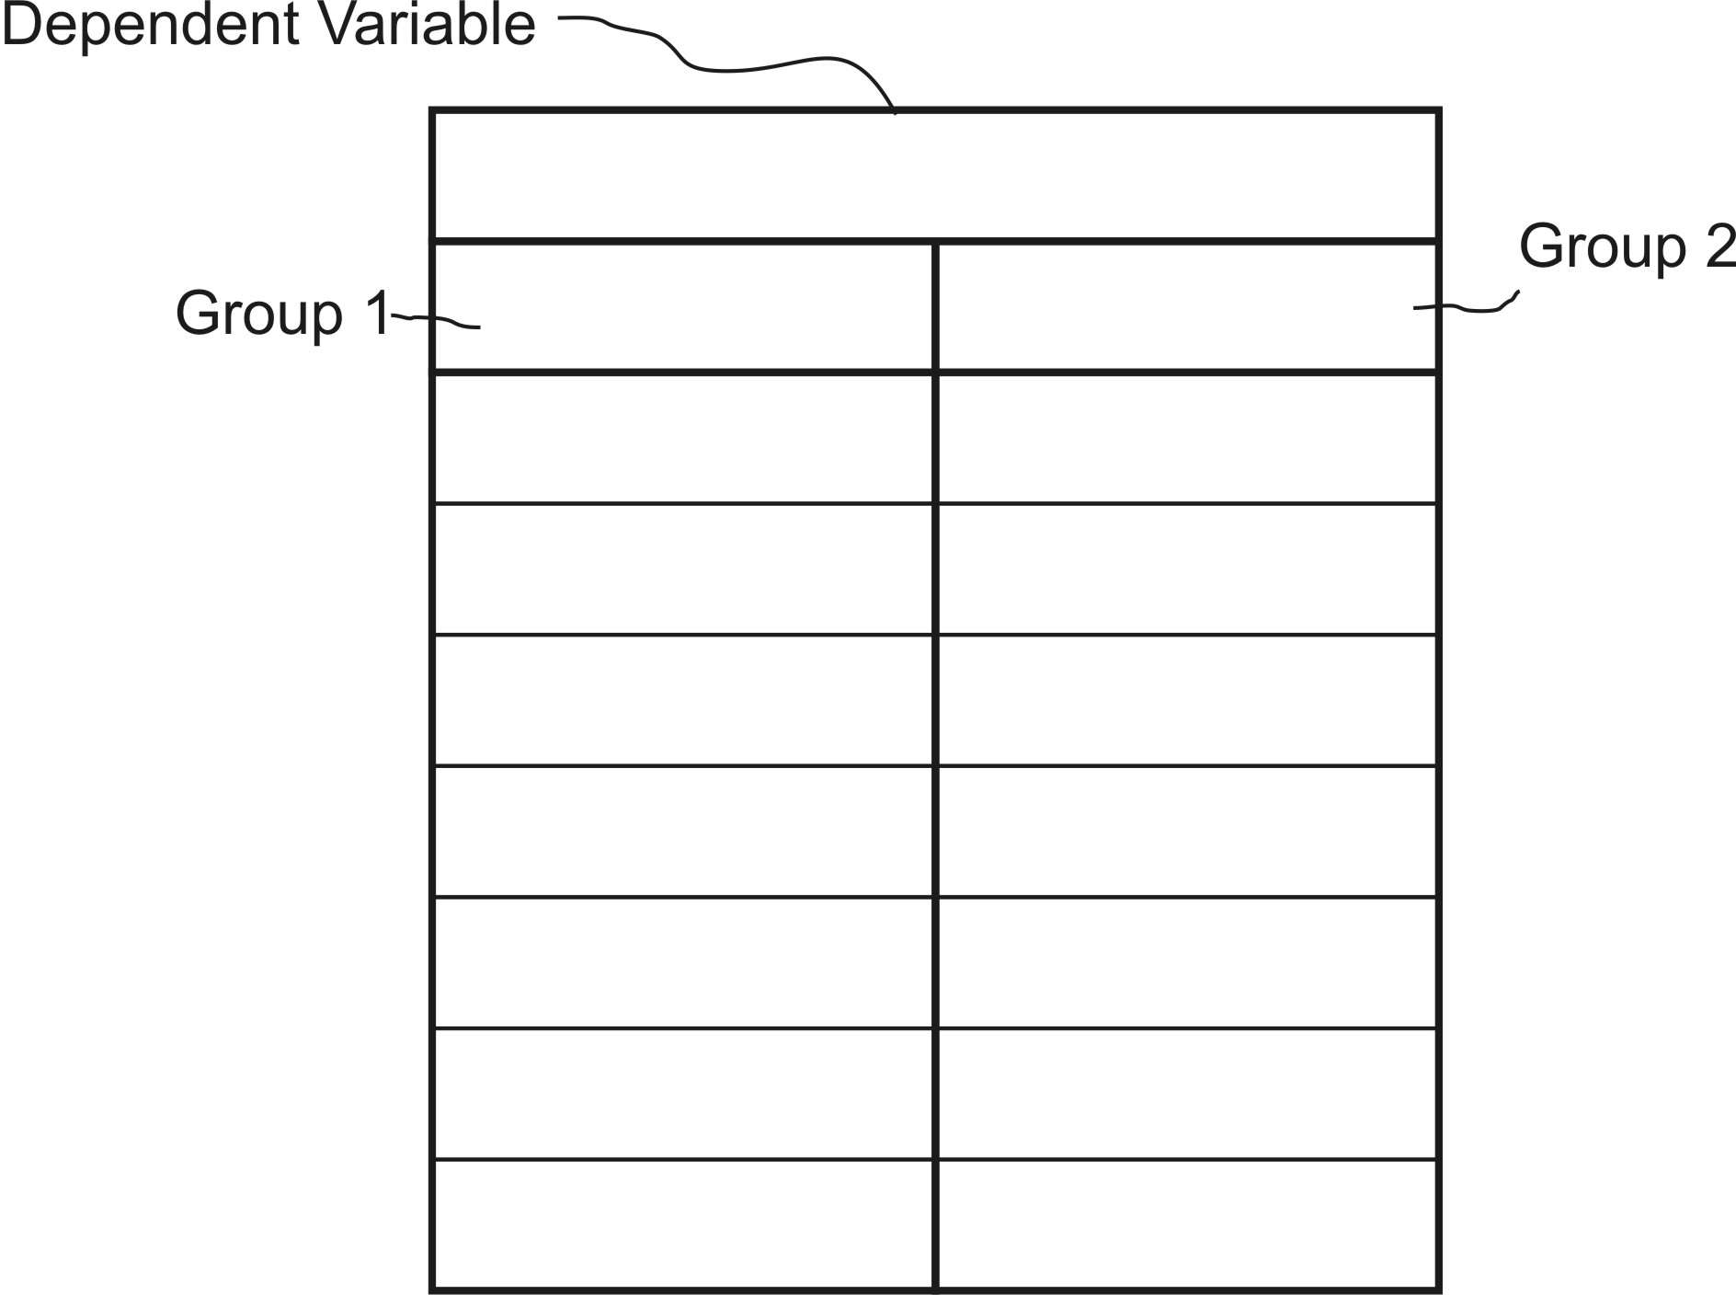
9. Create some fake data for your experiment and use those data to populate the data table on the right. Include appropriate units when applicable.

10. Write a null hypothesis for your experiment.

11. If your statistical test returns a p-value of 0.03, what does that tell you? Choose the best answer.
a. Your null hypothesis is likely, and your alternate hypothesis is unlikely.
b. Neither your hull hypothesis nor your alternative hypothesis is likely.
c. Your alternate hypothesis is likely, and your null hypothesis is unlikely.
d. Both your alternate hypothesis and your null hypothesis are likely.

12. What significance cutoff did we use in our scientific testing?

13. What does the p in p-value stand for?

14. Does the p-value apply directly to the alternate hypothesis, or does it apply to the null hypothesis?

