EPS 100 (Stapleton) Name: _______________________________________
2015-2016 Midterm Review

Matching: Volume, Mass, Density, Weight

1. _______________ is the amount of stuff in an object

2. _______________ describes the size of an object

3. _______________ is the force of gravity pulling on an object

4. _______________ is a ratio of an object’s mass to its volume; a measure of the crowdedness of the particles in an object

The objects below are mostly empty space. The circle is the edge of each object. The dots inside represent all of each object’s mass. The empty space inside the objects has no air or mass of any kind.

5. Which object has the most weight? 6. Which object has the least weight?
7. Which object has the most volume? 8. Which object has the least volume?
9. Which object is most dense? 10. Which object is least dense?
11. Which object has the most mass? 12. Which object has the least mass?
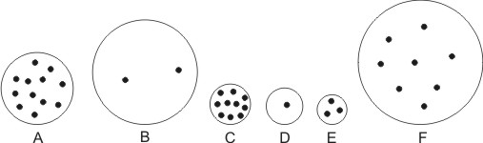

13. An object has been floating in water. The object does not gain or lose any matter, but it suddenly begins to sink. What has happened to these physical properties of the object to account for this change?
a. mass b. volume c. density d. weight

14. A squirrel gets heavier, but its size does not change. What has happened to the squirrel’s...
a. mass b. volume c. density d. weight

15. Someone blows up a latex balloon and then ties it so that no air can escape. Then the balloon is held near a flame, causing it to expand. While the balloon is expanding, what is happening to its...
a. mass b. volume c. density d. weight

16. A hot air balloon has been hovering in the sky. It does not change in size, but it suddenly begins to rise. What has happened to its…
a. mass b. volume c. density d. weight

17. What causes atmospheric air pressure?

18. What is the average value of air pressure at sea level?

19. a. In which direction do your ear drums stretch when you go to a higher elevation?

b. Why?

20. Why do suction cups “stick?”

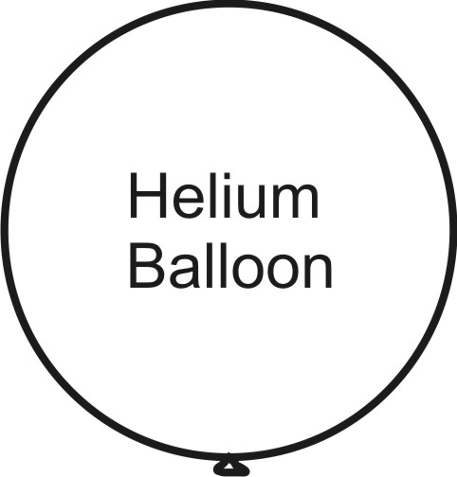
21. Objects that are less dense than their surrounding fluid float upward. How do they know which way to go? Use the helium balloon on the right to show/explain why objects upward.

22. A hot air balloon is hovering in air. It is neither rising nor sinking. Its total volume is 0.5m³. The density of the surrounding air is 1.2kg/m³. Before the balloon was flown, the balloon was crumpled into a small wad and its mass was determined to be 0.048kg. The means that its current mass (as it hovers in the air) is 0.048kg plus the mass of the hot air inside the balloon.

You will need to use the density formula to solve some of these problems.
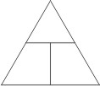
$D=\frac{m}{v}$

- What is the total mass of the floating balloon (including the hot air inside)?

- What is the mass of the hot air in the balloon?

c. What is the density of the hot air in the balloon?

23. Define or describe each of the following:

Atom:

Element:

Molecule:

Compound:

Ion:

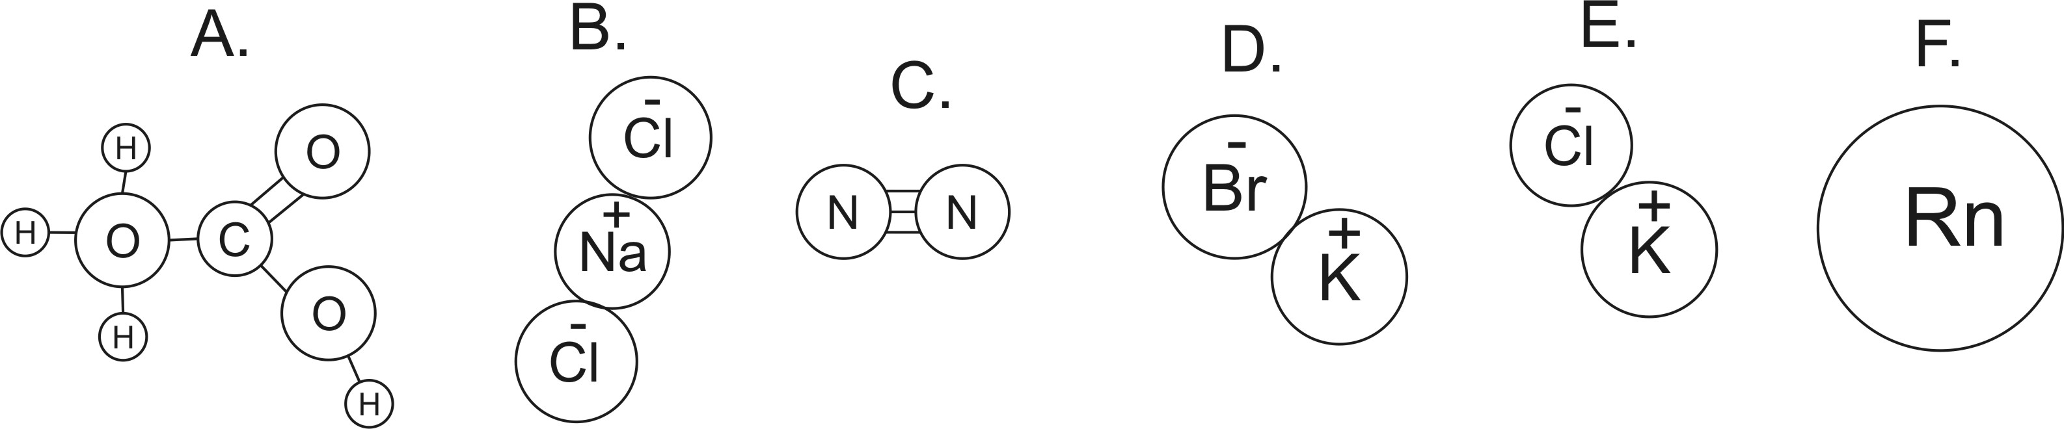
24. How many atoms are shown in the diagrams on the right?
25. How many elements are shown in the diagrams?
26. How many ions are shown in the diagrams?
27. Which lettered items are molecules?
28. Which lettered items are compounds?
29. Which items are neither molecules nor compounds? What are those items?
30. What is the approximate molecular weight of item C?

Matching:

Matching:
A. Liquid B. Absolute Zero C. Kinetic energy D. Temperature
E. Radiation F. Conduction G. Heat H. Thermal Energy
I. Solid J. Condensing K. Gas L. Convection
M. Melting

31. _____ This is the state of matter in which molecules (or individual atoms) are flying free, but they occasionally bump into one another.

32. The _____ contained in a substance is the sum (total) of all of the kinetic energies of the particles (atoms and/or molecules) in that substance.

33. The formula for _____ is ½mv².

34. _____ This is the state of matter in which molecules (or individual atoms) are touching one another, but they are sliding, bumping, moving around and changing positions.

35. _____ This is the state of matter in which molecules (or individual atoms) are locked in place, touching one another, and vibrating.

36. _____ Heat transfer by touch

37. _____ This is any transfer of thermal energy from a warmer object to a colder object.

38. _____ Heat transfer by the movement of a warm fluid (liquid or gas).

39. The _____ of a substance tells us the average kinetic energy of the particles (atoms and/or molecules) in that substance.

40. _____ This is the temperature at which all molecular motion stops.

41. _____ Heat transfer without contact and without movement a “mass” of particles. The energy that we get from the sun is an example of this type of heat transfer.

42. _____ This is what something is doing when it is gaining heat of fusion.

43. _____ This is what something is doing when it is losing heat of vaporization.

When air rises…
44. What type of pressure does it encounter?
a. higher pressure b. lower pressure c. no change in pressure
45. What happens to air’s volume?
a. it increases b. it decreases c. it does not change
46. What happen to air’s temperature?
a. it increases b. it decreases c. it does not change
47. What is most likely to happen to water that is in the air?
a. evaporate b. condense
48. What type of weather is likely to be produced?
a. clear b. cloudy

When air sinks…
49. What type of pressure does it encounter?
a. higher pressure b. lower pressure c. no change in pressure
50. What happens to air’s volume?
a. it increases b. it decreases c. it does not change
51. What happen to air’s temperature?
a. it increases b. it decreases c. it does not change
52. What is most likely to happen to water that is in the air?
a. evaporate b. condense
53. What type of weather is likely to be produced?
a. clear b. cloudy

54. Separate these words into two groups that go together…
Dry, Wet, Low Pressure, High Pressure, Sinking Air, Rising Air

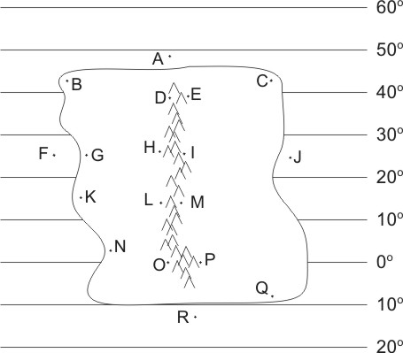
The descriptions below apply to locations on the climate map to the right. Identify all of the dotted map locations that meet each of the descriptions below.

55. In a high pressure belt
56. In a low pressure belt
57. Has a westerly (from the west) prevailing wind
58. In a major rainforest (not caused by a rain shadow or coastal breezes)
59. In a major desert (not caused by rain shadow)
60. Relatively warm ocean water
61. Wet due to breezes from the ocean
62. Wet due to rain shadow effect
63. Dry due to rain shadow effect

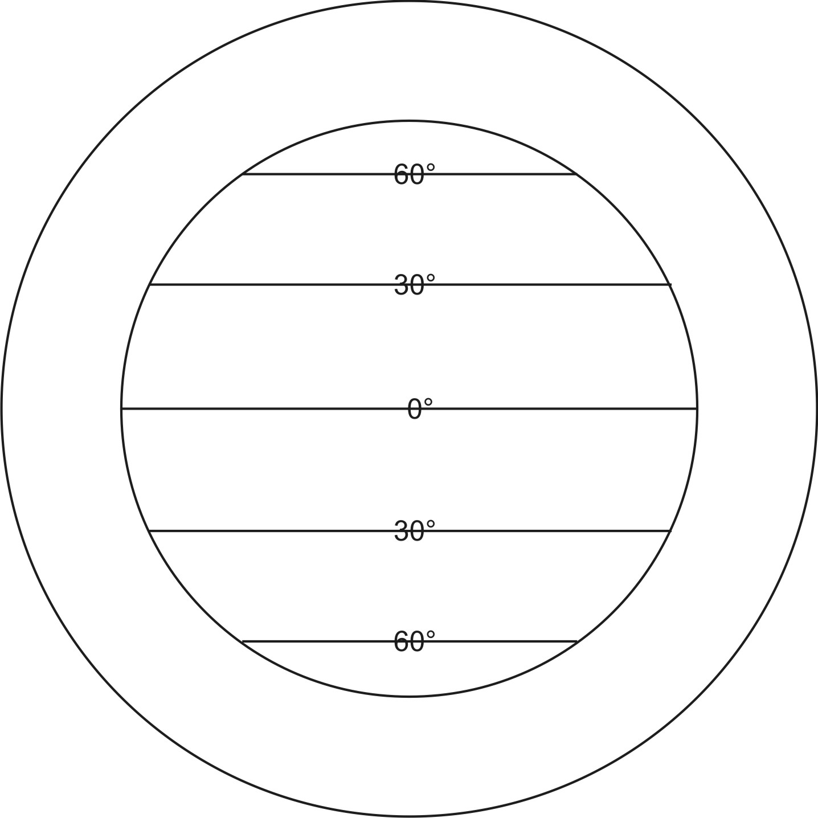
64. On the diagram to the right, sketch the pattern of air circulation in the Earth’s atmosphere. [This question is not asking you to draw the prevailing winds.]

65. The Earth’s atmosphere is constantly moving. Why does it move? Where does all of this movement start?

66. Where are the Earth’s major deserts? Why are they in those locations?

67. Where are the Earth’s major rainforests? Why are they in those locations?

68. Why do continents generally have warmer water on their east coasts and cooler water on their west coasts?

69. Why are continents’ east coasts usually more humid than their west coasts?

70. What causes ocean currents?

71. In the diagram below, show where the rain shadow will form. Then show and/or explain why one side of the mountain is rainy and why the other side is dry.
