EPS 100 Name: ________________________________
Test Review: Basic Chemistry and Cloud Formation

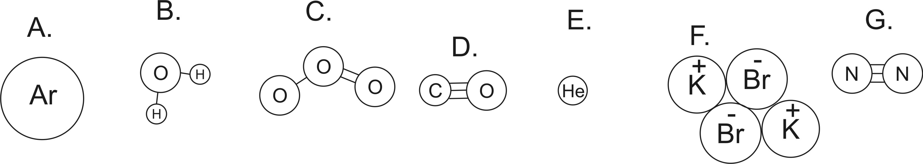
1. _____________ How many atoms are shown in the diagrams above?
2. _____________ How many elements?
3. _____________ How many ions?
3. _____________ Which lettered items are molecules?
4. _____________ Which lettered items are compounds?
8. _____________ Which item(s) are neither molecules nor compounds? What are they? _______________
10. _____________ Which (if any) of the substances are in the top three most common particles found in “air.”
11. _____________ What is the atomic weight of item E? (use the portion of the periodic table shown on the right.
12. _____________ What is the molecular weight of item D?

13. What is the molecular formula for glucose, shown below?
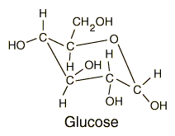

Matching: Solid, Liquid, Gas

14. _____________ Molecules are touching one another, but they are sliding and bumping around and changing positions.
15. _____________ Molecules are flying free, but they occasionally bump into one another.
16. _____________ Molecules (or individual atoms) are locked in place, touching one another and vibrating.

Matching: Temperature, Absolute Zero, Velocity, Kinetic energy, Heat, Thermal Energy, Mass

17. The ___________ of a molecule can be calculated with the formula ½mv².
18. _______________ is the transfer of thermal energy from a warmer object to a colder object.
19. The two factors that determine the temperature of some particles are their ____________ and their _______________.
19. The ________________ of a substance tells us the average kinetic energy of the particles (atoms and/or molecules) in that substance.
20. _____________________ is the temperature at which all molecular motion stops.
21. The ___________________ contained in a substance is the sum of the kinetic energies of the particles (atoms and/or molecules) in that substance.

Matching: Conduction, Convection, Radiation

22. _____________ Heat transfer without contact and without movement a “mass” of particles. This is the process by which the Sun’s energy travels through empty space on its way to the Earth.
23. _____________ Heat transfer by touch; when hot object touches cold object, the rapidly moving molecules of the hot object bump into the molecules of the cold object, causing them to begin moving faster. The molecules of the hot object lose some energy in the process, thus they slow down.
24. _____________ Heat transfer by the “wholesale movement” of a warm mass of some substance (e.g. blobs rising in a lava lamp)

Part II: Short Answer

1. Explain why a hotter object (higher temperature) can have less thermal energy than a colder object.

2. What is happening to an object that is…
- gaining heat of vaporization?

- losing heat of vaporization?

3. What is happening to an object that is…
- gaining heat of fusion?

- losing heat of fusion?

4. Skip #4.

5-8. Suppose you have a sealed balloon full of air (ordinary latex balloon, tied off). You heat the balloon.

5. What are the four most common gases in the air inside the balloon, in order of prevalence?

6. As you heat the balloon, what happens to its volume? Explain why.

7. As you heat the balloon as described above, what happens to the balloon’s mass? Explain how you know.

8. As you heat the balloon described on the previous page, what happens to the balloon’s overall density? Explain your reasoning.

9. If you screw the lid onto an empty 2-liter soda bottle, and then you rapidly squeeze the bottle, what happens to the temperature of the air inside the bottle? Explain why.

10-12. You can make a cloud in a 2-liter bottle by adding some smoke and some water. Then you screw the cap on tight and squeeze the bottle. After that, you need to release the bottle.

10. What necessary role does the squeezing play?

11. What necessary role does the releasing play?

12. What role does the smoke play?

13. Give a very brief (one sentence) explanation for why hot air rises.

14. Explain why rising air produces clouds.

- What happens to air’s volume as it rises? Why?

- What happens to air’s temperature as it rises? Why?

- As air rises, what phase change occurs, and why does it occur?

15. Explain why sinking air produces clear skies.

- What happens to air’s volume as it sinks? Why?

- What happens to air’s temperature as it sinks? Why?

- As air sinks, what phase change occurs, and why does it occur?

16. Explain why, under the right conditions,sweating makes humans cooler.

17. If you put a sealed container of cream in a bowl of ice, and then you mix rock salt into the ice, the cream will freeze. Explain why.

