EPS 200 (Stapleton) Name: _______________________________________
Unit 1 Practice Test : Physical Properties and Pressure

Choose the correct answer.
1. The size of something: mass volume density weight
2. The force of gravity acting on an object: mass volume density weight
3. The amount of stuff in something: mass volume density weight
4. The crowdedness of the stuff in an object: mass volume density weight

The objects on the right are mostly empty space. The circle is the edge of each object. The dots inside represent all of each object’s mass. The empty space inside the objects has no air or mass of any kind.

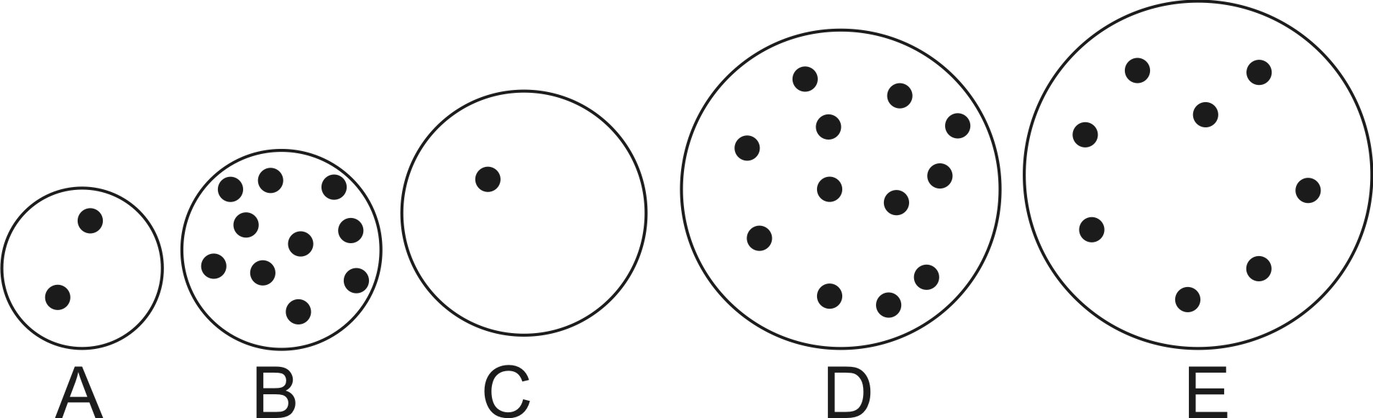
5. Which object has the most weight? ___
6. Which object has the least weight? ____
7. Which object has the most volume? ____
8. Which object has the least volume? ____
9. Which object is most dense? ____
10. Which object is least dense? ____
11. Which object has the most mass? ___
12. Which object has the least mass? ____
13. Which object is most likely to sink? ____
14. Which object is most likely to float? ____

Description of Change | Property | Change in Property  (+, -, or =) | Explanation
15. A piece of paper loses its corner when the corner is cut off and thrown away. | Mass
 | Volume
 | Density
 | Weight

16. A balloon is inflated by mouth. | Mass
 | Volume
 | Density
 | Weight

17. A moon rock is taken to the Earth. | Mass
 | Volume
 | Density
 | Weight
18. Right now, we are experiencing air pressure. It is pressing against every inch of our skin. Where is that air pressure coming from? What’s causing it?

19. a. Where in our world is air pressure strongest, at lower altitudes or at higher altitudes?

b. Why?

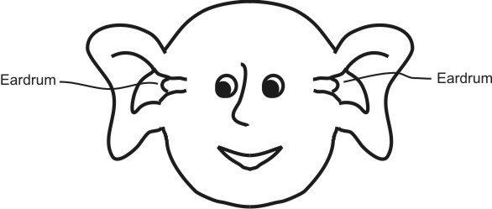
20. The average value of air pressure at sea level is approximately _________psi.

21. The person on the right is experiencing ear pain. According to the diagram, has the person just moved to a higher altitude or to a lower altitude?

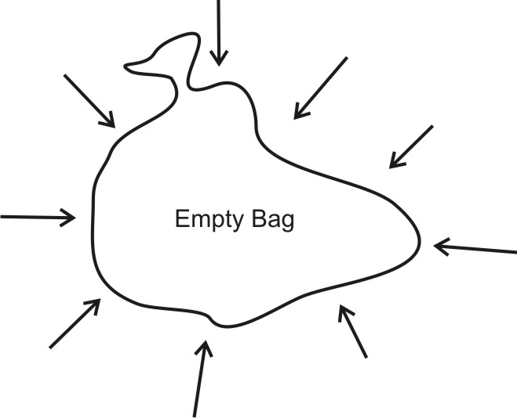

22. The picture on the right shows a trash bag full of air. If you consider all of the air pressure that is squeezing the outside of the bag, the total force is about 45,000 pounds! Show and explain why the bag is not being squeezed into a tiny lump.

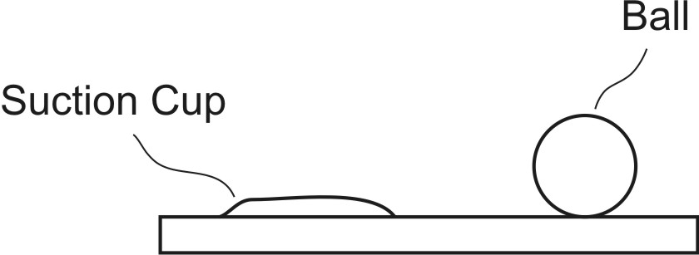
23. The diagram on the right shows a ball sitting on a table, and it also shows a suction cup that is stuck to the table. Explain why suction cups stick to tables and why balls don’t. Explain by using words and by drawing on the diagram.

24. You have a suction cup with an area of 20in³. You stick the suction cup to a wall. Use the formula
Force = Pressure x Area and your answer to #20 to calculate the force with which air pressure is holding the suction cup to the wall.

25. Suppose you want to lift your friends by having them sit on a bag that you are going to inflate with a shop vac.
a. If you are using the same shop vac with the same amount of pressure, will you produce more lifting force with a big bag or a little bag?

b. Explain why.

