ESS 200 (Stapleton) Name: ___________________________
Rock Dating Test, Version 3

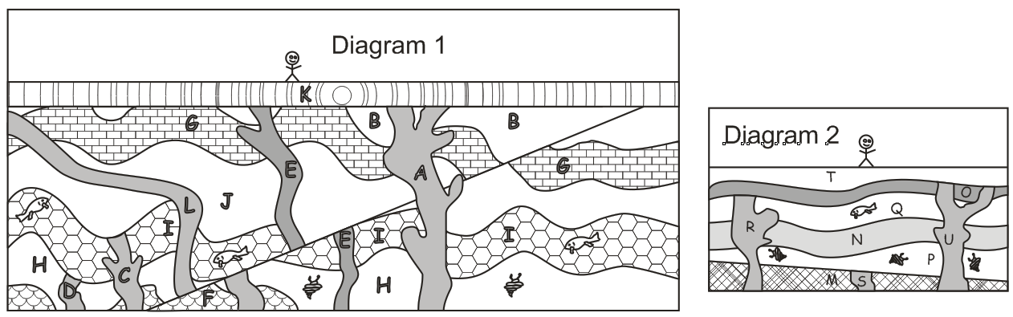

Part 1: For questions 1-10, use relative dating strategies to order all of the lettered strata or igneous intrusions in diagram 1. Then complete the questions below for diagram 1 only.

1. Which sample is barely older than B? _____
2. Which sample is barely older than L? _____
3. Which sample is barely older than J? _____
4. Which sample is barely older than I? _____
5. Which sample is barely older than H? _____
6. Which sample is barely younger than B? _____
7. Which sample is barely younger than L? _____
8. Which sample is barely younger than J? _____
9. Which sample is barely younger than I? _____
10. Which sample is barely younger than H? _____

Part 2: Assuming a half-life of 8 million years, find the ages of the igneous rock samples, below. You may use the graph on the back of this sheet.

Sample | Parent Atoms | Daughter Atoms | % of Parents remaining | Age of rock in Millions of years
A | 15 | 3 |  | 2 6 10 14 18 22 26 30 34 38
D | 36 | 649 |  | 2 6 10 14 18 22 26 30 34 38
C | 20 | 115 |  | 2 6 10 14 18 22 26 30 34 38
E | 16 | 38 |  | 2 6 10 14 18 22 26 30 34 38
U | 25 | 94 |  | 2 6 10 14 18 22 26 30 34 38
L | 32 | 22 |  | 2 6 10 14 18 22 26 30 34 38
R | 25 | 311 |  | 2 6 10 14 18 22 26 30 34 38
S | 13 | 234 |  | 2 6 10 14 18 22 26 30 34 38

Part 3: Use your data from the table above, plus both of the diagrams from the top of the page, to determine possible age ranges for the rock strata or events below.
Sample or Event | Age of rock in Billions of years
B | 0-2 2-6 6-10 10-14 14-18 18-22 22-26 26-30 30-34 34-38
J | 0-2 2-6 6-10 10-14 14-18 18-22 22-26 26-30 30-34 34-38
Appearance of fault in diagram 1 (left diagram) | 0-2 2-6 6-10 10-14 14-18 18-22 22-26 26-30 30-34 34-38
Q | 0-2 2-6 6-10 10-14 14-18 18-22 22-26 26-30 30-34 34-38
P | 0-2 2-6 6-10 10-14 14-18 18-22 22-26 26-30 30-34 34-38

