What will life be like in Vermont in the year 2100?

Due: May 26th
Format: Google Doc
Length: 750-1,250 words
Bibliography Required (with hyperlinks to online articles)

Write a 750 word essay about life in Vermont in the year 2100. This essay will be graded according to its adherence to the EHS writing rubric (see back of this sheet) and the guidelines below. Particular emphasis will be placed on the integration and elaboration of evidence. The essay must adequately address at least four of the topics laid out below, and it must include a bibliography. Citations for web articles must be hyperlinked to the source article. You may either weave all of your chosen topics into one cohesive whole or you may divide the essay into distinct sections. Note that, with regard to several of the topics below, life in Vermont may be affected in much the same way as life in other parts of the world. For those topics, you do not always have to cite evidence referring specifically to Vermont.

You are not expected to arrive at the right answers. We will not know the right answers for 84 years. You are expected to research these topics, to consider our limited understanding of these topics, and to make reasonable guesses based on that limited knowledge. In fact, your guesses/predictions can be possible scenarios rather than likely scenarios if you can provide evidence that they are possible.

- Describe Vermont’s climate in the year 2100. Describe the summers and the winters. Explain how you arrived at your prediction and support your argument by citing reliable sources.
- Predict how most Vermonters will get their electricity in 2100. Why will Vermonters opt for this type of energy generation? Support your argument by citing reliable sources.
- Describe Vermonters’ transportation in 2100. How will they do it? Why will Vermonters use this type of transportation? (Cite reliable sources)
- What important material resources (if any) will have become scarce by 2100? Why will those resources become hard to find? How will Vermonters cope with the scarcity of those resources? Cite reliable sources.
- How will the quality of life in Vermont compare to our quality of life today? Give examples of how you think life may be more difficult or more enjoyable than it is today and cite sources.
- Are there some emerging technologies that you think might help us deal with the issues facing humanity? If so, choose no more than three technologies. Explain briefly how they work and how they might help us. (Cite reliable sources)
- In no more than 200 words, describe what will you have done to prepare for the future? You might describe how your grandchildren feel about the way you lived your life. [You do not need to provide evidence or citations for this topic.]

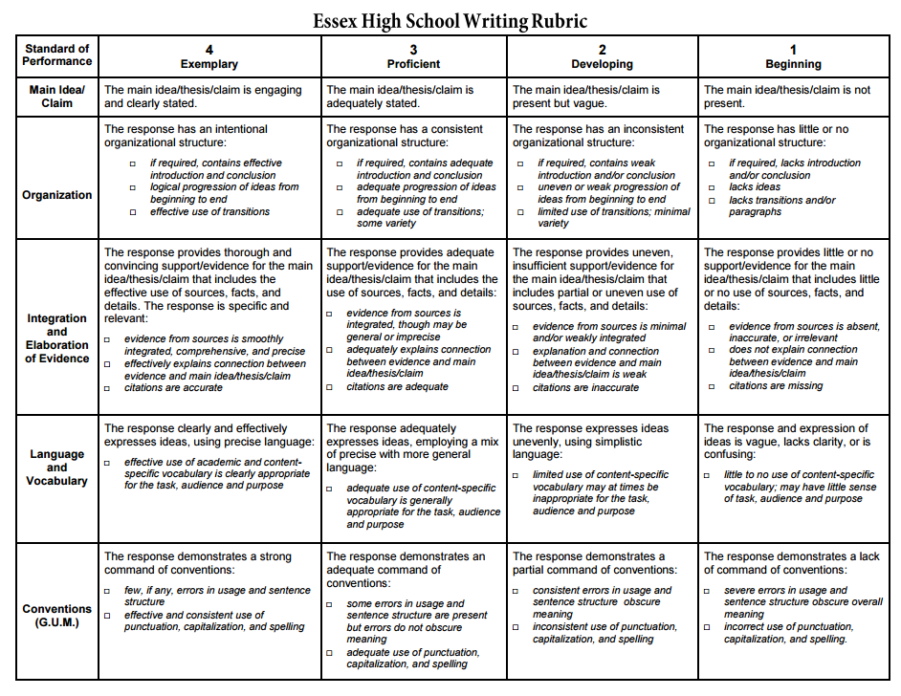
An exemplary score for integration and elaboration of evidence requires at least two in-text citations of relevant information sources for each topic that you address. The claims within your text must be supported by these in-text citations. Your bibliography entries will not count toward your score for integration and elaboration of evidence. In-text citations can be stated fully within text, enclosed within parentheses, or included as superscripted numbers tied to footnotes.

