EPS 200 Name:___________________________
Physical Chemistry Odds and Ends – Humidity, Heat Pumps, Etc.

1. What is the difference between absolute humidity and relative humidity?

2. Humans are generally comfortable at relative humidities between 25% and 60%. What does a relative humidity of 50% mean?

3. Define dew point.

4. What is the relationship between the air’s water vapor capacity and the air’s temperature?

5. Explain the reason for that relationship.

6. What typically happens to the relative humidity of air as air heats up?

7. Explain why relative humidity changes in this way as air heats up.

8. What happens to the relative humidity of air when it rises? Explain why.

9. Describe a situation in which relative humidity increases while temperature remains constant. Explain why relative humidity is increasing.

10. At what time of day does air most often reach the dewpoint? Why?

11. What happens to the relative humidity of air that travels from outside into a heated house during the winter? Explain why.

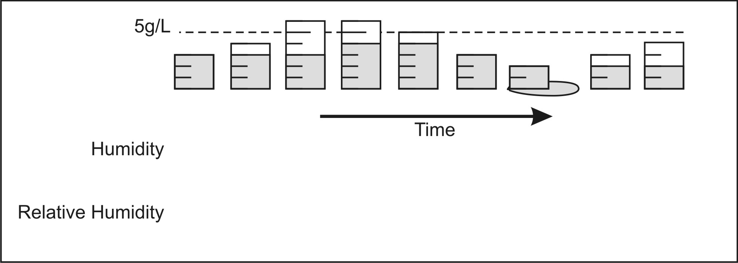
12. The containers on the right represent a mass of air with its evaporated water vapor. Sketch rough line graphs showing how the air’s humidity and relative humidity are changing over time.

13. A heat pump has a condenser and an evaporator…

a. What happens in each one?

b. Which one is hot, and which one is cold? For each one, explain why.

14. What is the purpose of a heat pump’s compressor? [There are two – sort of.]

15. What is the purpose of a heat pump’s evaporator? [There are two – sort of.]

16. A refrigerator is a type of heat pump. Instead of having a condenser and an evaporator, the refrigerator has evaporating coils and condensing coils. Where, relative to the refrigerator, should each of these types of coils be located?

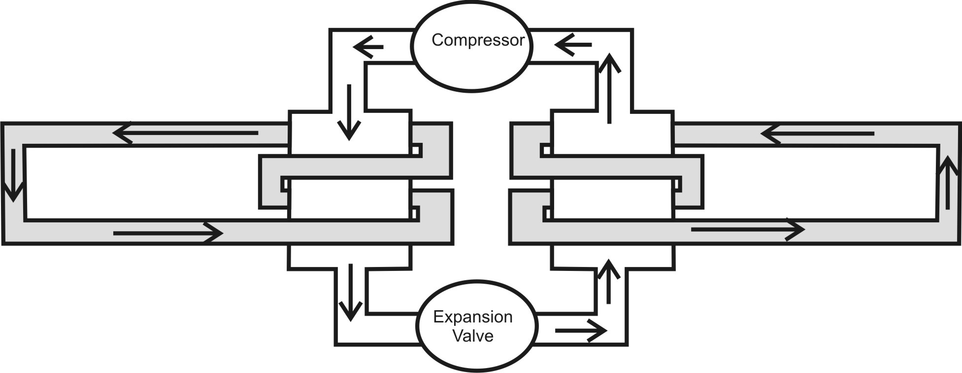
17. The diagram below shows a type of heat pump system. Trace the path of heat as it gets pumped through the system. Show where heat enters the system, where it leaves the system, and how it gets from its entry point to its exit point.

