EPS (Stapleton) Name: ________________________

Temperature, Pressure, and Composition of The Universe

**Kinetic Molecular Theory of Gases:** the idea that the behavior of gases can be understood by thinking of motions of individual moving particles (atoms, molecules, ionic compounds, ions…)

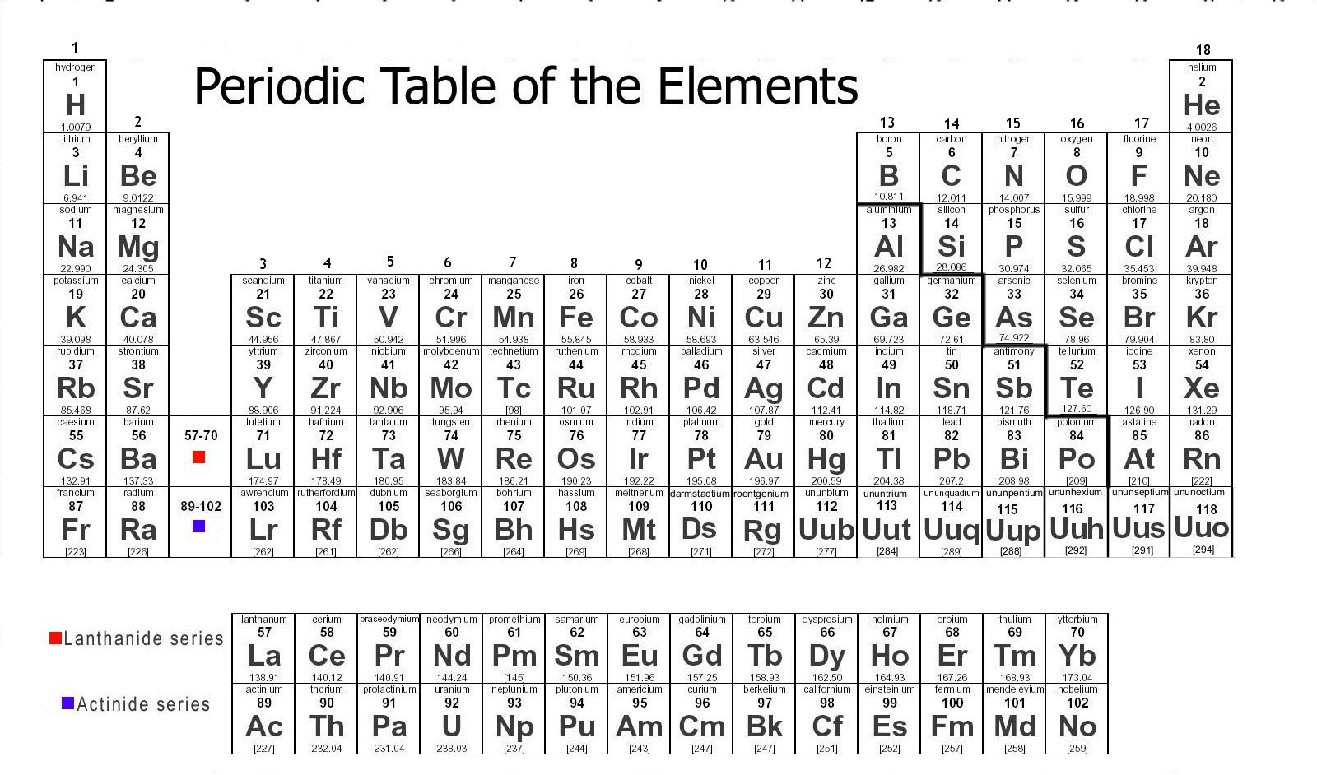

**Element:** a substance that cannot be chemically broken down into a simpler substance; a type of atom

**Atom:** the basic unit of a chemical element; the smallest particle of an element that is still considered to be that element.

**Gas Particle:** A single atom or a group of connected atoms that move together in a gas. [Gas particles can be atoms, molecules, and/or compounds.]

**Periodic Table of The Elements:** a table organizing all of the known elements by atomic masses and other characteristics.

**Molecule:** a group of atoms bonded together by sharing electrons (electron sharing is indicated in Mr. Stapleton’s drawings by lines connecting atoms)

**“Particle of Matter:”** one of a variety of molecules and atoms (or ionic compounds); To simplify understanding the effects of temperature and pressure change, you can think of any particle as a tiny sphere.

**Composition of the particles in the Universe (by mass)**

Hydrogen:

Helium:

Other Stuff:

**Temperature**: the average kinetic energy of the molecules or atoms in a substance

**Kinetic Energy**: Energy of motion; things have more kinetic energy when they have more mass and velocity

**Kinetic Energy Formula:** KE = ½ mv2

**States of Matter (a.k.a. phases of matter)**

**Solid phase:** Particles are locked in place, touching one another, vibrating. Hotter solids vibrate more violently.

**Liquid phase:** Particles are touching one another, but sliding and bumping around and changing positions; flowing. Hotter liquid particles slide and bump around faster.

**Gas phase:** Particles are flying free, but occasionally bumping into one another. Hotter gas particles fly faster.

**Evaporation:** turning from liquid to a gas; requires _______________________ energy.

**Condensation:** turn from a gas to a liquid; requires _______________________ energy.

**Melt:** turn from a solid to a liquid; requires _______________________ energy.

**Freeze:** turn from a liquid to a solid; requires _______________________ energy.

Temperature Changes Can Cause Pressure Changes

1. When nuclear fusion begins in a star, the process of nuclear fusion increases the star’s temperature. What immediate effect does this temperature increase have on the pressure inside the star?

2. Explain why.

3. What effect does this change in pressure have on the star’s volume? Why?

Pressure Changes Can Cause Temperature Changes

In the three pictures on the right, a “perfectly bouncy” ping pong ball is dropped onto a “perfectly bouncy” ping pong paddle.

A

B

C

4. In which situation will the ball speed up the most (and bounce highest) after being hit by the paddle?

5. In which situation will the ball slow down the most

(and bounce the least) after being hit by the paddle?

6. In which situation will the ball’s speed remain approximately the same after hitting the paddle?

The three pictures on the right show “boxes” which have tennis rackets for walls. Inside the boxes, tennis balls are bouncing around. In one box, the walls are pushing inward against the balls. In another box, the rackets are relaxed, allowing the balls to push them out. In a third box the walls are held stationary.

A

B

C

7. In which “box” will the walls’ behavior cause the balls to speed up?

8. In which “box” will the walls behavior cause the balls to slow down?

9. In which “box” will the walls behavior not affect the balls’ speeds?

10. What happens to the temperature of a dying star as it collapses and gravity squeezes it together? Why?

11. If the Universe is expanding, what is happening to its overall average temperature? Why?

12. a. Give an example of heating causing something to expand.

b. Give an example of compression causing something to heat up.

c. Give an example of cooling causing something to shrink.

d. Give an example of expansion causing something to cool down.

**Make a cloud in a bottle**

Complete these steps and then answer the questions that follow:

Get a clear 2-Liter bottle with a cap.

1. Get the inside of the bottle wet by putting water in it and shaking the water around. Then pour out the water.
2. Light a match and get it burning well. Blow it out as you place it in the bottle. The point is to get some smoke the bottle. Cap the bottle tightly before the smoke escapes.
3. Now squeeze the bottle as hard as you can for one second.
4. Stop squeezing and let the bottle expand for one second.
5. Squeeze again for another second, with all of your might. But don’t jump on the bottle. This should be a steady squeeze.
6. Release your squeeze.
7. Squeeze again….
8. Keep repeating this until you see a cloud forming and disappearing. Pay close attention to when the cloud is appearing and when it is disappearing. Holding the bottle in a bright light with a dark background will make the cloud easier to see.

13. When you squeeze…

a. What happens to the pressure in the bottle?

b. Are you pushing the gas particles in the bottle, or are they pushing you?

c. Are the gas particles gaining or losing energy?

d. Is the gas temperature increasing or decreasing?

e. Do you see a cloud appear or disappear? Why?

14. When you release, do you see a cloud appear or disappear? Why?