ESS 200 (Stapleton) Name: ___________________________
Notes: Why dense things sink: Pressure, Buoyancy, and Weight
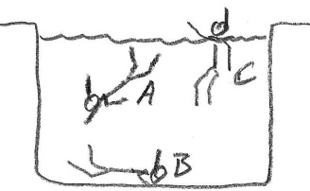
1. In the first picture on the right, which swimmer is experiencing the strongest water pressure?

2. In the second picture on the right, who is experiencing the greatest air pressure?
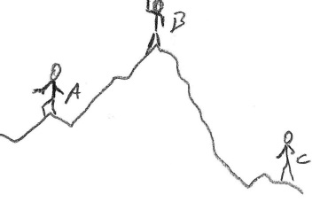

3. Whether you’re in air or water (or any other fluid), the origin of ambient pressure is the same. What creates the air pressure that we’re feeling right now?

4. When there is a pressure difference, in which direction to objects move? High pressure to low, or low pressure to high? Use the ears below to explain the source of pain with a change in altitude.

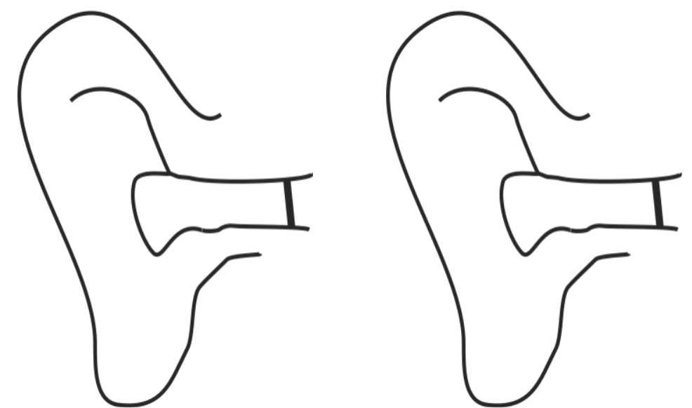

5. At sea level, one cubic meter of air weighs about _______ pounds and has a mass of about ______ kg.

6. Atmospheric Pressure (average air pressure at sea level) = ______ psi

7. “psi” stands for ____________________________________________________________________

8. So, at sea level, every square inch of the Earth has about _______ pounds of air stacked above it.

9. According to sources, an average human has about 1.8m² (≈2,800 in²) of skin. If you consider the force of air pressure pushing on that many square inches, what total force (in pounds) is pushing against an average human’s skin?
10. The two people on the right are inside trash bags. One has a vacuum hose inserted in the bag. The other does not. Use arrows to show how the sensation of vacuum packing is caused by air pressure pushing inward from the outside of the bag.
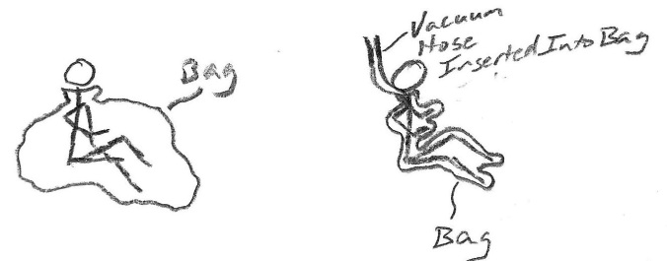

11. Show/explain why a suction cup sticks to a glass surface and why other things do not.

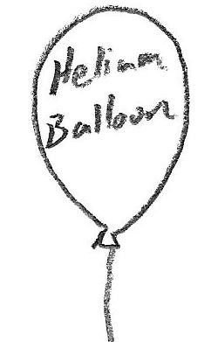
12. A helium balloon floats upward. Show /explain how it “knows” which way to go. [Hint: it’s the same as ear drums.]

13. The name for the pressure difference that pushes objects upward is ___________________.

14. Whether an object is in water or air, buoyancy (caused by pressure) pushes everything upward, against gravity. Explain why.

15. If pressure pushes everything upward, then why do dense objects sink?

16. Why don’t we float like helium balloons?

