ESS 200 (Stapleton) Name: _________________________________
Notes/Practice: Modeling Convection
Part 1: Hot Air Balloon Calculations

Density Formula →

Common Density Units →

1. What is the density of a 2cm x 2cm x 3cm box that has a mass of 24g?

2. What is the mass of a box with a volume of 8cm³ and a density of 0.5g/cm³?

3. What does “neutrally buoyant” mean?

4. How does the air pressure inside a hot air balloon compare to the pressure outside a hot air balloon? How do you know?

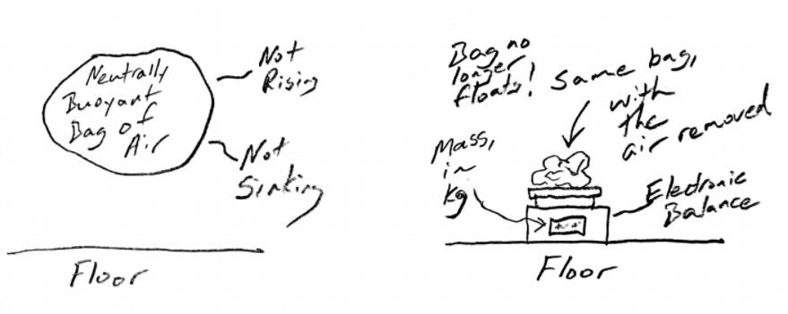

How hot is the air in this bag? #1: Suppose you have a 0.25m³ bag of air that is neutrally buoyant in the surrounding air. It is hovering. The density of the surrounding air is 1.2kg/m³. You remove all of the air from the bag, and you measure the mass that remains. That mass is 0.04kg.

a. What is the overall density of the bag (including the air inside) when it is hovering? How do you know?

b. What is the overall mass of the bag plus the air inside, when the bag is hovering?

c. How much of the floating bag’s mass is not air?

d. How much of the floating bag’s mass is air?

e. What is the volume of the air inside the bag?

f. What is the density of that air?

g. Given the following measurements, use an online air density calculator (link on class website) to find the temperature of the air in the balloon. Use the “guess and check” method. Pressure = 30inhg. Dewpoint = 50°F . Before you start, set the calculator units to: pressure = inHg; Dewpoint = F°; Density = kg/m³.

Practice Problem #2: Suppose you have a 0.4m³ bag of air that is neutrally buoyant in the surrounding air. It is hovering. Using an online calculator, you have determined that the density of the surrounding air is 1.22kg/m³. You remove all of the air from the bag, and you measure the mass that remains. That mass is 0.08kg. Before you start, set the calculator units to: pressure = inHg; Dewpoint = F°; Density = kg/m³.

a. What is the overall density of the bag (including the air inside) when it is hovering? How do you know?

b. What is the overall mass of the bag plus the air inside, when the bag is hovering?

c. How much of the floating bag’s mass is not air?

d. How much of the floating bag’s mass is air?

e. What is the volume of the air inside the bag?

f. What is the density of that air?

g. Given the following measurements, use an online air density calculator to find the temperature of the air in the balloon. Use the “guess and check” method. Pressure = 29.5 inhg. Dewpoint = 45°F. Before you start, set the calculator units to: pressure = inHg; Dewpoint = F°; Density = kg/m³.

