ESS 100 (Stapleton) Name: ___________________________
Physical Properties: Pressure
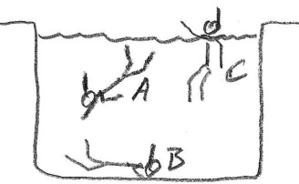
1. In the first picture on the right, which swimmer is experiencing the strongest water pressure?

2. What causes the water pressure you feel when you dive?

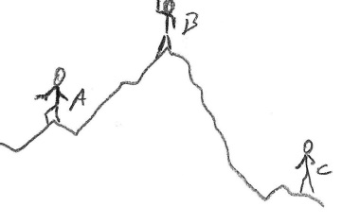
3. In the second picture on the right, who is experiencing the greatest air pressure?

4. What creates the air pressure that we’re feeling right now?

5. Show why our ear drums hurt when we rapidly descend or rise to different elevations.
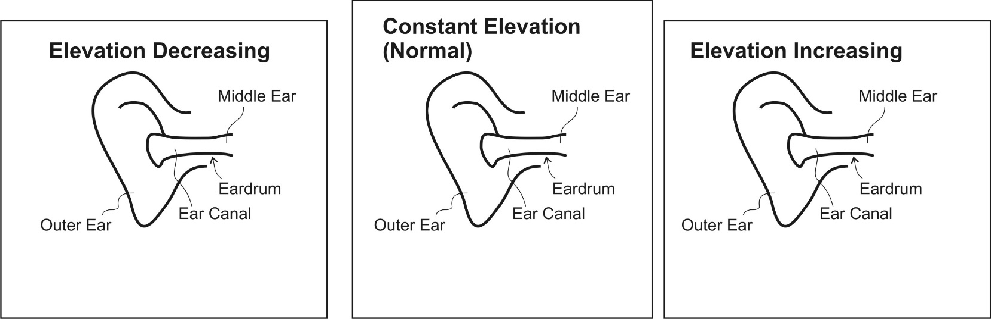

6. At sea level, one cubic meter of air weighs about _______ pounds and has a mass of about ______ kg.

7. Just to prove that air has weight, an empty balloon has a mass of _______ g. An inflated balloon has a mass of ________ g.

8. Atmospheric Pressure (average air pressure at sea level) = ______ psi

9. “psi” stands for ____________________________________________________________________
11. According to sources, an average human has about 1.8m² (≈2,800 in²) of skin. If you consider the force of air pressure pushing on that many square inches, what total force (in pounds) is pushing against an average human’s skin?

12. Why don’t we normally feel that force?

13. The two people on the right are inside trash bags. One has a vacuum hose inserted in the bag. The other does not. Use arrows to show how the sensation of vacuum packing is caused by air pressure pushing inward from the outside of the bag.
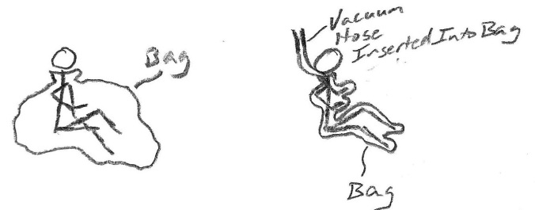

14. We can lift several people by placing them on top of an air bag and inflating the air bag with very little pressure (about 1psi). Why can one pound per square inch of pressure lift so much weight?

15. Explain why a suction cup sticks to a glass surface and why a book does not.

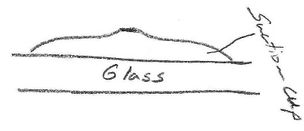

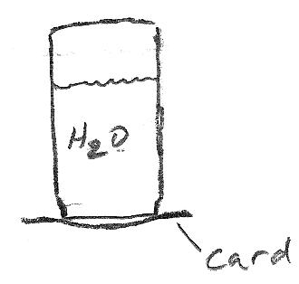

16. What happens if you fill a jar with water, cover it with a laminated card, and then turn the jar upside down? Explain why. Would this work on the moon? Why not?

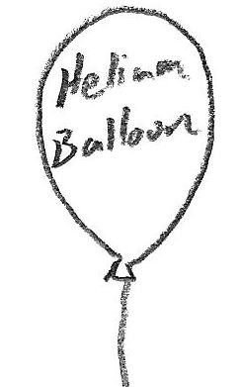
17. A helium balloon floats upward. Show and explain how it “knows” which way to go.

