ESS 100 (Stapleton) Name: __________________________________
Structure of Matter (especially water)
Part 1
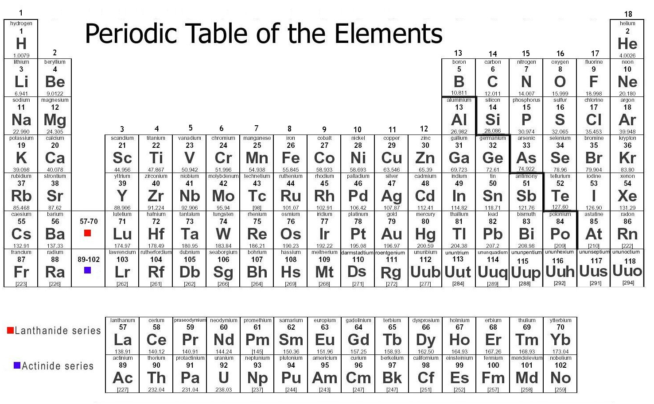
Element: a substance that cannot be chemically broken down into a simpler substance; a type of atom

Atomic Symbol: A two letter symbol representing an element.

Atom: the basic unit of a chemical element; the smallest particle of an element that is still considered to be that element

Periodic Table of The Elements: a table organizing all of the known elements by atomic masses and other characteristics.

Molecule: a group of atoms bonded together by sharing electrons (electron sharing is indicated in Mr. Stapleton’s drawings by lines connecting atoms)

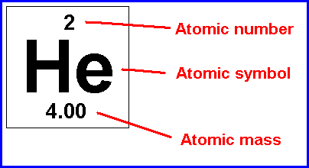
Chemical Compound: more than one type of element chemically combined

Ion: a charged atom or molecule; charge may be + or -

Ionic Compound: multiple types of atoms held together by opposite charges

Polar Molecule: A molecule that does not have an overall charge (it is not + or -), but which has one end that is more positive and one end that is more negative.

Non-Polar Molecule: A molecule that does not have a positive and a negative end.

Chemical formula: a shorthand way of listing the numbers of atoms of each element in a compound. The symbol of each element in the substance is followed by the number of atoms of that element.

Draw a water molecule:

1. How many elements are in water? What are they?

2. Is water a molecule? Explain.

3. Is water a compound? Explain.

4. How many atoms are in a water molecule?

5. Is water polar or non-polar? Explain. What causes it to be this way?

6. What is the chemical formula for water?

Vocabulary Practice:
1. How many atoms are shown in the diagrams below?
2. How many elements?
3. How many molecules?
4. How many compounds?
5. How many ions?
6. Which lettered items are compounds but not molecules?
7. Which lettered items are molecules but not compounds?
8. Which items are neither molecules nor compounds?
9. What is the molecular formula for the substance lettered “G?”
10. Which item is water?

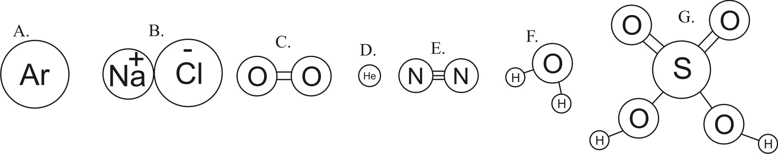
11. For each of the items above, tell what a chemist might call the item.

A.

B.

C.

D.

E.

F.

G.

States of Matter Simulation:

Open, download, and run the states of matter simulation at this web address: http://phet.colorado.edu/en/simulation/states-of-matter

1. Click the states of matter buttons to switch back and forth between Solid, Liquid, and Gas. Describe what the particles are doing in each state.

Solid:

Liquid:

Gas:

2. The simulation allows you to experiment with Neon, Argon, Oxygen, and Water. Fill in the table for each substance, as it is pictured in the simulation.

Substance | How many atoms make up one particle? | Is it a molecule? | Is it a compound? | What is the chemical formula?
Neon
Argon
Oxygen
Water

3. For each substance, rank the densities of different states of matter. 3 = most dense; 1=least dense
Substance | Solid | Liquid | Gas
Neon
Argon
Oxygen
Water

4. Based on your table of densities above, which substance is unique?

