EPS (Stapleton) Name: ________________________
Basic Chemistry and the Basis of Cloud Formation

Kinetic Molecular Theory of Gases: the idea that the behavior of gases can be understood by thinking of motions of individual particles (atoms, molecules, ionic compounds, ions…)

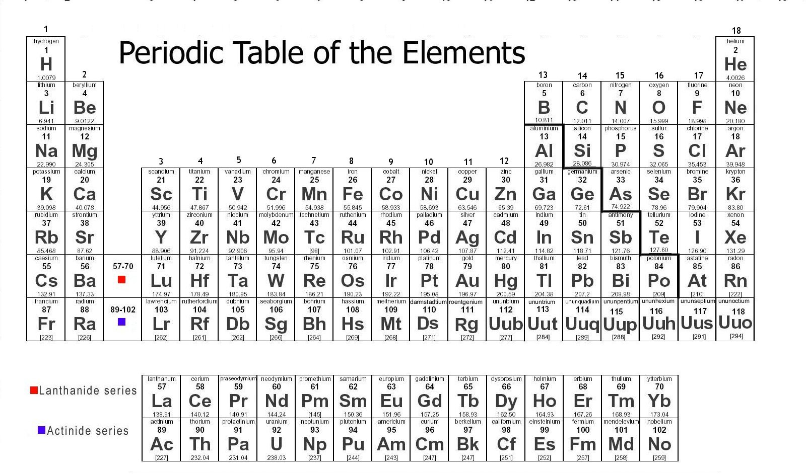

Element: a substance that cannot be chemically broken down into a simpler substance; a type of atom

Atom: the basic unit of a chemical element; the smallest particle of an element that is still considered to be that element

Periodic Table of The Elements: a table organizing all of the known elements by atomic masses and other characteristics.

Molecule: a group of atoms bonded together by sharing electrons (electron sharing is indicated in Mr. Stapleton’s drawings by lines connecting atoms)

“Air molecule:” one of a variety of molecules found in the atmosphere

Composition of air (approximate):
- 78% N₂ (nitrogen)
- 20% O₂ (oxygen)
- 0.93%Ar (argon)
- 0.04% CO₂ (carbon dioxide)
- about 1% other stuff
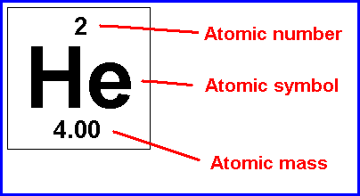
Chemical Compound: more than one type of element chemically combined

Ion: a charged atom or molecule; charge may be + or -

Ionic Compound: multiple types of atoms held together by opposite charges

Atomic “weight” of an atom (a.k.a. “relative atomic mass”): the mass, in grams, of one mole of those atoms. Bigger, heavier atoms have greater masses.

Molecular weight: the sum of the atomic weights of the atoms in a molecule

Chemical formula: a shorthand way of listing the numbers of atoms of each element in a compound. The symbol of each element in the substance is followed by the number of atoms of that element.

1. How many atoms are shown in the diagrams below?
2. How many elements?
3. How many molecules?
4. How many compounds?
5. How many ions?
6. Which lettered items are compounds but not molecules?
7. Which lettered items are molecules but not compounds?
8. Which items are neither molecules nor compounds?
9. What is the molecular formula for the substance lettered “G?”
10. Which substances are common “air molecules?”
11. What is the atomic weight of item A?
12. What is the molecular weight of item F?

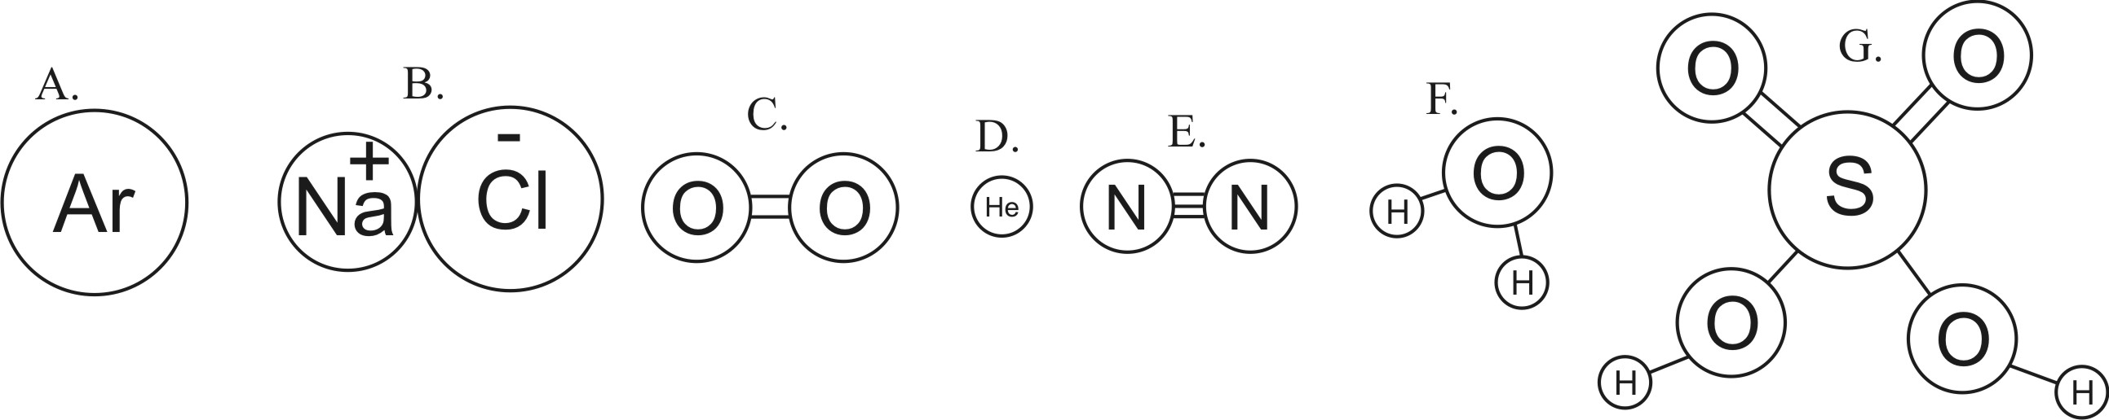

Temperature: the average kinetic energy of the molecules or atoms in a substance

Kinetic Energy: Energy of motion; think of it as the energy required to set something in motion at a given speed

Kinetic Energy Formula: KE = ½ mv²

13. What two factors determine a molecule’s temperature?

14. If you inflate a balloon and tie it off, heating the balloon will cause the balloon to expand. Explain why in terms of molecular motion.

Heat: the transfer of thermal energy

Thermal Energy of a substance: the total kinetic energy of the molecules moving within the substance

15. Which has more thermal energy, a swimming pool full of 50 degree water or a cup full of 95 degree water? Why?

States of Matter (a.k.a. phases of matter)

Solid phase: Molecules (or individual atoms)are locked in place, touching one another, vibrating. Hotter solids vibrate more violently.
Liquid phase: Molecules are touching one another, but sliding and bumping around and changing positions; flowing. Hotter liquid molecules slide and bump around faster.
Gas phase: Molecules flying free, but occasionally bumping into one another. Hotter gas molecules fly faster.

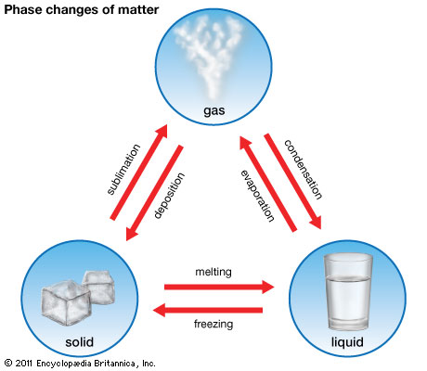

Evaporate: turn from a liquid to a gas
Condense: turn from a gas to a liquid
Melt: turn from a solid to a liquid
Freeze: turn from a liquid to a solid

Latent Heat of Vaporization: the energy that must be added to a substance to allow it to turn from liquid to gas (and which must be removed in order for a gas to turn to a liquid). Heat of vaporization does not change a substance’s temperature; it only changes the substance’s phase (see diagram).

Latent Heat of Fusion: the energy that must be added to a substance to allow it to turn from solid to liquid (and which must be removed in order for a liquid to turn to a solid). Heat of fusion does not change a substance’s temperature; it only changes the substance’s phase. (see diagram).
“Latent” means existing but not yet revealed; hidden. As the diagram below shows, as latent heat is being added, there is no change in the temperature of the water, so the effect of the heat is (in a way) “hidden.”

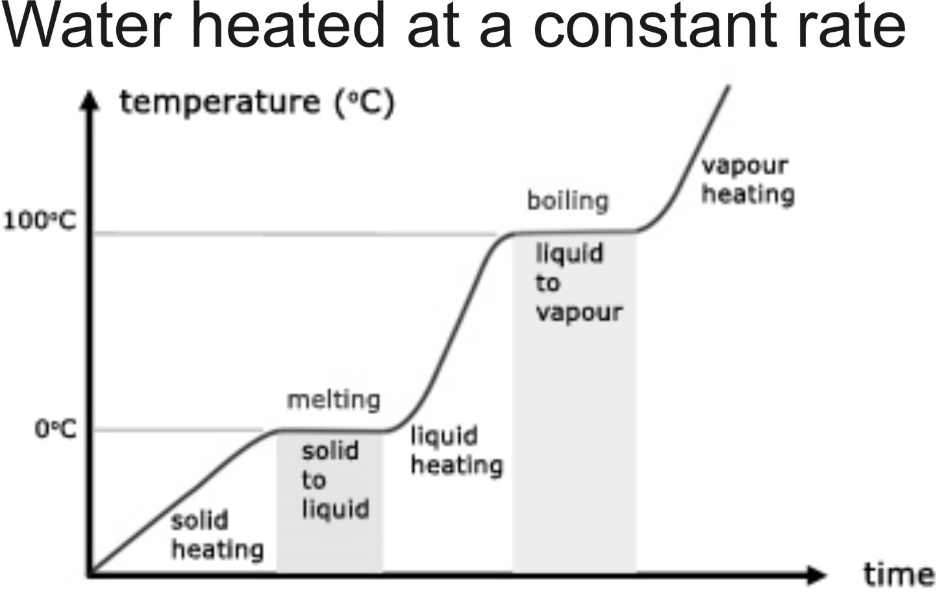

16. Why do humans sweat?

17. Why is salt added to ice in the traditional process of making ice cream?

Conduction: heat transfer by touch; when hot object A touches cold object B, the rapidly moving molecules of object A bump into the molecules of object B, causing them to begin moving. The molecules of object A lose some energy in the process, thus cooling down.

Convection: heat transfer by the flow of warm fluid (e.g. blobs rising in a lava lamp carry energy via convection)

Radiation: heat transfer by photons in electromagnetic waves – no touch and no movement of fluid (e.g. a campfire warms you from a distance even though the air around you flows toward the fire, not toward you. Infrared radiation from the fire is what warms you.)

Adiabatic Change:

In the three pictures on the right, a “perfectly bouncy” ping pong ball is dropped onto a “perfectly bouncy” ping pong paddle.
A
B
C
18. In which situation will the ball speed up the most (and bounce highest) after being hit by the paddle?
19. In which situation will the ball slow down the most
(and bounce the least) after being hit by the paddle?
20. In which situation will the ball’s speed remain approximately the same after hitting the paddle?

The three pictures on the right show “boxes” which have tennis rackets for walls. Inside the boxes, tennis balls are bouncing around. In one box, the walls are pushing inward against the balls. In another box, the rackets are relaxed, allowing the balls to push them out. In a third box the walls are held stationary.
A
B
C

21. In which “box” will the walls’ behavior cause the balls to speed up?

22. In which “box” will the walls behavior cause the balls to slow down?

23. In which “box” will the walls behavior not affect the balls’ speeds?

24. What happens to the temperature of air when the air is rapidly compressed?

25. What happens to the temperature of air when the air is allowed to rapidly expand?

Make a cloud in a bottle

Complete these steps and then answer the questions that follow:

Get a clear 2-Liter bottle with a cap.
- Get the inside of the bottle wet by putting water in it and shaking the water around. Then pour out the water.
- Light a match and get it burning well. Blow it out as you place it in the bottle. The point is to get some smoke the bottle. Cap the bottle tightly before the smoke escapes.
- Now squeeze the bottle as hard as you can for one second.
- Stop squeezing and let the bottle expand for one second.
- Squeeze again for another second, with all of your might. But don’t jump on the bottle. This should be a steady squeeze.
- Release your squeeze.
- Squeeze again….
- Keep repeating this until you see a cloud forming and disappearing. Pay close attention to when the cloud is appearing and when it is disappearing. Holding the bottle in a bright light with a dark background will make the cloud easier to see.

26. Do you see a cloud when you squeeze or when you release?

27. Explain why the cloud appears. Make sure you mention the effect of your action on the pressure and temperature inside the bottle, as well as the phase of the water.

28. Do you think this would work without the smoke? Why or why not?

29. If the weatherman says the air pressure is dropping, should you expect clear or cloudy skies?

Cloud Formation at the Equator:

The equator is one of the rainiest parts of the world. At the equator, the Sun’s rays warm the ocean’s surface as well as the air near the ocean’s surface. Explain how this warming of the ocean and the air above it causes cloud formation at the equator.

The warmth at the ocean’s surface transfers heat to the ocean water, causing the speed of water and air molecules to _____________________ (increase or decrease). Eventually, the water molecules have gained enough energy to _________________________(evaporate or condense). Their state of matter turns from __________________ to _______________, and they leave the ocean to become an invisible part of the warm air near the ocean’s surface. The energy the water molecules have gained in order for this change to occur is called latent heat of _________________________.
Another effect of this increasing warmth near the ocean’s surface is that the surface air’s volume begins to __________________. This change in volume causes the air’s density to _________________. This density change causes the air to ____________________ (rise or sink). As it moves upward, this rising mass of air carries heat with it, so it is called a __________________ (conduction, convection, or radiation) current. As the air rises, it encounters _________________ (higher or lower) air pressure. This change in air pressure causes the volume of the air to _________________. This ____________________ (expansion or compression) of the air causes the temperature of the air to _________________. This new change in the temperature of the air causes the speed of the air molecules to _______________. The change in molecular motion causes the water molecules to change phase (state) again from _________________ to _______________. When this happens, tiny droplets of water form around specs of dust, creating clouds. At first the droplets are too small and light to fall to the ground. They fall so slowly that even gentle updrafts keep pushing them back up. Eventually, when enough individual droplets coalesce, they form bigger drops that fall fast enough to make it to the ground as rain.

