EPS (Stapleton) Name: ________________________
Practice Questions:
Basic Chemistry and the Basis of Cloud Formation

1. How many atoms are shown in the diagrams below?
2. How many elements?
3. How many molecules?
4. How many compounds?
5. How many ions?
6. Which lettered item(s) are compounds but not molecules?
7. Which lettered item(s) are molecules but not compounds?
8. Which item(s) are neither molecules nor compounds?
9. What is the molecular formula for the substance lettered “C?”
10. Which (if any) of the substances are common “air molecules?”
11. What is the atomic weight of item A?
12. What is the molecular weight of item B?

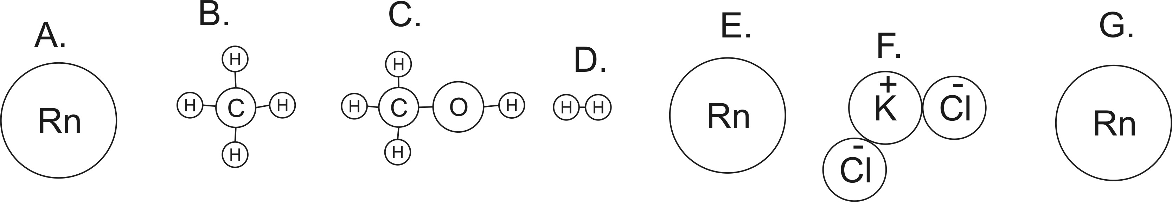

Matching Answer Choices: Temperature, Kinetic energy, Heat, Thermal Energy

13. ______________ If you know exactly how fast a single molecule in a substance is moving, and if you know that molecule’s mass, then you can calculate this.
14. ______________ If you know the average speed and mass of the molecules in a substance, then you know this.
15. ______________ If you know the average speed and mass, as well as the total number of molecules in a substance, you can determine this.
16. ______________ The formula is ½ mv²
17. ______________ This is the movement of energy from hotter objects to colder objects.

18. Explain how one object can have a lower temperature than another, but it can have more thermal energy.

19. List the three most common substances in the atmosphere, in order. Tell whether each should be d described as a bunch of molecules, compounds, and/or individual atoms.

20. How would you classify the substance F in the diagram on the other side of this sheet? And what holds it together?

21. Why is latent heat called “latent?”

22. Explain why humans sweat in order to stay cool.

23. Explain why salt is used in the process of making ice cream.

24. What happens to the temperature of a gas when you rapidly compress that gas?

25. What happens to the temperature of a compressed gas when the pressure is suddenly released, and the gas is allowed to rapidly expand?

