EPS 200 Name: _______________________________
Possible Quiz Questions: Stars and The Big Bang (and The Greenhouse Effect)
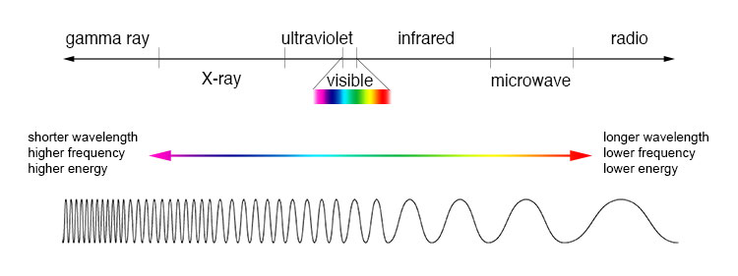
- Electromagnetic radiation:
  - What is visible light?
  - Define Wavelength:
  - Order the colors of visible light according to their wavelength.
  - Which wavelengths of electromagnetic radiation have more energy, shorter wavelengths or longer wavelengths?
  - Objects give off radiation with wavelengths that depend on the objects’ temperatures. This is true for stars, hot metal, humans, and all other objects. The wavelength of this radiation is based on the temperature of the object. Rank these star colors from hottest to coolest. Red, Blue, Orange, Yellow, White.
  - Some objects are just a little too hot for their radiation to be visible. Others are a little too cool for us to see their radiation. What type of electromagnetic radiation do these slightly-too-hot objects emit? What type of radiation do these slightly-too-cool objects emit?
  - What is the speed of light?
  - What is special about the speed of light?
  - What is a light year?
  - The distance from the Earth to the Sun is about 8 light minutes. What does that mean?
  - We always see things as they were in the past. The farther away we look, the farther into the past we see. Explain why.

- How we know what elements are in stars:
  - What is an element’s absorption spectrum?
  - How can we tell which elements are in stars?
  - What does a spectrometer do?

- The Greenhouse Effect
  - What kind of electromagnetic radiation is most prominent in sunlight? Why?
  - What kind of electromagnetic radiation does the Earth emit? Why?
  - List two prominent greenhouse gases in the Earth’s atmosphere.
  - How do Greenhouse gases increase the Earth’s temperature?

- The Doppler Effect:
  - Describe the change in wavelengths observed when the source of the waves is moving toward an observer. Do the same for a wave source moving away from an observer.
  - How do red and blue shifts occur?

- The Big Bang Theory
  - How long ago did the Big Bang occur? (i.e. what is the age of the Universe)
  - How big was the Universe at the first moment of the Big Bang?

- Describe three pieces of evidence for the Big Bang.

- The origin of matter:
  - Where did Hydrogen and Helium come from?
  - Where did elements between the weights of Helium and Iron come from?
  - Where did elements heavier than iron come from?

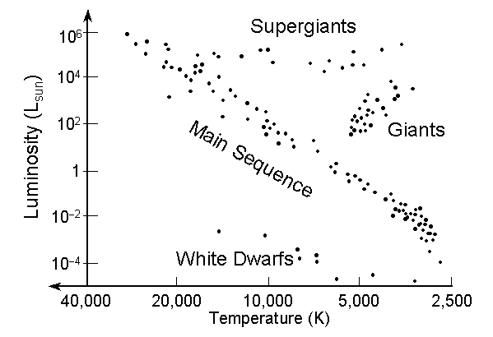
- Hertzsprung-Russell diagrams:
  - What do the axes of an H-R diagram tell us? X axis? Y axis?
  - What is a main sequence star?
  - In an H-R diagram, where are the main sequence stars located?
  - In an H-R diagram, what is happening in stars that are on the top right?
  - In an H-R diagram, what is happening in stars on the bottom left?
  - Where are the largest stars usually located in an H-R diagram?

- Describe the stages in a star’s life time.
  - Small to Medium Stars (less than 1.4 solar masses):
  - Large Stars (1.4 solar masses or greater):

- Describe the three possible fates of stellar material after a supernova occurs.

EPS 200 Name: _______________________________
Notes: Stars and The Big Bang (and The Greenhouse Effect)

- Electromagnetic radiation:
  - What is visible light? Electromagnetic waves with wavelengths that allow them to be seen by human eyes.
  - Define Wavelength: The distance from the crest of one wave to the crest of the next wave.
  - Order the colors of visible light according to their wavelength. Longest wavelength to shortest wavelength: ROYGBIV (Red, orange, yellow, green, blue, indigo, violet)
  - Which wavelengths of electromagnetic radiation have more energy, shorter wavelengths or longer wavelengths? Shorter wavelength = higher energy
  - Objects give off radiation with wavelengths that depend on the objects’ temperature. This is true for stars, hot metal, humans, and all other objects. The wavelength of this radiation is based on the temperature of the object. Rank these star colors from hottest to coolest. Red, Blue, Orange, Yellow, White. Hottest to Coolest: Blue, White, Yellow, Orange, Red
  - Some objects are just a little too hot for their radiation to be visible. Others are a little too cool for us to see their radiation. What type of electromagnetic radiation do these slightly-too-hot objects emit? Ultraviolet radiation What type of radiation do these slightly-too-cool objects emit? Infrared radiation
  - What is the speed of light? 671 million miles per hour
  - What is special about the speed of light?
    - All electromagnetic radiation travels at this speed in a vacuum.
    - Nothing can travel through space faster than the speed of light.
    - And there’s more (for later).
  - What is a light year? The distance light travels in one year (5.879x10¹² miles). A Light year is a unit of distance, not a unit of time.
  - The distance from the Earth to the Sun is about 8 light minutes. What does that mean? It means light takes 8 minutes to travel from the sun to the Earth.
  - We always see things as they were in the past. The farther away we look, the farther into the past we see. Explain why. Light travels fast, but it does not travel instantaneously. We see an object as it looked when the light that is now reaching our eyes left that object.
- How we know what elements are in stars:
  - What is an element’s absorption spectrum? An absorption spectrum is a fingerprint of specific wavelengths of light that are absorbed by that element.
  - How can we tell which elements are in stars? Stars emit radiation because they are hot, but some of that radiation gets absorbed by the elements in the star. We look at the absorption spectra of the light that is coming from stars and use those fingerprints to identify the elements in the stars.
  - What does a spectrometer do? A spectrometer works like a prism. It separates light into individual wavelengths so that we can see the spectrum of wavelengths coming from a star.
- The Greenhouse Effect
  - What kind of electromagnetic radiation is most prominent in sunlight? Why? Visible Electromagnetic Radiation (because the sun’s surface is about 5,700◦K)
  - What kind of electromagnetic radiation does the Earth emit? Why? Infrared (because the Earth is much cooler – about 300◦K)
  - List two prominent greenhouse gases in the Earth’s atmosphere. Carbon Dioxide, Methane
  - How do Greenhouse gases increase the Earth’s temperature? Greenhouse gases are transparent to visible radiation from the sun (sunlight can easily pass through them), but they block much of the infrared radiation that is emitted by the Earth. This means the sun’s energy can make it’s way to the Earth, but it changes to a form (infrared) that gets trapped by greenhouse gases.
- The Doppler Effect:
  - Describe the change in wavelengths observed when the source of the waves is moving toward an observer. Do the same for a wave source moving away from an observer. When the source is moving toward the observer, the wavelengths become shorter (compressed). When the source is moving away from the observer, the wavelengths become longer (stretched out).
  - How do red and blue shifts occur? When an object is moving toward an observer, the observed waves become compressed, thus shortening their wavelengths and shifting them toward the shorter (blue) end of the electromagnetic spectrum. When an object is moving away, the observed waves become stretched out, thus increasing their wavelengths and shifting them toward the longer (red) end of the electromagnetic spectrum.
- The Big Bang Theory
  - How long ago did the Big Bang occur? (i.e. what is the age of the universe?) About 13.8 billion years ago
  - How big was the Universe at the first moment of the Big Bang? smaller than a Planck Length (1.6x10⁻³⁵m) in diameter
  - Important Aspects of the Big Bang Theory:
    - In the first few seconds of the Universe, light elements were created (about 73% Hydrogen and 25% Helium)
    - The early universe extremely hot and dense (10^{32◦}K). It was so dense that light could not travel through it. It was opaque.
    - After about 380,000 years, the universe first became transparent to light. Everything was about 3,000◦K (as hot as a red star), so the whole universe glowed like a red star. [This is the microwave radiation that we can still see today.]
    - The universe continues to expand and cool. As the Universe expands, it does not expand into space or through space; space within the universe grows.
- Describe the evidence for the Big Bang.
  - We can see heat that was produced during the Big Bang. This heat is called the Cosmic Background Radiaton. The Big Bang Theory postulated that high energy radiation should have been emitted from every part of the hot, young Universe (like light from a 3,000◦K red star). This radiation would have filled the Universe. Over time, as the Universe has stretched out, the theory holds that this radiation should have stretched out along with the rest of the Universe. Today, that radiation should have a wavelength in the microwave region of the electromagnetic spectrum. These microwaves should have a wavelength similar to those that would be emitted from a very cold, 2.76◦K object. After this prediction was made, scientists have confirmed that the sky is filled with this radiation, and it has the predicted wavelength.

  - Hubble’s Law: Almost all galaxies are moving away from us. When galaxies’ speeds and distances are graphed, we see that more distant galaxies are moving away from us faster. This suggests that space is expanding.
    - How did Hubble get his data? He examined the Doppler shifts of distant galaxies. The extent of their red shifts told him how fast the galaxies were moving away from us.
  - The Universe’s Composition: The Big Bang theory predicted the Universe’ composition to be approximately 73% Hydrogen and 25% Helium. This has been confirmed by recent measurements.

- The origin of matter:
  - Where did Hydrogen and Helium come from? They formed a few seconds after the Big Bang
  - Where did elements between the weights of Helium and Iron come from? Fusion of Hydrogen and Helium into heavier elements.
  - Where did elements heavier than iron come from? Supernovae (explosive deaths of large stars) provided enough pressure to fuse atoms into even heavier elements.
- Hertzsprung-Russell diagrams:
  - What do the axes of an H-R diagram tell us? X axis? Temperature (high to low) Y axis? Brightness (low to high)
  - What is a main sequence star? A star whose current energy sources is primarily the fusion of Hydrogen into Helium; a middle-aged star.
  - In an H-R diagram, where are the main sequence stars located? Along a diagonal from the top left to the bottom right
  - In an H-R diagram, what kinds of stars are on the top right? Red giants or red supergiants.
  - In an H-R diagram, what kinds of stars are on the top right? White dwarfs.
  - Where are the largest stars usually located in an H-R diagram? The top
- Describe the stages in a star’s life time.
  - Small to Medium Stars (less than 1.4 solar masses):
    - Nebula – cold cloud of dust and frozen gas
    - Main Sequence Star – Hydrogen is fusing to Helium
    - Red Giant – Fusable Hydrogen is used up. Helium and other elements are fusing.
    - White Dwarf – Nuclear fusion stops. The star collapses but then heats back up due to compression. This heating causes the color to change from red to white.
    - Black Dwarf – Eventually the star radiates all of its heat into space . It is cold and dark.
  - Large Stars (1.4 solar masses or greater):
    - Nebula – cold cloud of dust and frozen gas
    - Main Sequence Star – Hydrogen is fusing to Helium
    - Red Supergiant – Fusable Hydrogen is used up. Helium and other elements are fusing into elements up to the weight of iron.
    - Supernova – Nuclear fusion stops. The star collapses and slams into its iron core with explosive pressure. This compression fuses elements heavier than iron and blasts material into space.
- Describe the three possible fates of stellar material after a supernova occurs.
  - Recycling: Some matter is blasted into space and incorporated into new nebulas, like ours.
  - Black Hole: If the matter left behind is more than 3 solar masses, a black hole will form.
  - Neutron Star: If the matter left behind is between 1.4 and 3 solar masses, a neutron star will form.

