EPS 200 Name: __________________________
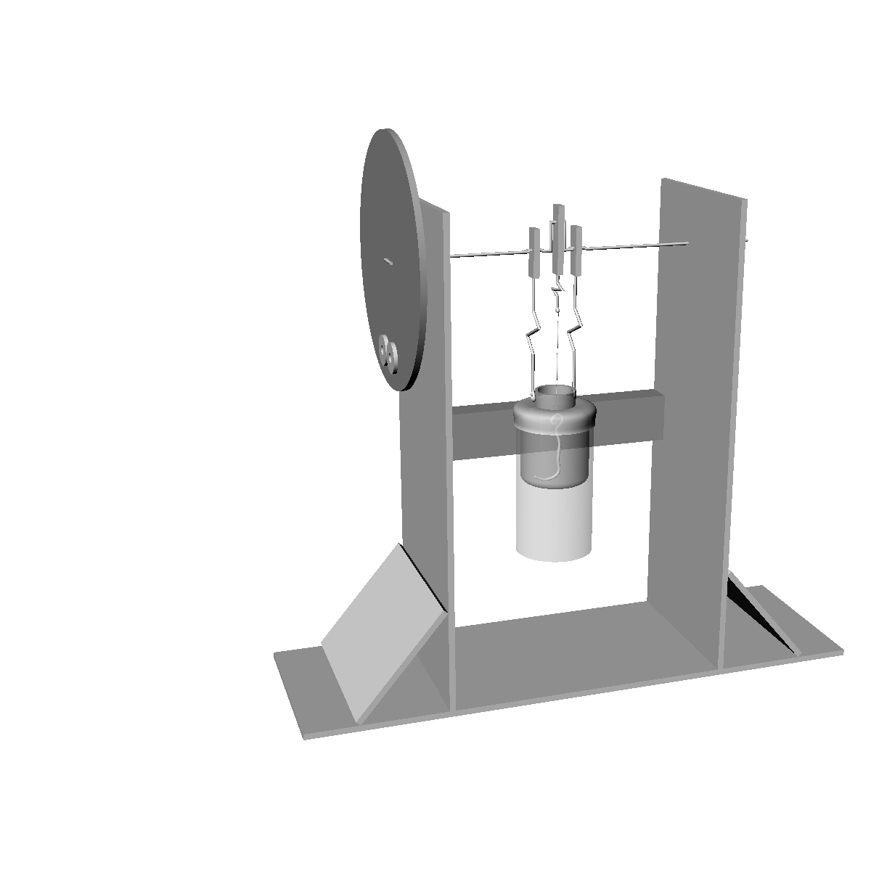
Stirling Engine Questions
Figure 1

1. On the Figure 1 to the right, label the following parts: Displacer, Crankshaft, Cylinder, Power Piston (balloon), Flywheel, Counterweights, Piston rods, Displacer Rods, Working fluid (air in the cylinder)

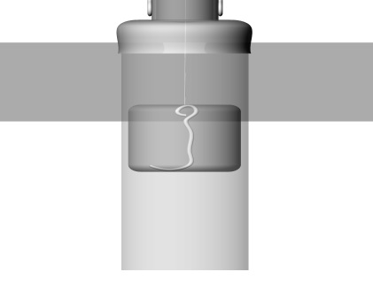
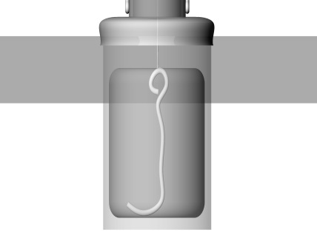
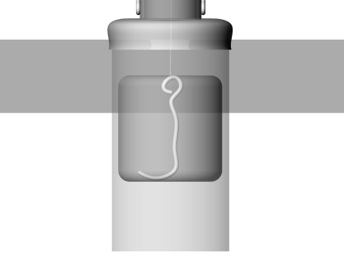
2. Figure 3 shows three possible displacers. Choose the one that will work best and explain why the other two will not work well.

Figure 3

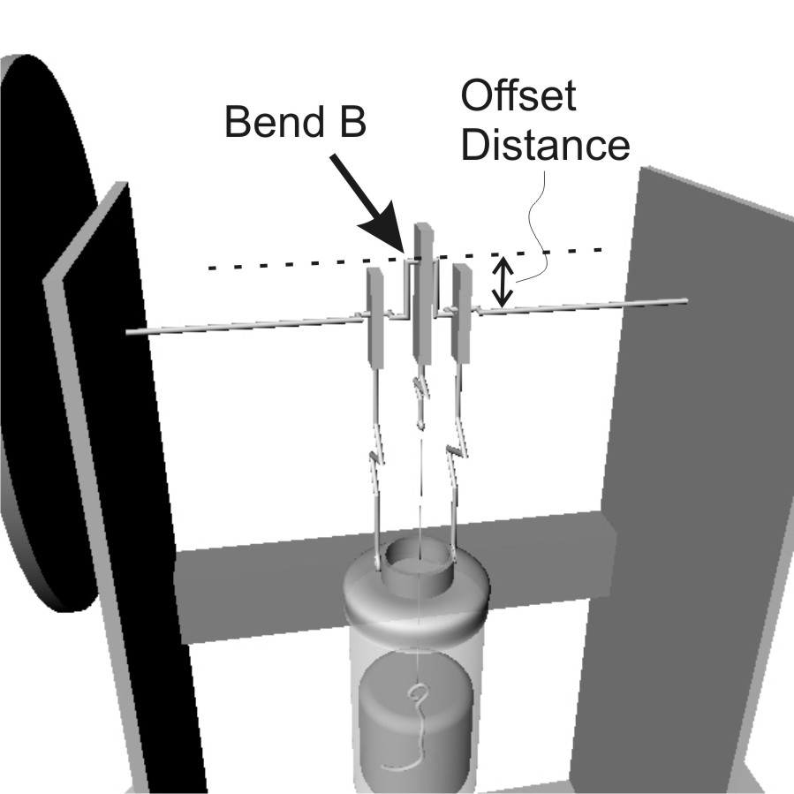
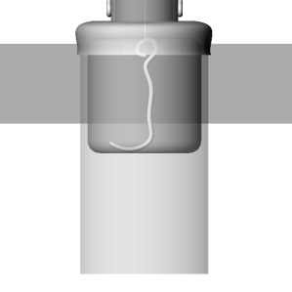
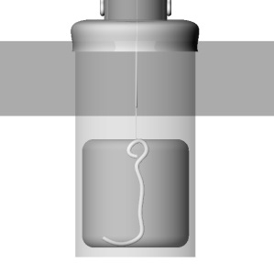
3. Figure 4 shows the highest and lowest possible positions of the displacer. Use a line to draw the correct offset distance for bend B (fig 5). Draw your line in proportion to the cylinders in Figure 4.

Figure 5
Figure 4
4. Figure 6 shows the most deflated and inflated conditions of the power piston (balloon). Use a line to draw the correct offset distance for bends A and C (Fig 7). Draw your line in proportion to the cylinders in Figure 6.
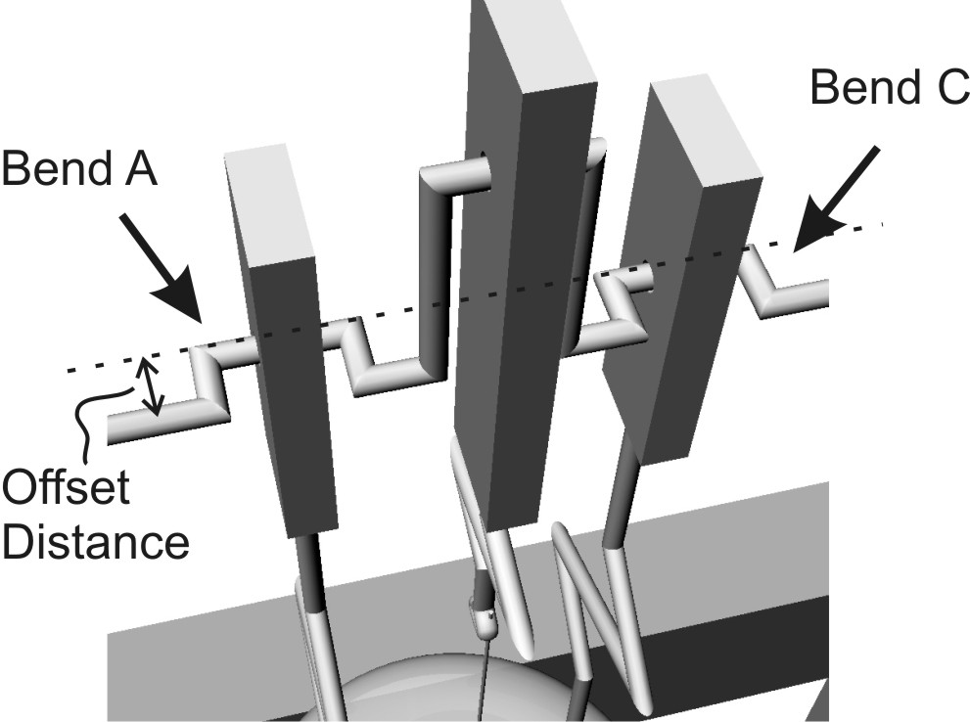
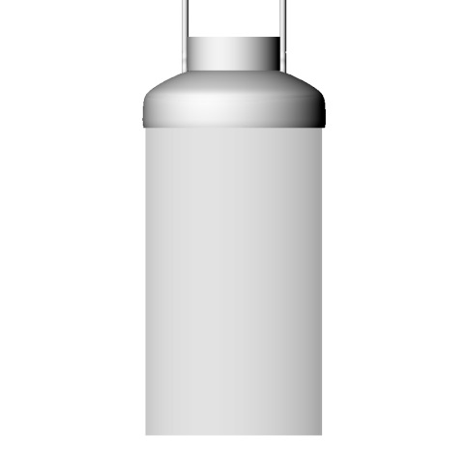
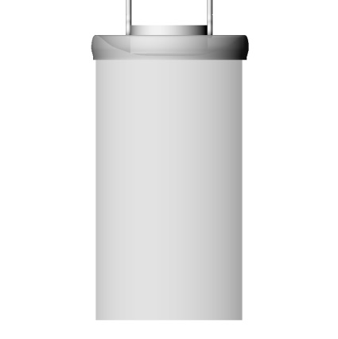

Figure 7

Figure 6

5. In Figure 8, label the position of the working fluid (air). For each diagram, tell whether the fluid is heating up or cooling down. Also tell whether the power piston (balloon) is about to inflate or deflate.

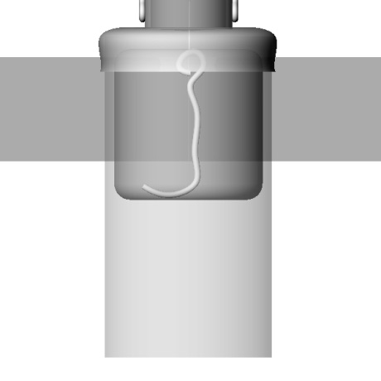
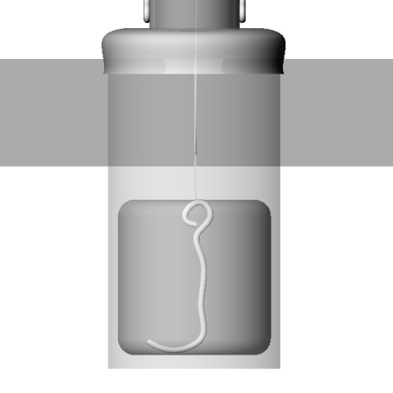

Figure 8

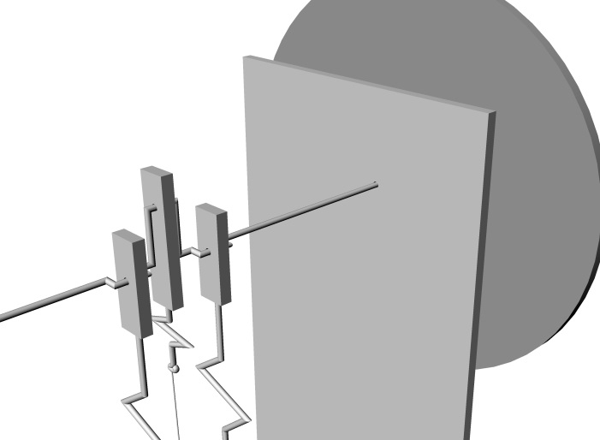
Figure 2

6. a. From the perspective shown in Figure 2, which way is the flywheel going to rotate? Clockwise or counter-clockwise? Assume that the heat source is at the bottom of the can.

b. Explain how you can tell.

c. At this point in the cycle, where are the counterweights in their rotation? (top, bottom, or middle height) How do you know?

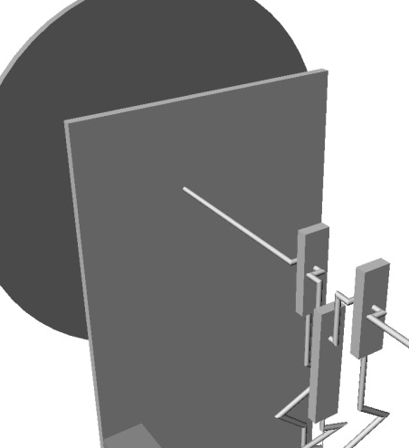

7. a. From the perspective shown in Figure 9, which way is the flywheel going to rotate? Clockwise or counter-clockwise? Assume that the heat source is at the bottom of the can.

b. Explain how you can tell.

Figure 9

c. At this point in the cycle, where are the counterweights in their rotation? (top, bottom, or middle height) How do you know?

8. Explain, in general terms, what makes the crank shaft (and the rest of the Stirling engine) move. For example, in the Figure 1 on the right, where is the push or pull about to come from?
Figure 1

9. What is the purpose of the displacer?

10. What is the purpose of the counterweight?

11. How can you tell where to place the counterweight?

12. How can you tell when you have added the right amount of counterweight?

13. Explain why a Stirling engine with a leaky cylinder will not work. A leaky cylinder is far from airtight.

14. What is the purpose of a flywheel? Why does this Stirling engine need one?

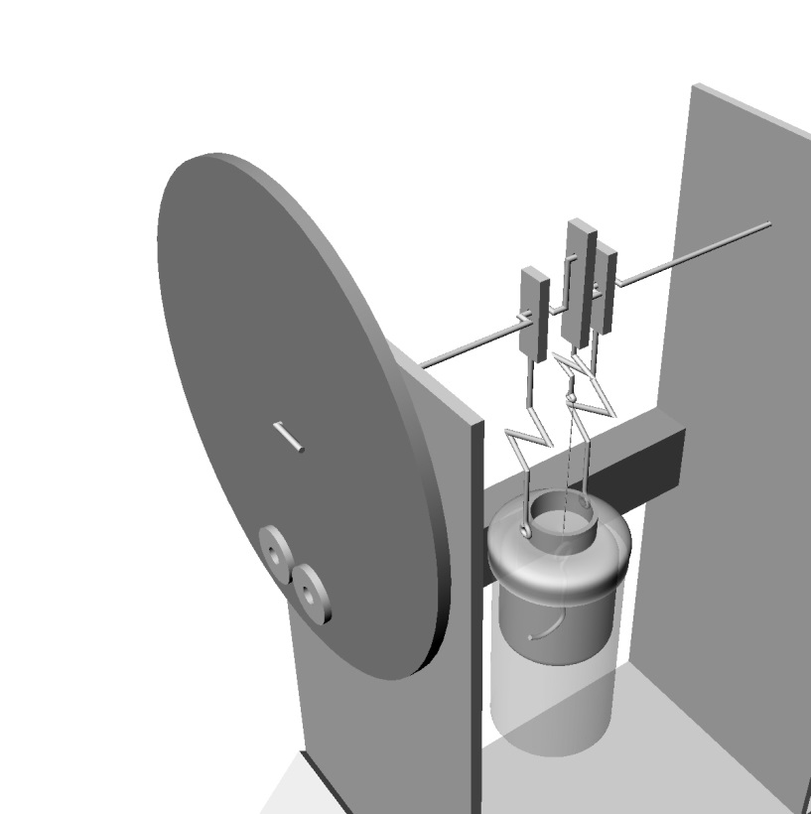
Figure 10
15. What would happen if you cooled the bottom of the can in Figure 10, and you heated the top? If the engine could handle the heat, which way would the flywheel rotate?

16. Friction can be a big problem for Stirling Engines. Identify as many sources of friction as you can by labeling their locations on Figure 1 below.
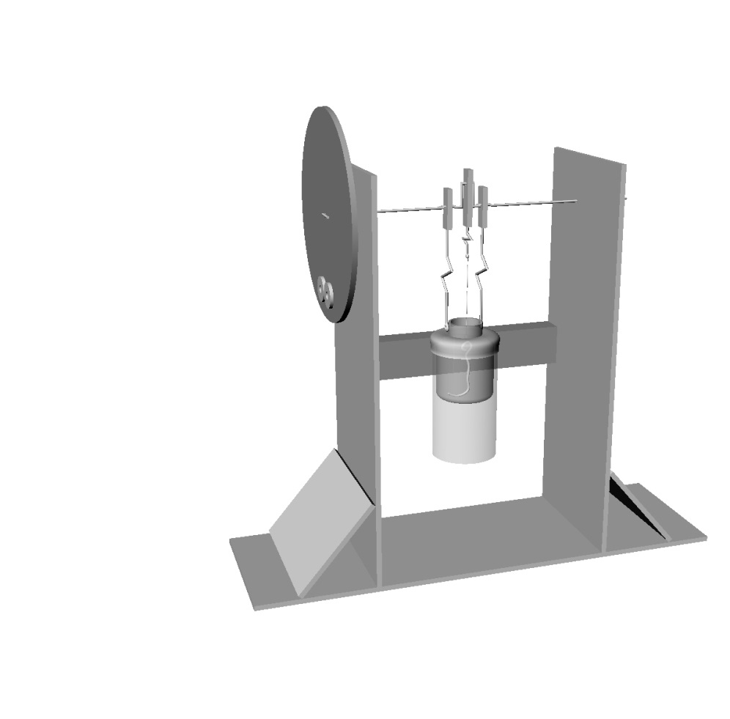
Figure 1

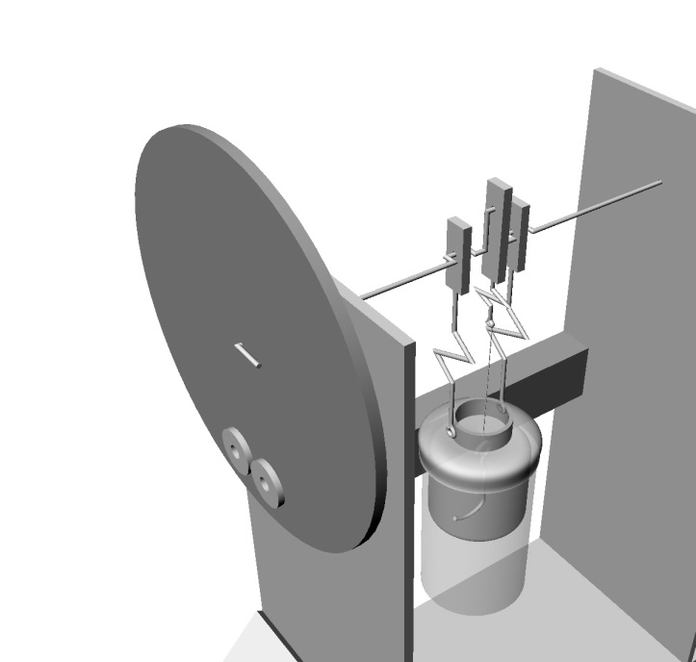
Figure 10
17. **Very Difficult** If you don’t heat or cool a Stirling engine, but you physically rotate it, it becomes a heat pump (a very weak one). Which way should you turn the flywheel in Figure 10 to cause the bottom of the can to cool down? Explain your reasoning.

