EPS 200 (Stapleton) Name: _________________________
Physical Chemistry Applications -- Humidity

- Absolute Humidity: the actual mass of water that can be kept in gas phase in a cubic meter of air. The units of humidity are g/m³.
- Saturation: the condition of “fullness”; the point at which the air is holding the maximum mass of water that can be kept in gas phase. Room temperature air is saturated at around 17grams of H₂O/m³. Air that is saturated has a relative humidity of 100%.
- Relative Humidity: the ratio of the current humidity of air to the air’s humidity at saturation, expressed as a percentage. In other words, relative humidity is a percentage describing “how full” of water vapor the air is. Relative humidity provides a good gauge of how humid the air feels.
- Dew point: the temperature to which some air must be cooled in order to reach saturation (100% relative humidity).
- Water Vapor: water in gas phase
- Warm air can “hold” (evaporate) more water vapor than cold air. As air heats up, its water vapor holding capacity increases.

1. If you think of air as being a bucket for holding water, ___________ ( warm or cold) air is like a tall bucket, and _____________ (warm or cold) air is like a short bucket.

2. In the diagram on the right, letter _____ represents a mass of warmer air, and letter _______ represents a mass of colder air.
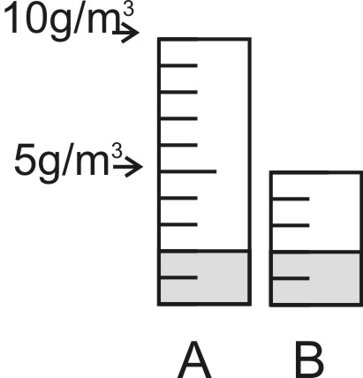
If we try to understand humidity and relative humidity using buckets, then…
3. How full the bucket is corresponds to:
a. absolute humidity b. relative humidity c. air temperature
4. Bucket size corresponds to:
a. absolute humidity b. relative humidity c. air temperature
5. The actual amount of water in the bucket corresponds to:
a. absolute humidity b. relative humidity c. air temperature

6. In the diagram on the right, air mass A has a capacity of 10g of water vapor for every cubic meter of air. Air mass B has a capacity of 5g/m³. Room temperature air can typically hold about 17g/m³. Do A and be represent air that is warmer or colder than room temperature? _____________________

7. What is the absolute humidity of air mass A, in g/m³? __________

8. What is the relative humidity of air mass A, in %? __________

9. What is the absolute humidity of air mass B, in g/m³? __________

10. What is the relative humidity of air mass B, in %? __________

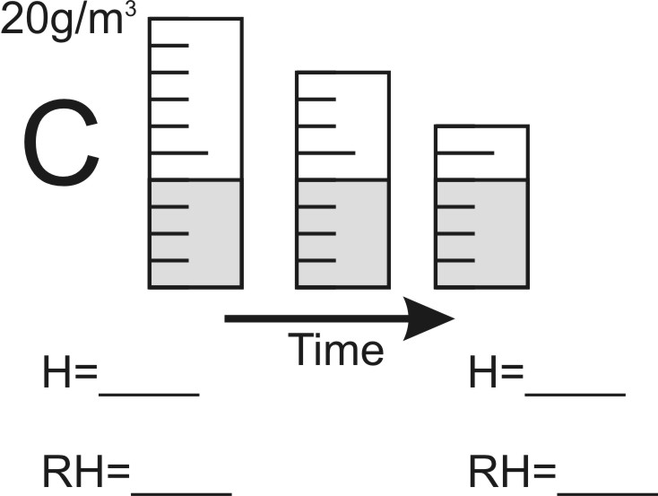
11. Figure C shows a shrinking container that represents an air mass whose properties are changing over time.

a. Beneath the diagram, write the starting and ending humidity and relative humidity.

b. What is changing; temperature, absolute humidity, or both?

c. Propose a possible cause for this change.

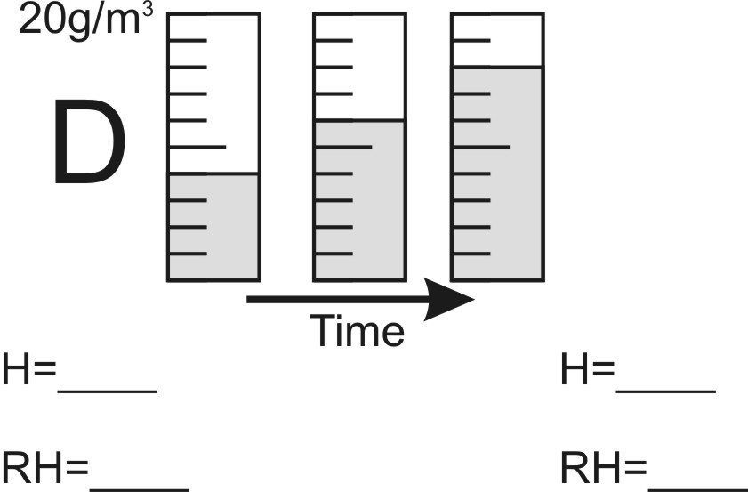
12. Figure D shows a container of constant size that represents an air mass whose properties are changing over time.

a. Beneath the diagram, write the starting and ending humidity and relative humidity.

b. What is changing; temperature, absolute humidity, or both?

c. Propose a possible cause for this change.

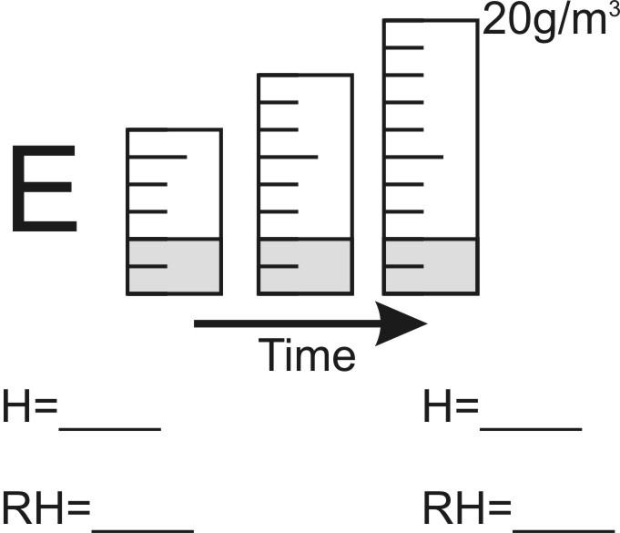
13. Figure E shows an expanding container that represents an air mass whose properties are changing over time.

a. Beneath the diagram, write the starting and ending humidity and relative humidity.

b. What is changing; temperature, absolute humidity, or both?

c. Propose a possible cause for this change.

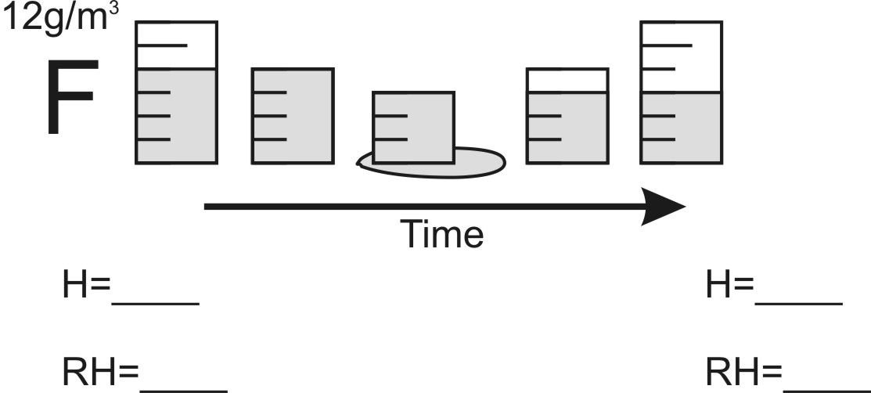
14. Figure F shows a container that represents an air mass whose properties are changing over time.

a. Beneath the diagram, write the starting and ending humidity and relative humidity.

b. What is changing; temperature, absolute humidity, or both?

c. Propose a possible cause for this change.

15. Which set of diagrams depicted an air mass that actually reached the dew point? How could you tell?

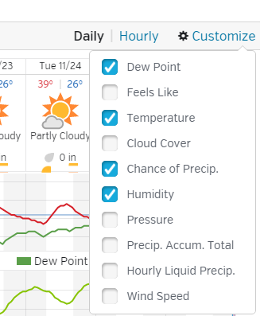
16. Go to www.wunderground.com. Set the location to Essex, VT. Choose the “graph” tab of the 10 day forecast. Then click the “customize” and select dew point, temperature, chance of precipitation, and humidity (as shown on the right).

On the graph, “humidity” is actually relative humidity. Both relative humidity and dew point fluctuate over time.

a. How are their fluctuations different?

b. Propose an explanation for why these fluctuations are different.

17. Is the dew point dependent on humidity or relative humidity? Explain your reasoning.

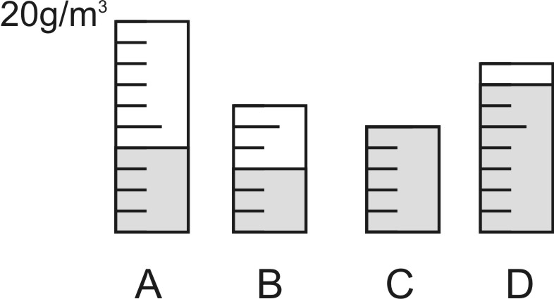

18. The containers on the right represent air masses. Rank the air masses according to their dew points.

19. Consider two days. One is a cold winter day (-10F), and the other is a hot summer day (90F). In both cases, the outside relative humidity is 50%. In both cases, air from the outside enters a house. The basement of the house stays at a constant temperature of 50 degrees during all seasons.

- When is the absolute humidity higher outside of the house -- on the winter day or on the summer day? Explain your reasoning.

- When the outside air travels into the house’s basement, its temperature changes to 50 degrees. How does the air’s relative humidity change when air enters the basement during the winter? Why?

- Describe how and why the air’s relative humidity changes when it enters the basement during the summer.

20. Why do people have more trouble with dry skin during the winter?

21. Herman showers every morning. In the winter, Herman’s bathroom is really cold. Herman has tried stepping out of the shower to dry off, and he has tried toweling off inside the shower, with the shower curtain closed. What he has discovered is that he stays much warmer when he dries off before leaving the closed shower. Why?

