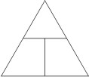
EPS 100 Name: ____________________________
Your Hot Air Balloon

$$Density= \frac{mass}{volume}$$

$Mass in kg= \frac{mass in g}{1000}$

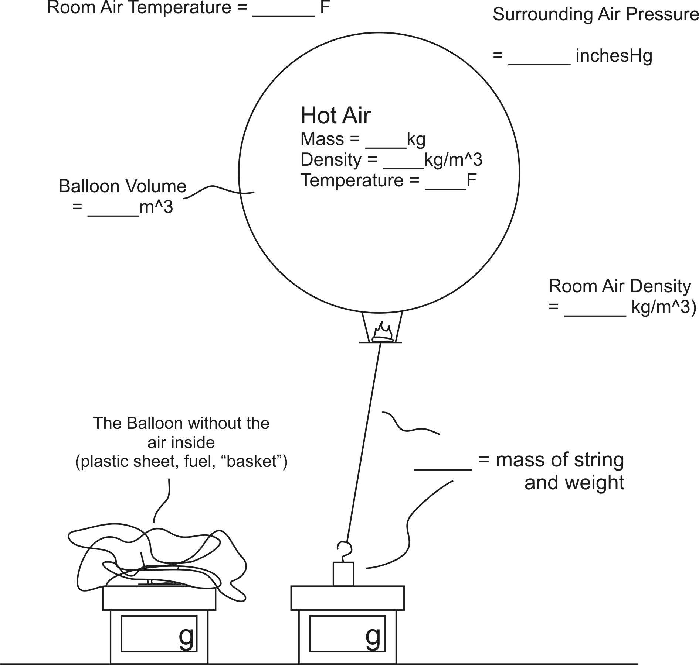
1. Find the room air temperature and air pressure, and record them on the diagram to the right. For air pressure, use the link on the class website.

2. Copy the spreadsheet that is provided on the class website, and use it to determine the Room air density. Record the room air density on the diagram to the right.

3. Use data from your balloon launch to fill in the masses on the electronic balances at the bottom of the diagram.

4. Fill in the mass of the string and weight.

5. Use the shop vac and box device to record the amount of time it takes to fill your balloon.

Fill Time = _______ seconds.

6. Calculate your balloon’s volume by multiplying the fill time (from #5) by 0.014. Record your balloon’s volume on the diagram.

Calculating your Balloon’s Hot Air Density (this is just like the homework you did earlier):

7. The overall density of the balloon (and the stuff it is lifting) = ______ kg/m³

8. The overall mass of the balloon (and the stuff it is lifting) = ______ kg

9. Add up the masses of all of the things that are being lifted – except for the hot air. This includes the string, the empty balloon, and part of the weight.

Total Lifted Mass (excluding air) = __________g

10. Convert that mass to kilograms.

Total Mass (excluding air) = __________kg

11. The overall mass (from #8) is _______kg. The non-air mass

(from #10) is _______kg. This means that the mass of the hot air in the balloon must be _______ kg.

Enter this hot air mass into the diagram on the front.

12. Use the density formula to calculate the density of the hot air in the balloon.

Density of the Hot Air = __________ kg/m³. Enter this hot air density into the diagram on the front.

13. Use the spreadsheet that you copied earlier to determine the temperature of the hot air in the balloon.

Enter this hot air temperature into the diagram on the front.

