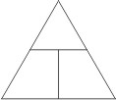
EPS 100 Name: ____________________________
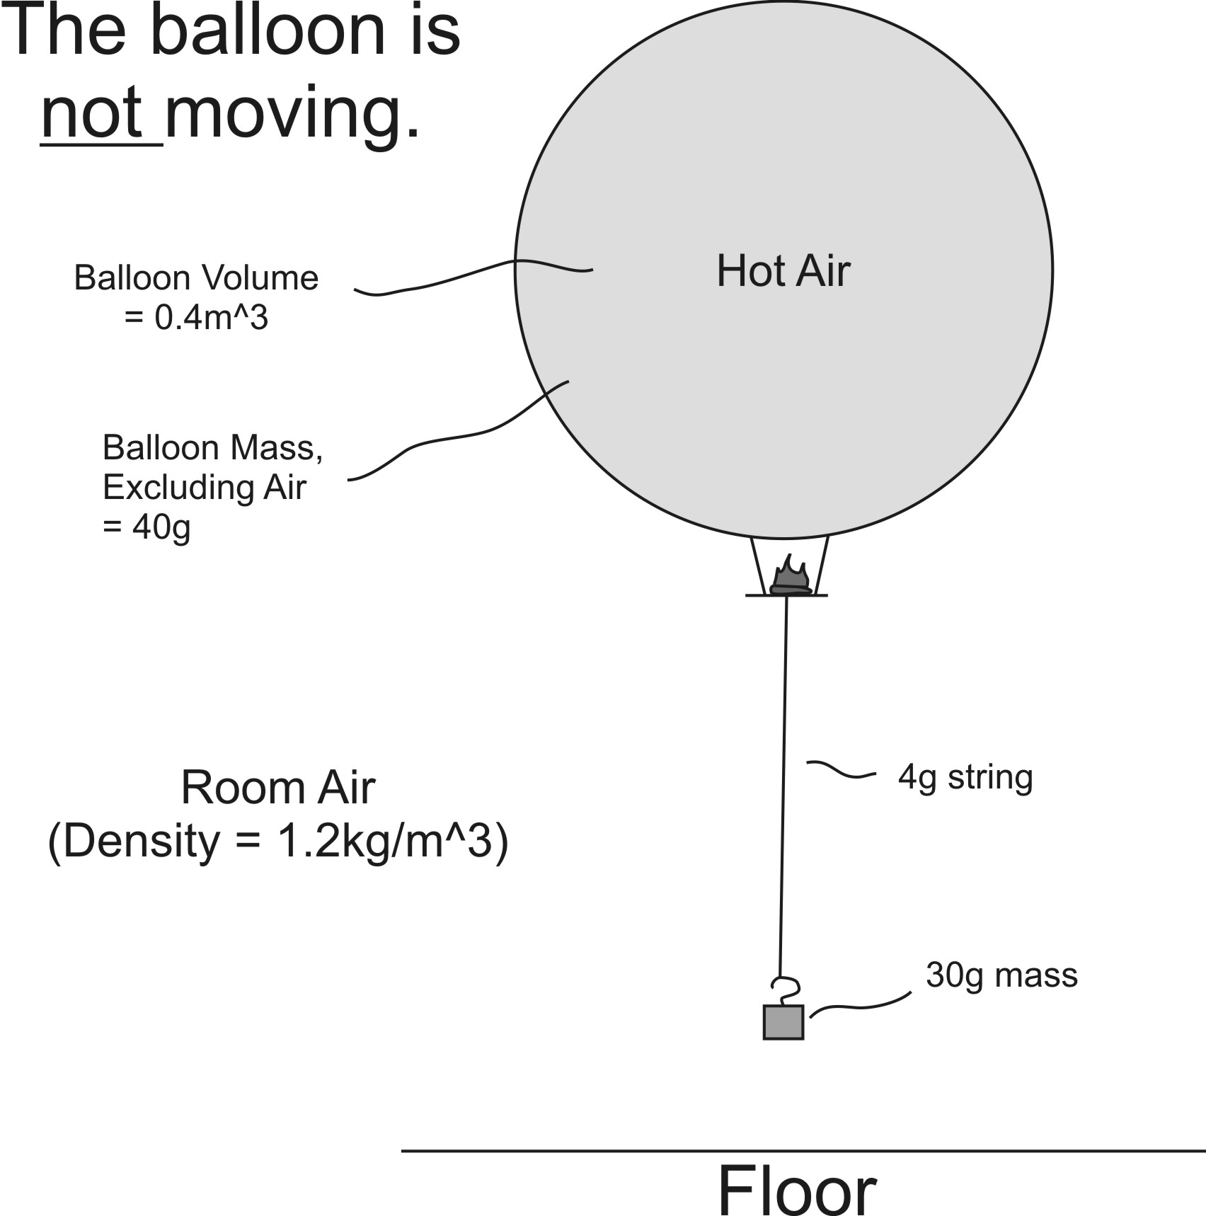
More Hot Air Balloon Problems

$$Density= \frac{mass}{volume}$$

$Mass in kg= \frac{mass in g}{1000}$

1. If the balloon is not moving, what is the overall density of the balloon and everything that is attached to it?

Overall Density = ______ kg/m³

2. Use the density formula to calculate the overall mass of the balloon and everything that is attached to it.

Overall Mass = _________ kg

3. Add up the masses of all of the things that are being lifted – except for the hot air.

Total Mass (excluding air) = __________g

4. Convert that mass to kilograms.

Total Mass (excluding air) = __________kg

5. The overall mass (from #2) is _______kg. The non-air mass (from #4) is _______kg. This means that the

mass of the hot air in the balloon must be _______ kg.

6. Use the density formula to calculate the density of the hot air in the balloon.

Density of the Hot Air = __________ kg/m³.

Problem Set 2
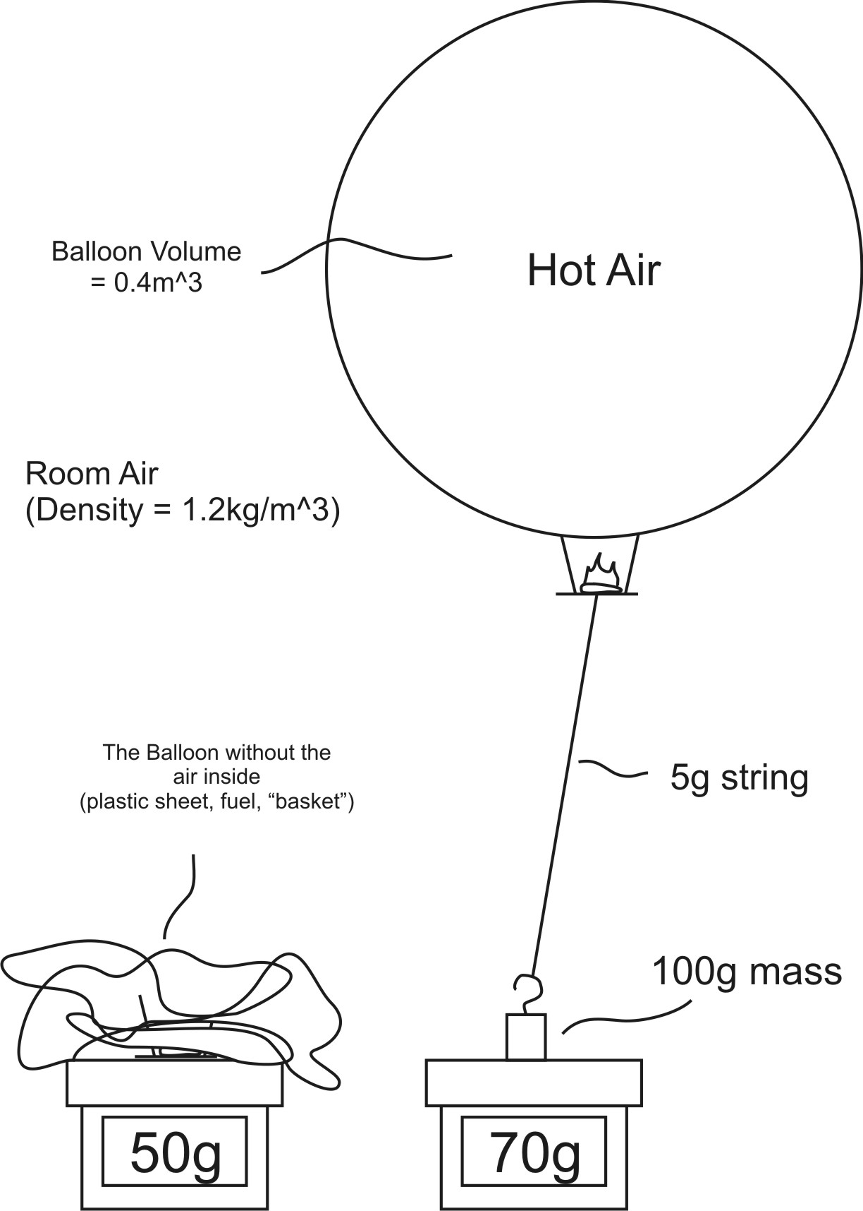
1. The overall density of the balloon (and the stuff it is lifting) = ______ kg/m³

2. The overall mass of the balloon (and the stuff it is lifting) = ______ kg

3. Add up the masses of all of the things that are being lifted – except for the hot air.

Total Mass (excluding air) = __________g

4. Convert that mass to kilograms.

Total Mass (excluding air) = __________kg

5. The overall mass (from #2) is _______kg. The non-air mass

(from #4) is _______kg. This means that the mass of the hot air in the balloon must be _______ kg.

6. Use the density formula to calculate the density of the hot air in the balloon.

Density of the Hot Air = __________ kg/m³.

Problem Set 3
1. The overall density of the balloon (and the stuff it is lifting) = ______ kg/m³

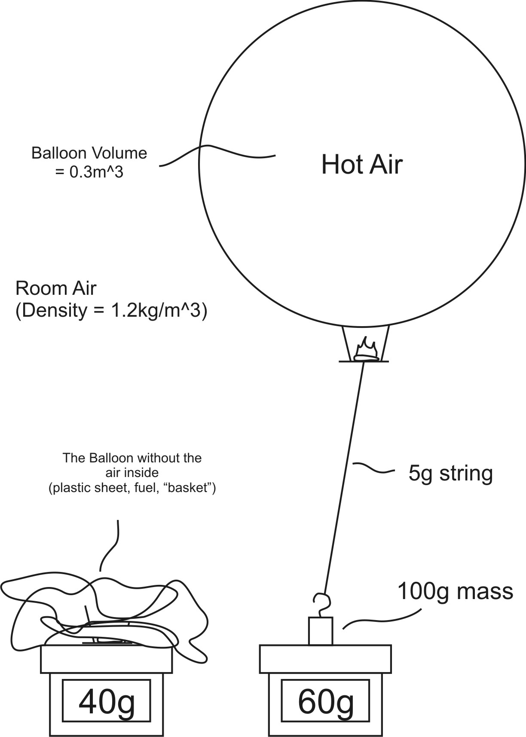
2. The overall mass of the balloon (and the stuff it is lifting) = ______ kg

3. Add up the masses of all of the things that are being lifted – except for the hot air.

Total Mass (excluding air) = __________g

4. Convert that mass to kilograms.

Total Mass (excluding air) = __________kg

5. The overall mass (from #2) is _______kg.

The non-air mass (from #4) is _______kg.

This means that the mass of the hot air in the balloon must be _______ kg.

6. Use the density formula to calculate the density of the hot air in the balloon.

Density of the Hot Air = __________ kg/m³.

