EPS 100 Name: __________________________
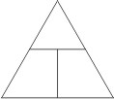
Hot Air Balloon Calculations

Formulas:

$Density= \frac{mass}{volume}$ or $D= \frac{m}{v}$

Mass of Plastic Object = Surface Area X 0.001 or $m=A×0.007$
[1 in² of plastic sheet has a mass of about 0.007g.]

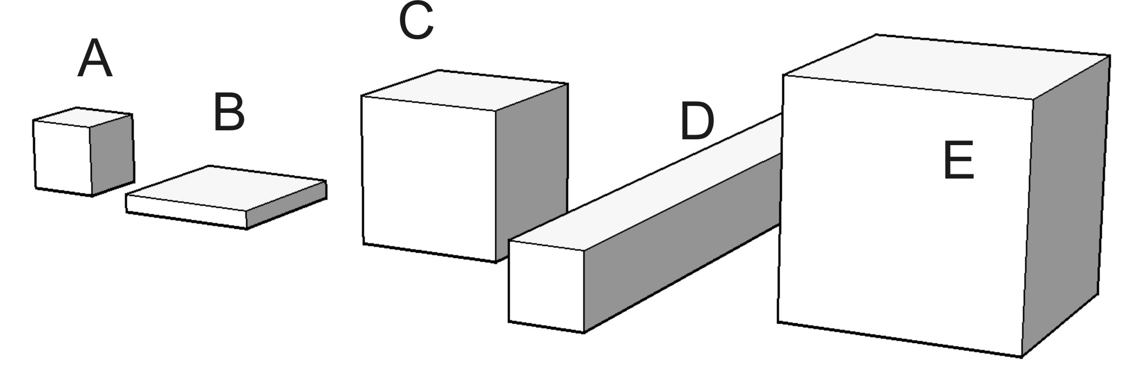
Volume of a box = Length X Width X Height or $V=L×W×H$

The boxes on the right are made out of very thin plastic. For each of the boxes, calculate the box’s area, mass, volume, and density.

Box A:
Length = 1 in Width = 1 in Height = 1 in Surface Area = 6 in²
1. Mass = _______g

2. Volume = _______in³

3. Density = _______ g/in³

Box B:
Length = 0.5 in Width = 2 in Height = 2 in Surface Area = 10 in²

4. Mass = _______g

5. Volume = _______in³

6. Density = _______ g/in³

Box C:
Length = 2 in Width = 2 in Height = 2 in Surface Area = 24 in²

7. Mass = _______g

8. Volume = _______in³

9. Density = _______ g/in³

Box D:
Length = 9 in Width = 1in Height = 1in Surface Area = 38in²

10. Mass = _______g

11. Volume = _______in³

12. Density = _______ g/in³

Box E:
Length = 3 in Width = 3 in Height = 3 in Surface Area = 54in²

13. Mass = _______g

14. Volume = _______in³

15. Density = _______ g/in³

Questions:

- The boxes in the diagram are arranged in order. Are they arranged in order of area, mass, volume, or density?

- On the diagram, label the boxes with their densities.
- Based on your answers, what shape is best for having a low density?

