EPS 100 (Stapleton) Name: _____________________________
Coriolis Effect
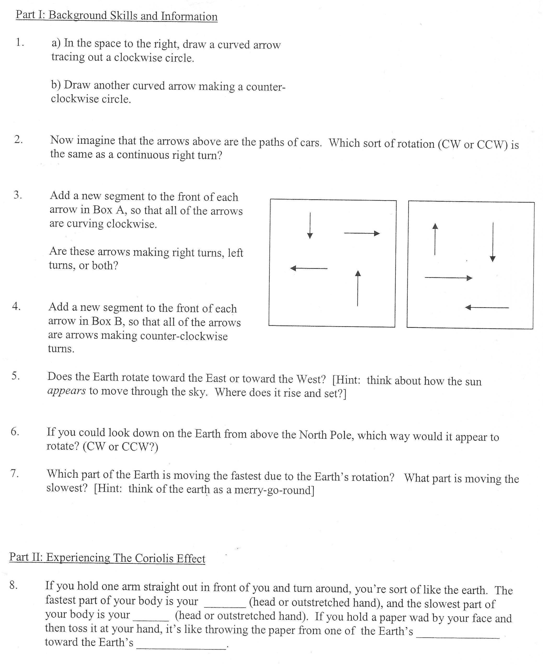

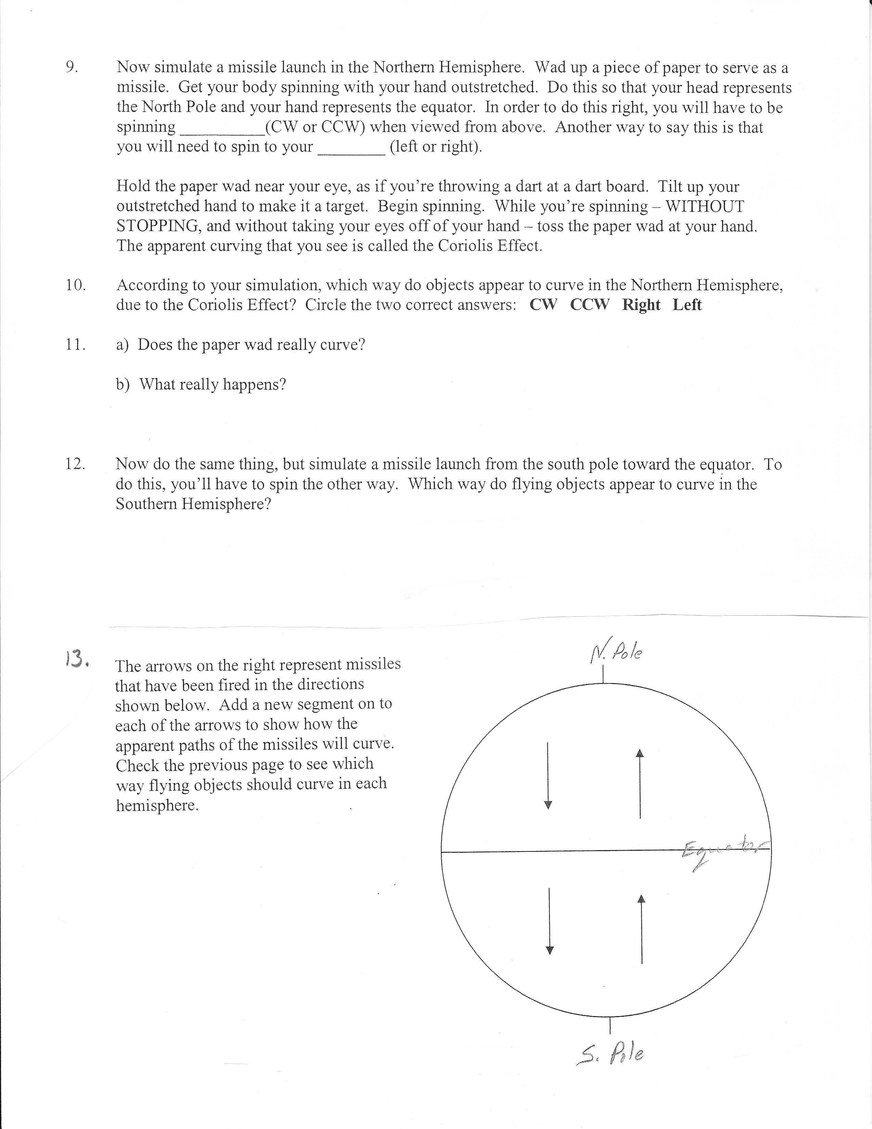

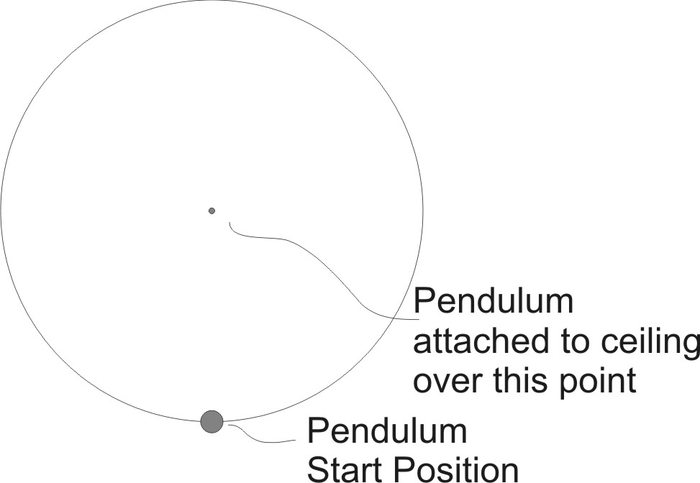
14. The “Foucault Pendulum” is a device named after Jean Foucault. It swings back and forth on a long cable. The diagram to the right shows a “bird’s eye” view of a circular room. The pendulum is suspended from the ceiling at the center of the room.

The pendulum will not return to its starting position. Show how, in the northern hemisphere, the pendulum’s position changes over the course of the day.

